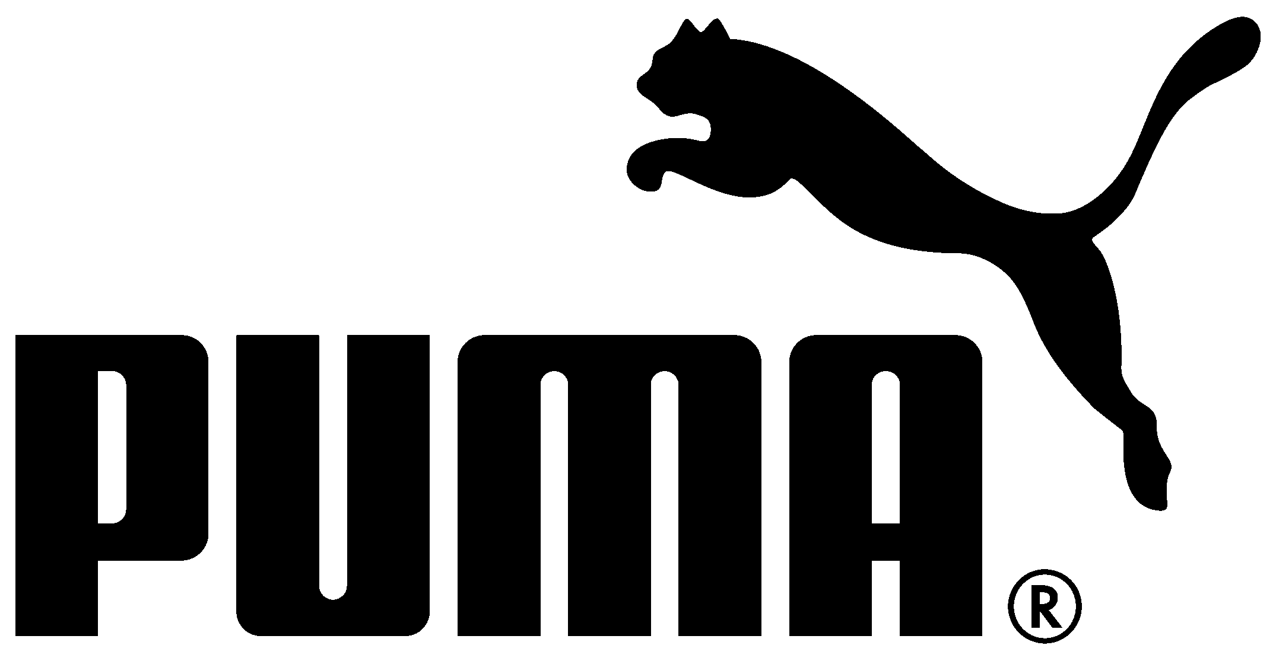

PRESS RELEASE

PUMA Drops the Latest Fierce Trainer

Adding Fierceness to Your Training Routine. Worn by Kylie Jenner.

Herzogenaurach, Germany (27th October, 2016) – Global Sports Brand PUMA continues to slay with innovative performance gear merged with contemporary styling. Dropping this month is the latest style of the brand’s next level training shoes, the PUMA Fierce KRM.

First introduced in April and worn by style icon Kylie Jenner, the PUMA Fierce features a lightweight lace-less design that mixes performance technology and street-worthy style. The PUMA Fierce has a demi height slip-on construction, a supportive midsole, and flexible outsole allowing for fast, multi-directional movements. The style’s performance functionality and distinct design will carry the wearer from their latest training class to the street.

There’s not a fitness routine that the Fierce KRM couldn’t handle. It works with you – never against you – through every workout. It’s inspired by dance movements and designed for rigorous training: a lightweight construction, supportive high collar, and full length flex groove for stronger moves. In addition to its fierceness, it exudes beauty. The upper material features an exquisite 3-dimensional kurim lace-like pattern intertwined with the Fierce’s trademark neoprene construction. Available in four sophisticated colourways - Black, Winetasting, Olive and Whisper White, you are sure to rock the gym in style.

The PUMA Fierce KRM drops in PUMA.com, PUMA stores and selected retailers worldwide starting November 1st. In Europe the Fierce KRM is available exclusively from the 31st October in Black, Winetasting and Olive at Footlocker EU stores and online at www.footlocker.eu

#ForeverFierce

# # #

PUMA Media Contacts:

Alberto Turincio Smith, Sr. Manager PR

Tel: +1 617 488 1018 / email: Alberto.Turincio@puma.com

PUMA
PUMA is one of the world’s leading Sports Brands, designing, developing, selling and marketing footwear, apparel and accessories. For over 65 years, PUMA has established a history of making fast product designs for the fastest athletes on the planet. PUMA offers performance and sport-inspired lifestyle products in categories such as Football, Running and Training, Golf, and Motorsports. It engages in exciting collaborations with renowned design brands to bring innovative and fast designs to the sports world. The PUMA Group owns the brands PUMA, Cobra Golf and Dobotex. The company distributes its products in more than 120 countries, employs more than 11,000 people worldwide, and is headquartered in Herzogenaurach/Germany. For more information, please visit http://www.puma.com

