PUMA PARTNER FEDERATIONS

GRENADA

Grenada first competed at the 1984 Olympic Games in Los Angeles and have participated in every Games since. Grenada won its first and only medal at the 2012 Games in London when 400m sprinter Kirani James won a Gold medal, making him their most successful Olympian and the London Games their most successful Olympics.

Grenada and PUMA have been partners since 2011.

GRENADA OLYMPIC KIT BY PUMA

PUMA is supplying the Grenada Track & Field Team with racing, training and village wear for the Olympic Games.

The Grenada federation kits are designed by PUMA to be bold, they’re colourful and they’re going to get noticed. The colourways represent the youthful, fun-loving nature of the country’s culture and athletes. The striking yellow, green and red mix also mirrors the colours found in the flag of Grenada.

The kits are equipped with innovative features such as ACTV taping to which provides focused muscle support and energy return, bonded seams for ultimate comfort and are made from lightweight compression fabrics to allow for the ultimate performance. The kits are also reinforced with a 6-way stretch fine gauge warp knit fabric that assures targeted graduated advanced compression while assuring a full range of movement. The kits are designed with one goal in mind; to be forever faster.
Additional images available here: https://fastcat.puma.com/transfer/520b8daa90a3c5efb799bd5873b05adee86d967b9fea257012b87bee363493f8

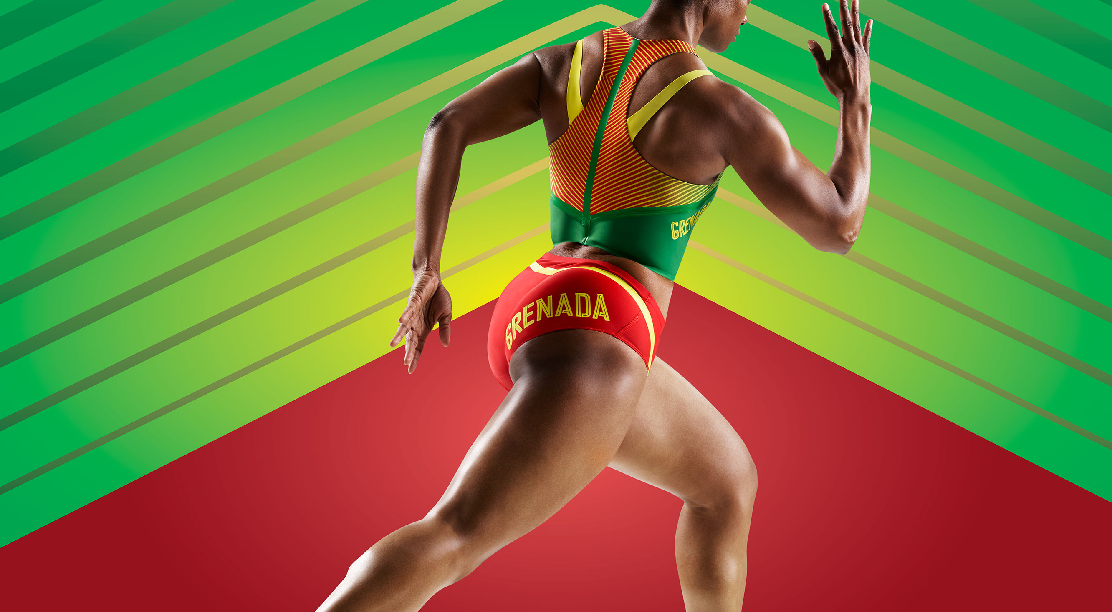
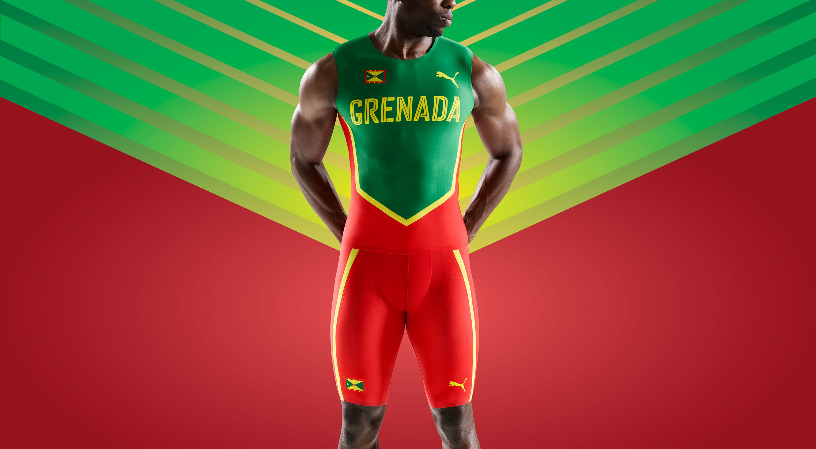

# # #

PUMA
PUMA is one of the world’s leading Sports Brands, designing, developing, selling and marketing footwear, apparel and accessories. For over 65 years, PUMA has established a history of making fast product designs for the fastest athletes on the planet. PUMA offers performance and sport-inspired lifestyle products in categories such as Football, Running and Training, Golf, and Motorsports. It engages in exciting collaborations with renowned design brands to bring innovative and fast designs to the sports world. The PUMA Group owns the brands PUMA, Cobra Golf and Dobotex. The company distributes its products in more than 120 countries, employs more than 11,000 people worldwide, and is headquartered in Herzogenaurach/Germany. For more information, please visit http://www.puma.com

