PUMA PARTNER FEDERATIONS

SWITZERLAND

Switzerland first appeared at the Olympic Games back in the inaugural Games in Athens in 1896. Since then they have sent athletes to every Games except from the 1956 Games in Melbourne. Switzerland have won 185 medals at the Olympic Games, with Gymnastics proving their most successful sport bringing 48 medals, 16 of which were Gold.

Switzerland’s most successful Games based on medals won are:
- Paris 1924: 25 medals won
- London 1948: 20 medals won
- Amsterdam 1928: 15 medals won
- Berlin 1936: 15 medals won
- Helsinki 1952: 14 medals won
Switzerland’s most successful Olympians are:
- Georges Miez: 3 Gold, 2 Silver
- Eugen Mack: 1 Gold, 3 Silver, 2 Bronze
- Michael Reusch: 1 Gold, 2 Silver
- Louis Zutter: 1 Gold, 2 Silver
- Josef Stalder: 1 Gold, 1 Silver, 3 Bronze
- Hermann Hanggi: 1 Gold, 1 Silver, 1 Bronze
- Fabian Cancellara: 1 Gold, 1 Silver
- Hans Eugster: 1 Gold, 1 Bronze
- Emil Grunig: 1 Gold
- Fritz Hagmann: 1 Gold
PUMA and Switzerland Athletics Association have been partners since 2013.

SWITZERLAND OLYMPIC KIT BY PUMA

PUMA is supplying the Swiss Track & Field Team with racing, training and village wear for the Olympic Games.

The Swiss federation kits have got attitude, they’re dark and strong; these kits mean business. The colours are powerful and they represent a proud, traditional nation. The strong red and white combination found in the kit is an unmistakable reference to the bold and minimal coloring in the flag of Switzerland.
The kits are equipped with innovative features such as ACTV taping which provides focused muscle support and energy return, bonded seams for ultimate comfort and are made from lightweight compression fabrics to allow for the ultimate performance. The kits are also reinforced with a 6-way stretch fine gauge warp knit fabric that assures targeted graduated advanced compression while assuring a full range of movement. The kits are designed with one goal in mind; to be forever faster.
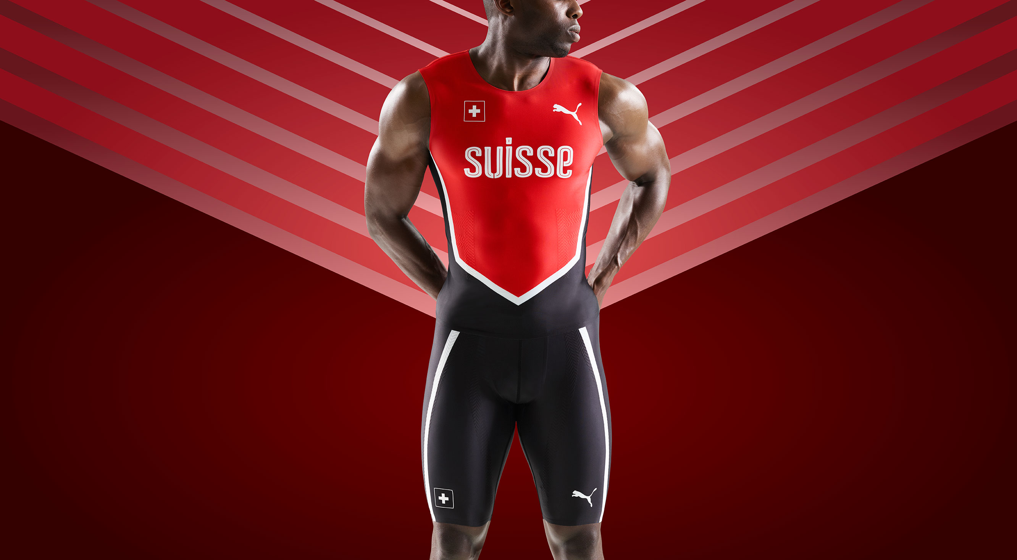
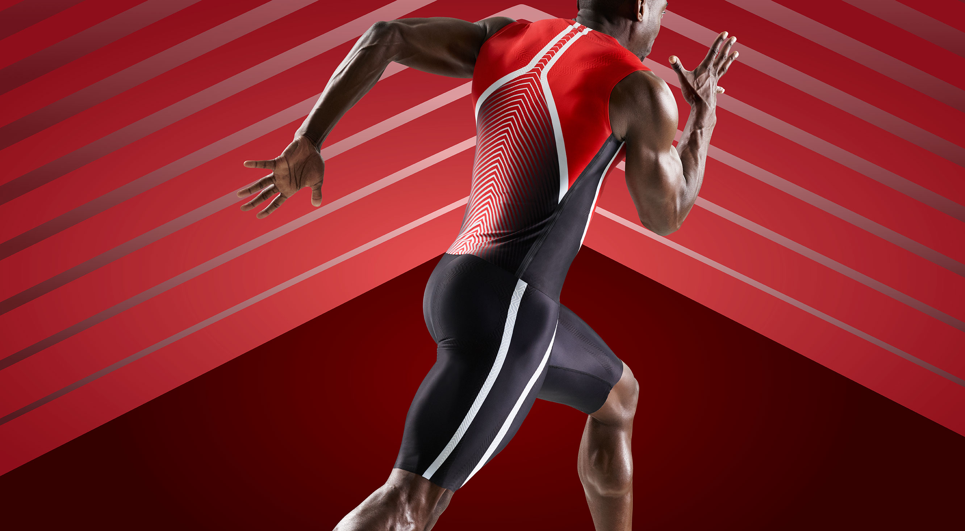
Additional images available here: https://fastcat.puma.com/transfer/2cefd376e9162ad6e16f42d4005b78fa6d2aa84758de016fea3ef6907ae4a227

# # #

PUMA
PUMA is one of the world’s leading Sports Brands, designing, developing, selling and marketing footwear, apparel and accessories. For over 65 years, PUMA has established a history of making fast product designs for the fastest athletes on the planet. PUMA offers performance and sport-inspired lifestyle products in categories such as Football, Running and Training, Golf, and Motorsports. It engages in exciting collaborations with renowned design brands to bring innovative and fast designs to the sports world. The PUMA Group owns the brands PUMA, Cobra Golf and Dobotex. The company distributes its products in more than 120 countries, employs more than 11,000 people worldwide, and is headquartered in Herzogenaurach/Germany. For more information, please visit http://www.puma.com

