PUMA PARTNER FEDERATIONS

BAHAMAS

The Bahamas first appeared at the Olympic Games in 1952 and barring the 1980 Games in Moscow they have sent athletes to every Olympic Games since. Bahamas have claimed 12 medals in total, 10 of these coming in athletics disciplines.

Bahamas’ most successful Games based on medals won are:
- Sydney 2000: 3 medals won
- Beijing 2008: 2 medals won
- Athens 2004: 2 medals won
- London 2012/Atlanta 1996/Barcelona 1992/Tokyo 1964/Melbourne 1956: 1 medal won
Bahamas’ most successful Olympians are:
- Pauline Davis-Thompson: 2 Gold medals, 1 Silver medal
- Tonique Williams-Darling: 1 Gold medal
- Durward Knowles & Cecil Cooke: 1 Gold medal
- Women’s 4x100m relay team 2000 (Savatheda Fynes, Chandra Sturrup, Pauline Davis Thompson, Debbie Ferguson, Eldece Clarke-Lewis): 1 Gold medal
- Men’s 4x400m relay team 2012 (Michael Mathieu, Ramon Miller, Chris Brown, Demetrius Pinder): 1 Gold medal
Bahamas and PUMA have been partners since 2012.

BAHAMAS OLYMPIC KIT BY PUMA

PUMA is supplying the Bahamas Track & Field Team with racing, training, podium, ceremony and village wear for the Olympic Games.

The Bahamas federation kits are designed by PUMA to represent the expressive, colourful and friendly culture of the Island, the light colourways mirror Bahamas’ hospitable and easy-going ethos, but the injection and contrast of the black shades also shows that they’re here, and they mean business. The combination of blue, black and yellow was also chosen as a nod towards the official colours found on the flag of the Bahamas.
The kits are equipped with innovative features such as ACTV taping to which provides focused muscle support and energy return, bonded seams for ultimate comfort and are made from lightweight compression fabrics to allow for the ultimate performance. The kits are also reinforced with a 6-way stretch fine gauge warp knit fabric that assures targeted graduated advanced compression while assuring a full range of movement. The kits are designed with one goal in mind; to be forever faster.
Additional images available here: https://fastcat.puma.com/transfer/83b20503758c9bde278306525d52eed3de9c671ded1336cab97c655cfa904511
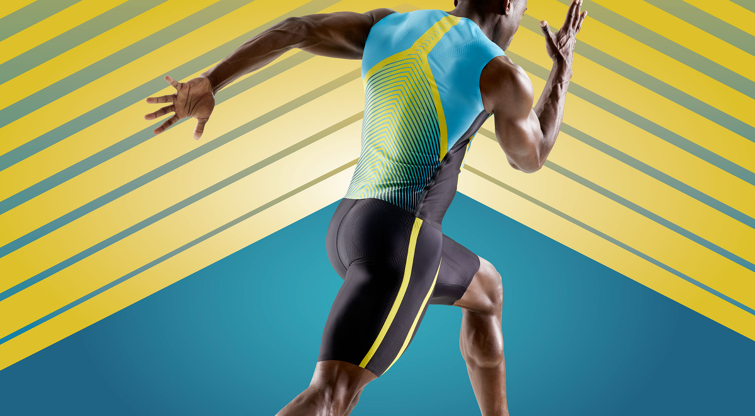
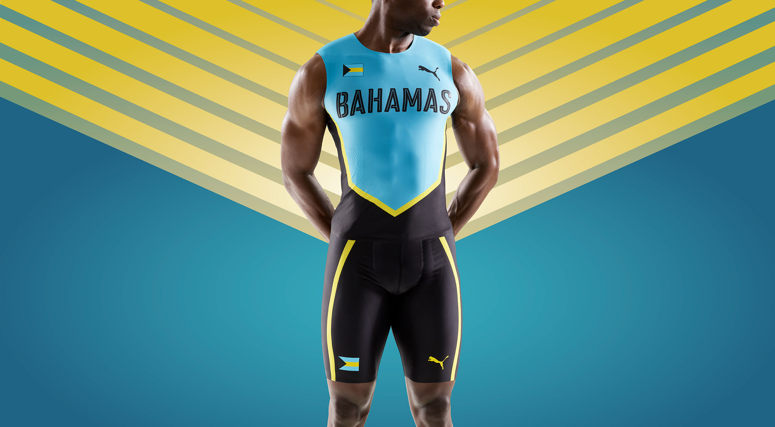

# # #

PUMA
PUMA is one of the world’s leading Sports Brands, designing, developing, selling and marketing footwear, apparel and accessories. For over 65 years, PUMA has established a history of making fast product designs for the fastest athletes on the planet. PUMA offers performance and sport-inspired lifestyle products in categories such as Football, Running and Training, Golf, and Motorsports. It engages in exciting collaborations with renowned design brands to bring innovative and fast designs to the sports world. The PUMA Group owns the brands PUMA, Cobra Golf and Dobotex. The company distributes its products in more than 120 countries, employs more than 11,000 people worldwide, and is headquartered in Herzogenaurach/Germany. For more information, please visit http://www.puma.com

