PUMA PARTNER FEDERATIONS

BARBADOS

Barbados first competed at the Olympic Games in 1968 and apart from the 1980 Games has competed in every Olympics since. Barbados only has one Olympic medal. This medal came at the Sydney Games of 2000 when sprinter Obadele Thompson won a Bronze medal in the men’s 100m.

Barbados and PUMA became partners in 2016.

BARBADOS OLYMPIC KIT BY PUMA

PUMA is supplying the Barbados Track & Field Team with racing, training and podium and village wear for the Olympic Games.

The Barbados federation kits are designed by PUMA to represent the energetic, larger than life athletes that will be representing the island nation in Rio. The bright colours bring to life the fun loving and friendly that typifies the people of Barbados; until they step onto the track, of course. The blue and yellow blend on the Barbados kit also link to the colours on the flag of Barbados.

The kits are equipped with innovative features such as ACTV taping to which provides focused muscle support and energy return, bonded seams for ultimate comfort and are made from lightweight compression fabrics to allow for the ultimate performance. The kits are also reinforced with a 6-way stretch fine gauge warp knit fabric that assures targeted graduated advanced compression while assuring a full range of movement. The kits are designed with one goal in mind; to be forever faster.
Additional images available here: https://fastcat.puma.com/transfer/e0c96d42db7ebc1ae8eb18f93cb20f9ff41310d8e05b9335cfa4cd58ed5e1ef9

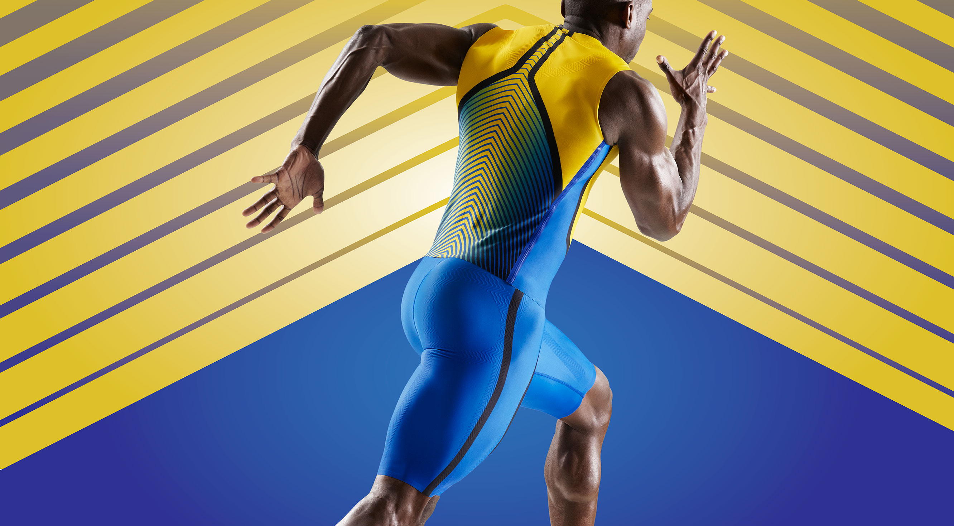

# # #

PUMA
PUMA is one of the world’s leading Sports Brands, designing, developing, selling and marketing footwear, apparel and accessories. For over 65 years, PUMA has established a history of making fast product designs for the fastest athletes on the planet. PUMA offers performance and sport-inspired lifestyle products in categories such as Football, Running and Training, Golf, and Motorsports. It engages in exciting collaborations with renowned design brands to bring innovative and fast designs to the sports world. The PUMA Group owns the brands PUMA, Cobra Golf and Dobotex. The company distributes its products in more than 120 countries, employs more than 11,000 people worldwide, and is headquartered in Herzogenaurach/Germany. For more information, please visit http://www.puma.com

