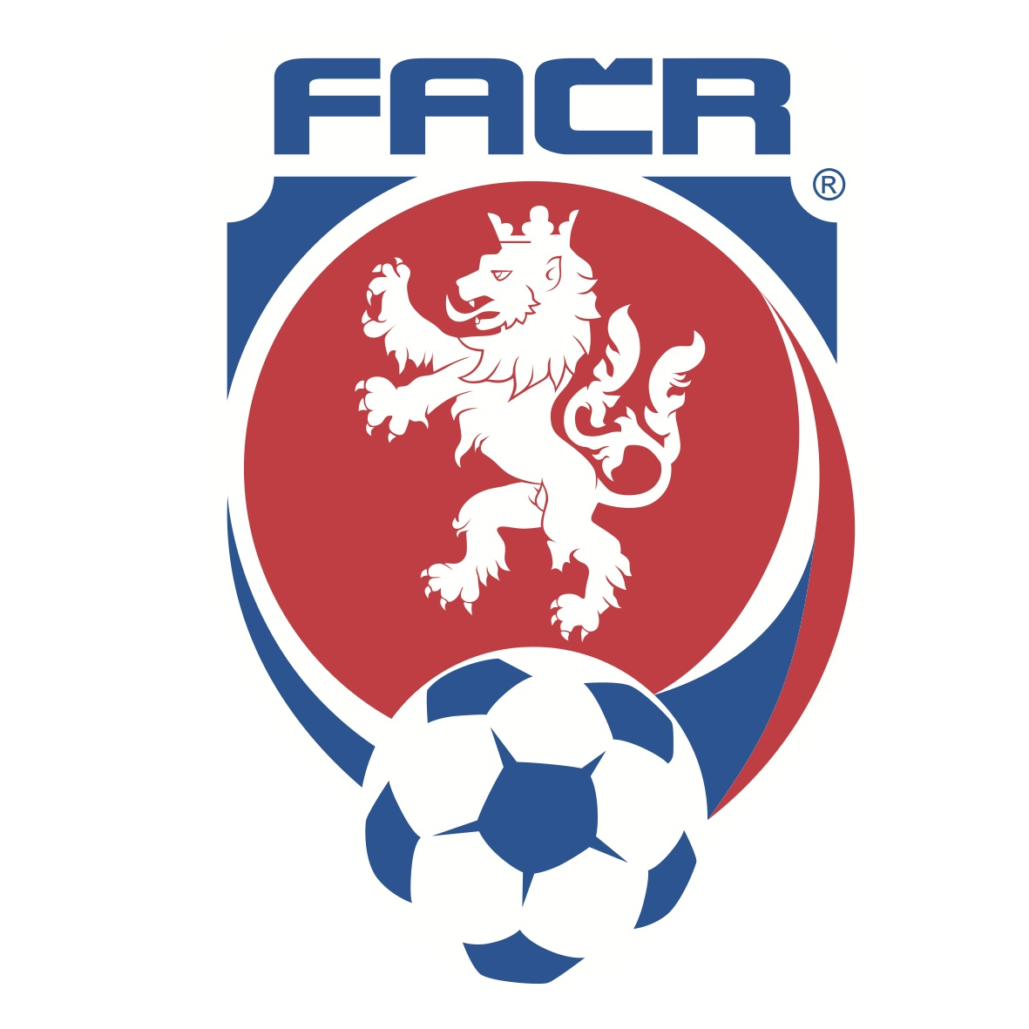

PRESS RELEASE

ALL RED CZECH REPUBLIC HOME KIT LAUNCHED BY PUMA
Dynamic Graphic Design Will be Worn At The Euros Next Year in France

Prague, Czech Republic (9 November 2015) – Global Sports Brand PUMA and the Football Association of the Czech Republic (FACR) today launched a new, all red home kit to be worn at the European Championships 2016TM in France. At a press conference in the newly refurbished PUMA Palladium store in Prague, members of the national team presented the new kit that will be first worn on pitch when Czech Republic play Serbia in an international friendly match on 13 November.

Czech Republic’s new home shirt is inspired by the great Czech national team that reached the final of the ’96 European Championships. Featuring a dynamic graphic on the front, which takes its inspiration from the FACR crest, Form Stripe panels are inserted along the sleeves, whilst the underarm mesh inserts allow for better air circulation to the body. The shirt features a crew neck collar with the collar tape shaped off at the front. The PUMA logo and FACR badge are both located centrally on the chest, with the badge adding the only blue detail to the otherwise full red kit that also includes red shorts and red socks.

The new Czech shirt features PUMA’s new apparel technology ACTV Thermo-R, strategically inserted in both the front and the back of the shirt to help players maintain an optimum body temperature. A unique phase-change material is injected into the shirt’s inner athletic tape, which allows microcapsules to absorb excess heat and release it back to the body when needed. The taping in the shirt provides an extra snug fit, micro-massaging the skin in specific areas to provide a faster, more effective energy supply to the active muscles.

Pavel Kadeřábek of the Czech national team said, “Our new kit looks stunning and the team are looking forward to wearing it in France next summer. We finished top of our group in the qualification, and this is the fifth time in a row that our team qualified for the Euros, so I hope these are good signs for our desire to go far in the tournament. We hope we can make the Czech people proud.”

The new Czech Republic Home Kit is available for purchase in the newly refurbished PUMA Concept Store OC Palladium Prague beginning today, in TOP4FOOTBALL (Ječná 15, Prague), SportFotbal.cz (Voroněžská 28, Prague), Sportisimo and A3Sport and on www.puma.com, www.top4football.cz, www.sportfotball.cz, www.sportisimo.cz, www.a3sport.cz and www.reprefotbal.cz starting tomorrow, 10 November. PUMA today also launched the new home kits for their other partnered European federations Slovakia, Italy, Switzerland and Austria.

Images of the press conference, all the new shirts and further press materials are available to download from PUMA’s media center: news.puma.com

###

International Media Contacts:

PUMA

Tim Stedman, International PR, PUMA
+49 151 1474 3148
tim.stedman@puma.com

FACR

Ondřej Lípa, Director of Communication and IT, FACR
+420 233 029 258
lipa@fotbal.cz

PUMA
PUMA is one of the world’s leading Sports Brands, designing, developing, selling and marketing footwear, apparel and accessories. For over 65 years, PUMA has established a history of making fast product designs for the fastest competitors on the planet. PUMA offers performance and sport-inspired lifestyle products in categories such as Football, Running, Training and Fitness, Golf, and Motorsports. It engages in exciting collaborations with renowned design brands such as Alexander McQueen and Mihara Yasuhiro to bring innovative and fast designs to the sports world. The PUMA Group owns the brands PUMA, Cobra Golf, Dobotex and Brandon. The company distributes its products in more than 120 countries, employs more than 10,000 people worldwide, and is headquartered in Herzogenaurach/Germany. For more information, please visit http://www.puma.com

