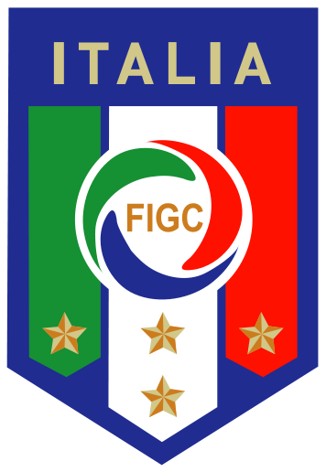
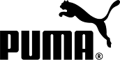

PRESS RELEASE

NEW ITALY HOME KIT INSPIRED BY PASSION, PRIDE & TRADITION
Azzurri Football Icon Launched for the European Championships 2016TM

Florence, Italy (9 November 2015) – PUMA and the Italian Football Federation (FIGC) today presented the new Italy home kit for the European Championships 2016TM at an event in Florence. The blue and white kit is inspired by triumphs of the past, with a design that is befitting of the great history of Italian football along with a homage to Italian sartorial fashion. The new kit will debut on pitch on Friday when ‘Gli Azzurri’ play Belgium in a friendly game.

With the pride, passion and tradition of Italian football as a guiding inspiration, PUMA has designed the new kit with rich attention to detail. The high crew neck collar is a reference to great Azzurri shirts from the past, keeping this design detail alive in the modern day. Thin embossed vertical stripes along the front, sleeves and back draw back to the traditional pinstripe detail of Italian fashion. Additional design elements include form stripe mesh inserts along the shoulders, high sleeve cuffs, golden sleeve piping and the side vent ‘tricolore’ flag detail on the left and right of the hem. The blue home shirt is combined with traditional white shorts and blue socks that also feature subtle golden details.

Italy’s new shirt features PUMA’s new apparel technology ACTV Thermo-R, strategically inserted in both the front and the back of the shirt to help players maintain an optimum body temperature. A unique phase-change material is injected into the shirt’s inner athletic tape which allows microcapsules to absorb excess heat and release it back to the body when needed. The taping in the shirt provides an extra snug fit, micro-massaging the skin in specific areas to provide a faster, more effective energy supply to the active muscles.

PUMA’s Global Creative Director Torsten Hochstetter said, “The Italian shirt for us is an icon. It represents so many things to many people – a symbol of pride, of passion, great history and heritage, tradition and elegance. It also gives me great personal satisfaction having studied design in Florence, to work on such an iconic symbol, and present it in my ‘home away from home’. It is celebrated, along with the national teams who wear it, all over the world and we take great care to create a kit that is worthy of its reputation.”

FIGC Captain Gianluigi Buffon added, “I have known and worked with PUMA for a long time now, more than a decade, and throughout this period the focus and attention they give to the design of the Italian kit is truly impressive. Italian people like to present themselves well, especially in our physical appearance and it is important to us that we have a shirt we believe in. This shirt shows that PUMA understand this, and again they have met our high expectations.”

The new Italy Home Kit is available for purchase on puma.com and at global sports retailers from tomorrow, 10 November. PUMA today also launches the new home kits for their other partnered European federations Austria, Switzerland, Slovakia and Czech Republic.

Images of the press conference, all the new shirts and further press materials are available to download from PUMA’s media center: news.puma.com

###

International Media Contacts:

PUMA

Tim Stedman, International PR, PUMA
+49 151 1474 3148
tim.stedman@puma.com

FIGC

Insert Contacts

PUMA
PUMA is one of the world’s leading Sports Brands, designing, developing, selling and marketing footwear, apparel and accessories. For over 65 years, PUMA has established a history of making fast product designs for the fastest competitors on the planet. PUMA offers performance and sport-inspired lifestyle products in categories such as Football, Running, Training and Fitness, Golf, and Motorsports. It engages in exciting collaborations with renowned design brands such as Alexander McQueen and Mihara Yasuhiro to bring innovative and fast designs to the sports world. The PUMA Group owns the brands PUMA, Cobra Golf, Dobotex and Brandon. The company distributes its products in more than 120 countries, employs more than 10,000 people worldwide, and is headquartered in Herzogenaurach/Germany. For more information, please visit http://www.puma.com

