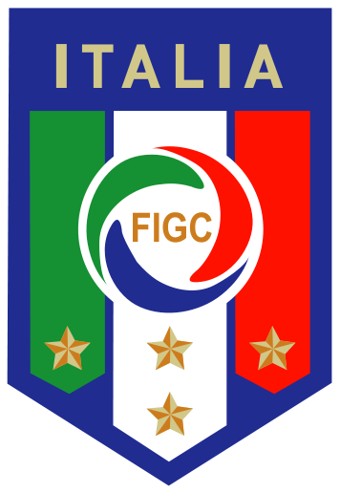

PRESS RELEASE

FIGC & PUMA PRESENT THE NEW ITALY AWAY KIT
Striking Design Inspired By the Tradition, Passion & Pride of the Italian Football Federation

Florence, Italy (2 September 2015) – The Italian Football Association (FIGC) and PUMA today revealed the new away kit for all national men’s, women’s and youth teams. Inspired by the long-standing tradition, the ever-growing passion and the steadfast pride of Italian football, the new kit features many unique design details. Gli Azzurri will wear the new white away shirt for the first time tomorrow at the Euro 2016TM qualifying game tomorrow night when they play Malta in Florence.

The new away shirt features an Italian flag inspired sublimation print stripe that reaches all the way from the collar to the hem, with a 3D framed FIGC badge being bedded into the stripe to complete the look. The tailored blue collar adds a nice contrast to the white base colour of the shirt. Further details include the blue mesh form stripe inserts on the shoulders, and the blue PUMA logo on the chest. The official PUMA font, which is exclusively designed for the FIGC offers a finishing touch to this new shirt.

As with the official FIGC home shirt, the new away shirt features PUMA’s performance enhancing ACTV Thermo-R technology. The ACTV tape is placed in strategic positions on the shirt to fulfil different functions, supporting the body’s physiological performance by cooling it in hot conditions and heating it in cool weather. PUMA’s dryCELL technology further improves the comfort as it wicks moisture away from the skin’s surface to keep the wearer dry.

Torsten Hochstetter, Global Creative Director at PUMA said, “The new Italy away kit was created with a lot of attention to detail. Strong Italian cultural influences inspire the design, there is such richness in the heritage of Italian football and we had a lot to work with. We are proud of the end result and look forward to a big event in France next summer. We wish the Italian team well for the remainder of their qualification.”

Carlo Tavecchio, President of the FIGC commented, “We would like to thank PUMA for the kit that will tomorrow make its debut with our National Team, and then be provided to all our youth, women’s futsal and beach soccer teams. The national team is the sporting symbol of our country's best known and appreciated players that are celebrated across the world, and the flag in the centre of the jersey will be another means to promote the image of Italian football and the Italian system. PUMA remains a partner of great value for the FIGC."

The new Italy away shirt (with and without the ATCV technology) and a new collection of matching fan wear is now available to buy on puma.com/Italy

###

International Media Contacts:

PUMA
Tim Stedman, International PR, PUMA
+49 151 1474 3148
tim.stedman@puma.com

FIGC
Paolo Corbi, Capo Ufficio Stampa FIGC
+39 335 7636050
p.corbi@figc.it

PUMA
PUMA is one of the world’s leading Sports Brands, designing, developing, selling and marketing footwear, apparel and accessories. For over 65 years, PUMA has established a history of making fast product designs for the fastest competitors on the planet. PUMA offers performance and sport-inspired lifestyle products in categories such as Football, Running, Training and Fitness, Golf, and Motorsports. It engages in exciting collaborations with renowned design brands such as Alexander McQueen and Mihara Yasuhiro to bring innovative and fast designs to the sports world. The PUMA Group owns the brands PUMA, Cobra Golf, Dobotex and Brandon. The company distributes its products in more than 120 countries, employs more than 10,000 people worldwide, and is headquartered in Herzogenaurach/Germany. For more information, please visit http://www.puma.com

