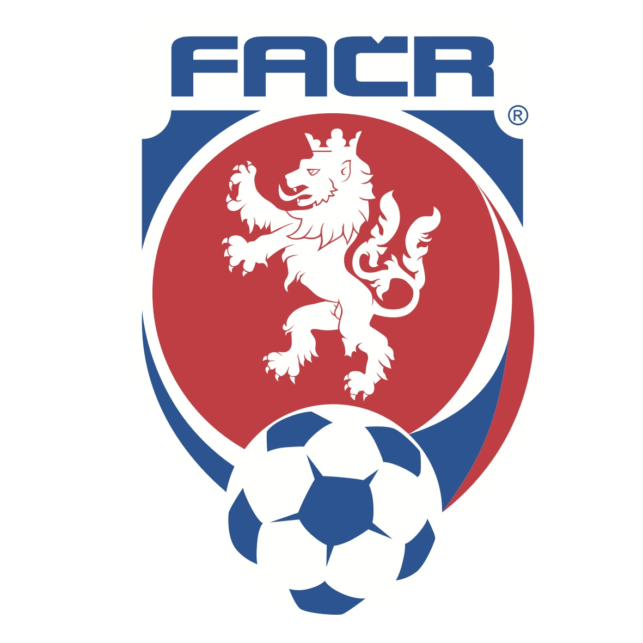

PUMA AND CZECH REPUBLIC FOOTBALL ASSOCIATION ANNOUNCE LONG TERM RENEWAL OF PARTNERSHIP
Revised Agreement is Effective into the Next Decade and now Includes
Beach Football and Futsal

Prague, Czech Republic (September 8, 2014) – PUMA, the Global Sports Brand and the Football Association of the Czech Republic (FACR) are pleased to announce the renewal of their longstanding partnership. PUMA has supported Czech football since 1995, this agreement will see both organisations working together for a further long term.
PUMA will remain a long-term partner of the FACR, supporting Czech football teams in all age and branch categories. The new agreement has also been extended to include beach football and futsal. On the threshold of the EURO 2016 qualifications, this renewal sends a strong and positive message to all football supporters in the Czech Republic.
Christian Voigt, Senior Head of Global Sports Marketing, PUMA International commented, “We are proud to renew our longstanding partnership with the Czech Republic Football Association. Next year, we will celebrate the 20th year of this partnership and we are delighted to be extending it for another long-term period. The FACR was one of PUMA’s first major football sponsorships in our company's modern era, and has played a role in PUMA becoming one of the most innovative and leading football brands. We look forward to building on the success we have enjoyed together for the coming years.”
Miroslav Pelta, Chair of FACR said, “The duration of this extended partnership between PUMA and the Football Association of the Czech Republic is testament to our mutual satisfaction and trust. PUMA has become a sponsor of ours with enhanced representation that now includes soccer futsal and beach football, which we see as an important step in strengthening our cooperation.”
Marek Drvota, General Manager PUMA Eastern Europe added, “The partnership with the Football Association is very important for us on the local level. I’m pleased that we can build on the almost-twenty-year successful partnership. Our company wants to support the Football Association both in successful times and in the times when things don’t go as expected, because this is what sports are about. We are a sport brand that wants to support all the sportsmen in the world. I believe we will manage to be a stable partner for the FACR for years to come.”

###

PUMA Media Contacts:

Gabriela Hrubá

PUMA Czech Republic, s.r.o.

Tel.: 777 009 818

gabriela.hruba@puma.com

FAČR Media Contacts:
Ondřej Lípa

Fotbalová asociace České republiky

Tel.: 603 171 763

lipa@fotbal.cz

PUMA
PUMA is one of the world’s leading Sports Brands, designing, developing, selling and marketing footwear, apparel and accessories. For over 65 years, PUMA has established a history of making fast product designs for the fastest competitors on the planet. PUMA offers performance and sport-inspired lifestyle products in categories such as Football, Running, Training and Fitness, Golf, and Motorsports. It engages in exciting collaborations with renowned design brands such as Alexander McQueen and Mihara Yasuhiro to bring innovative and fast designs to the sports world. The PUMA Group owns the brands PUMA, Cobra Golf, Tretorn, Dobotex and Brandon. The company distributes its products in more than 120 countries, employs more than 10,000 people worldwide, and is headquartered in Herzogenaurach/Germany. For more information, please visit http://www.puma.com

FACR
The Football Association of the Czech Republic (abbreviated as FACR) is a Member Association of FIFA and UEFA and the body which manages football in the country. It is one of the followers of the Czech Union of Football, founded in 1901. It organizes amateur and professional football leagues, SYNOT league and The Czech Post Cup. Its responsibilities include Czech national football team, futsal and beach football. In the association, there are over 3,000 clubs registered and around 300,000 active members. For more information, please visit www.fotbal.cz

