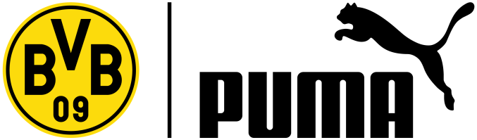

PRESS RELEASE

PUMA UNVEILS NEW BVB HOME SHIRT FOR 2013/14 SEASON
Shirt Design Revealed Through Spectacular Floral Display in Dortmund’s Westfalen Park

Dortmund, Germany (5th July, 2013) – PUMA today introduced the new BVB home shirt for the 2013/14 season at a special event in Dortmund’s Westfalen Park. 80,645 yellow flowers symbolising the average home attendance of BVB were planted, covering a huge area of a thousand square metres in the shape of the new kit, to present the new design to the public in the heart of Dortmund.

The new shirt, which is designed in the classic club colours of yellow and black, features interesting highlights and stylish details, including a subtle plaid print on the front. The collar of the shirt is a mix of a v-neck and classical round shape, which gives the kit a special look. Two black stripes on the sides of the shirt add to this dynamic appearance. Besides the PUMA logo, the shirt features the BVB emblem with two symmetrical stars, which stand for the five Bundesliga championship titles the club has won.

Marco Reus commented on the new shirt, “The design and the comfort of the new shirt absolutely meet my expectations and I especially like the new collar. Black and yellow are the traditional colours of the club and the whole region of Dortmund. I hope with this new shirt we can once again play a successful season.”

For maximum comfort, the new BVB shirt is made of high quality polyester and offers excellent moisture management. The shirt belongs to PUMA’s KING silo and includes the brand’s dryCELL technology which is amongst the highest industry standards in performance apparel.

PUMA today also launched Dortmund’s new away shirt, with a black design and yellow details, which is produced to the same high quality and performance standard as the home shirt. The third shirt is identical to the home goalkeeper shirt and is designed in a white and grey colourway featuring the same design characteristics as the home and away shirts.

The new BVB home, away and goalkeeper shirt as well as the latest merchandise and fanwear collections will be available to buy from Saturday 6th July.

###
International Media Contacts:
Sarah Stade, International PR, PUMA
+49 170 56580234
sarah.stade@puma.com

PUMA
PUMA is one of the world’s leading Sportlifestyle companies that designs and develops footwear, apparel and accessories. It is committed to working in ways that contribute to the world by supporting Creativity, SAFE Sustainability and Peace, and by staying true to the principles of being Fair, Honest, Positive and Creative in decisions made and actions taken. PUMA starts in Sport and ends in Fashion. Its Sport Performance and Lifestyle labels include categories such as Football, Running, Motorsports, Golf and Sailing. Sport Fashion features collaborations with renowned designer labels such as Alexander McQueen and Mihara Yasuhiro. The PUMA Group owns the brands PUMA, Cobra Golf and Tretorn. The company, which was founded in 1948, distributes its products in more than 120 countries, employs about 11,000 people worldwide and has headquarters in Herzogenaurach/Germany, Boston, London and Hong Kong. For more information, please visit http://www.puma.com

