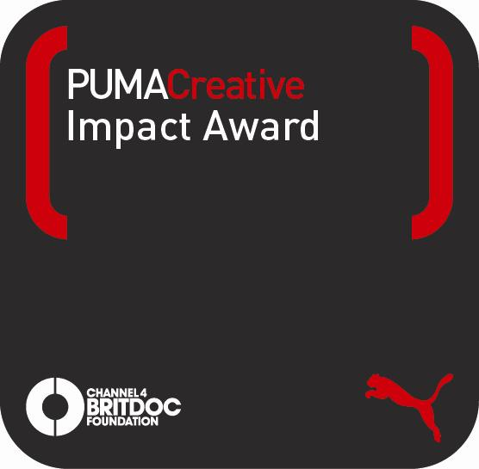

The PUMA.Creative Impact Award, in Partnership with Channel 4 BRITDOC Foundation, to Honour Documentary Film with Most Significant Social or Environmental Impact

The PUMA.Creative Impact Award, through a collaboration with PUMA.Creative and Channel 4 BRITDOC Foundation, was developed to provide industry recognition to documentary filmmakers who address social or environmental issues in their work. The annual PUMA.Creative Impact Award, the first of its kind, will honour the documentary film that has generated the most outstanding and significant impact around the world since release. With an impressive cast of judges reviewing submissions, the winning documentary will be announced at the PUMA.Creative and Channel 4 BRITDOC Foundation Gala in London, England on October 11, 2011. Fifty thousand Euros will be awarded to the creative minds behind the selected film and will be divided between the filmmaking and outreach teams.

The five 2011 PUMA.Creative Impact Award finalists have been announced, and are as follow:

The Age of Stupid
Director: Franny Armstrong
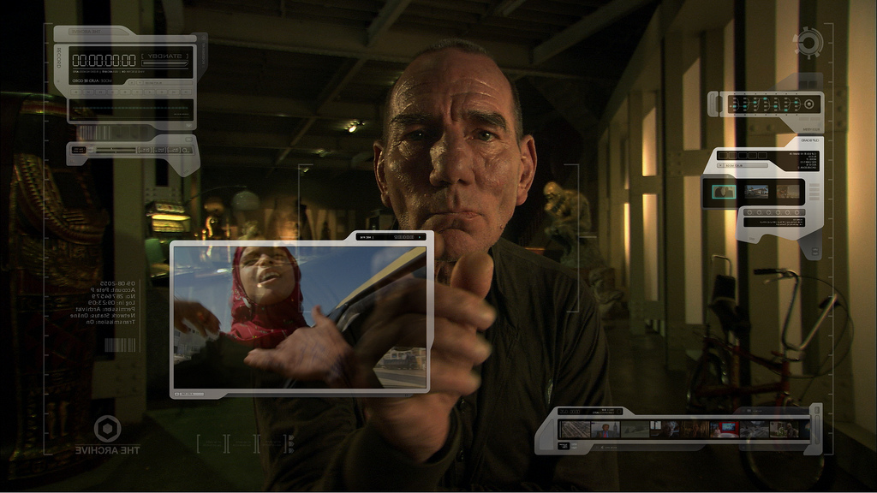Producer: Lizzie Gillett

“The Age of Stupid” stars Oscar-nominated Pete Postlethwaite as a man living alone in the devastated world of 2055, watching “archive” footage of our time now and asking… Why didn’t we stop climate change when we had the chance?

Impact Highlights:

- Launched the 10:10 Global campaign in 46 countries, with over 100,000 individuals signing up alongside corporations and government departments, pledging to cut 10% of emissions
- Launched the “Global Day of Doing” (10:10:10) coordinating over 7,000 local carbon cutting events in 188 countries
- Raised almost £1m to sustain the 10:10 campaign

Burma VJ
Director: Anders Østergaard
Producer: Lise Lense-Møller

Armed with small handycams, undercover video journalists in Burma keep up the flow of news from their closed country despite risking torture and life in jail. Their material is smuggled out of Burma and broadcast back via satellite.

Impact Highlights:

- With an estimated 30 million viewers, Burma VJ put the issue of Burma firmly on the international agenda
- The ensuing political pressure helped bring about the release of Aung San Suu Kyi
- Inspired a new generation of VJs and independent journalists within Burma

The End of the Line
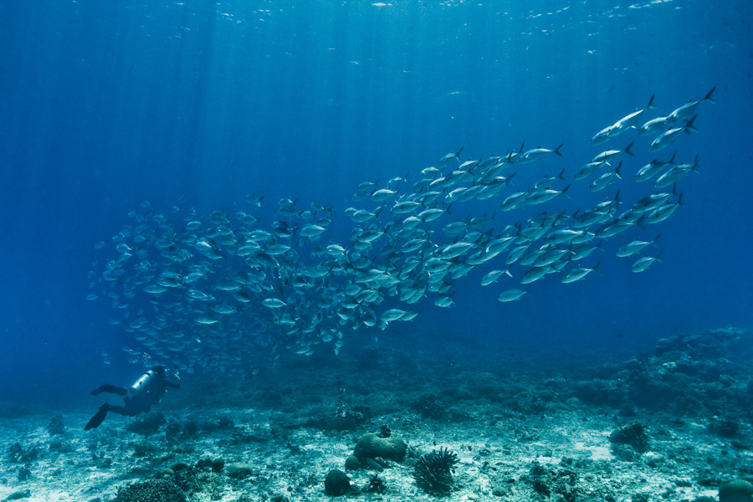Director: Rupert Murray
Producers: Claire Lewis & George Duffield

“The End of the Line,” is the world’s first major feature documentary about the devastating impact that overfishing has had – and is having – on our oceans. The film provides a dramatic expose of those in power who are taking advantage of the seas with catastrophic consequences on the world’s fish supply.

Impact Highlights:

- Raised £6m to launch the Blue Marine Foundation, dedicated to creating a global network of marine reserves
- Had significant impact on supermarket and consumer brands – from sandwich chain Pret A Manger to cat food brands Sheba and Whiskas all moving to use sustainably-sourced fish
- Used as a strategic lobbying tool in both the UK and European parliaments to engage politicians in the issue of over-fishing

The Reckoning: The Battle for the International Criminal Court
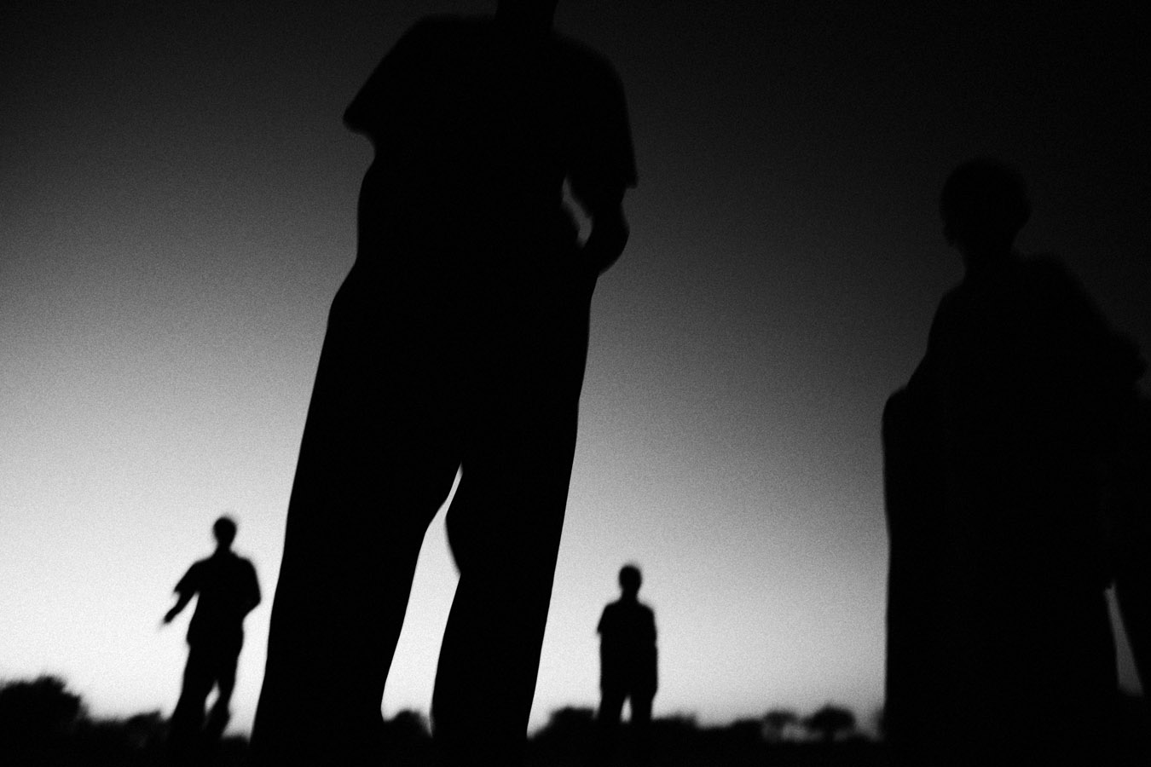Director: Pamela Yates
Producer: Paco de Onís

A David and Goliath battle of titanic proportions unfolds as International Criminal Court Prosecutor Luis Moreno Ocampo faces down warlords, genocidal dictators, and world superpowers in his struggle to tame the Wild West of global conflict zones and bring perpetrators of crimes against humanity to justice.

Impact Highlights:

- The film team distributed, free of charge, screening kits to over 600 NGOs from 78 countries, to raise awareness of the International Criminal Court
- Used extensively in education programmes including a 2-week ‘Teach the Reckoning’ workshop bringing together 700 educators from 70 countries representing a network of over 25,000 high school teachers
- Used widely in Africa; it supported critical debate within the Kenyan judiciary and triggered an investigation into post-election violence

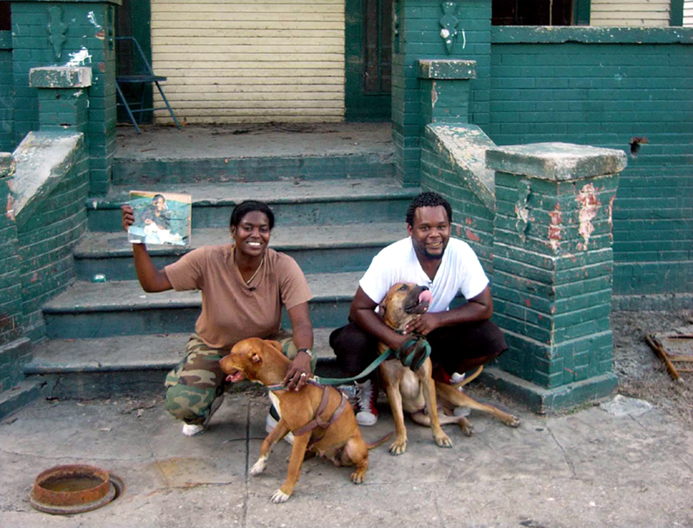Trouble the Water
Director-Producers: Tia Lessin & Carl Deal

An aspiring rap artist, trapped in New Orleans by deadly floodwaters, survives the disaster and seizes a chance for a new beginning. Celebrating community resilience in the face of massive government failures, “Trouble the Water” raises searing questions about race and class in America.

Impact Highlights:

- Repeatedly used in strategic political campaigning; from raising a 20,000-strong letter campaign to the speaker of the House of Representatives, to strategic screenings at the national Democratic and Republican conventions
- Triggered a major lobbying effort by 400 campaigners, including hurricane-survivors and supporters from across the country who travelled to Washington DC for training, advocacy and action.
- Launched a “Share Your Story” campaign to gather hundreds of testimonies from constituents that were used to lobby policy leaders.

