FOR IMMEDIATE RELEASE

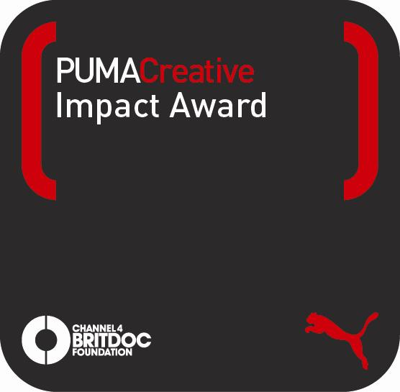

Finalists for 2011 PUMA.Creative Impact Award announced at Durban International Film Festival

Durban, South Africa, July 25, 2011 –Today PUMA.Creative and Channel 4 BRITDOC Foundation announced the five finalists for the first annual PUMA.Creative Impact Award. This €50,000 award will honour and support the documentary film that has made the most significant impact on society. The top films cover topics ranging from environmental issues to social justice and global conflict, and all five documentaries have enlightened and inspired individuals about global concerns.

The final five films will be judged by an elite jury later in the year that includes: Her Majesty Queen Noor of Jordan, Morgan Spurlock (Academy Award-nominated Director of “Super Size Me”), Orlando Bagwell (Director of the JustFilms initiative at the Ford Foundation), and Emmanuel Jal (musician and activist).

Morgan Spurlock said of the PUMA.Creative Impact Award, “Finally an award that acknowledges the unique role that documentary plays in society.”

The finalists for 2011 are:

- The Age of Stupid (2009), directed by Franny Armstrong and produced by Lizzie Gillett
This film, set in 2055, looks back on the damage caused by years of climate destruction.

- Burma VJ (2008), directed by Anders Østergaard and produced by
Lise Lense-Møller
An undercover camera in Burma helps shed light on the country’s happenings in this film.

- The End of The Line (2009), directed by Rupert Murray and produced by
Claire Lewis and George Duffield
The film focuses on the devastating impact of overfishing in the world’s oceans.

- The Reckoning: The Battle for the International Criminal Court (2009),
directed by Pamela Yates and produced by Paco de Onís
The struggle between the International Criminal Court and world superpowers is highlighted in this film.

- Trouble The Water (2008), directed and produced by Tia Lessin & Carl Deal
In the film, an aspiring rap artist survives natural disaster and seizes the chance for a new beginning.

“Film is a unique and compelling medium for exploring who we are; a tool for reflection as well as a catalyst for shifting perceptions and even affecting social change,” said Mark Coetzee, Program Director PUMAVision and Chief Curator, PUMA.Creative, speaking from the Durban International Film Festival. “The award is the highlight of our documentary film platform with Channel 4 BRITDOC Foundation, and a strategic part of PUMAVision, our contribution to creating a better world for generations to come.”

The winning film will be announced at the PUMA.Creative and Channel 4 BRITDOC Foundation Gala in London on October 11, 2011. Fifty-thousand Euros will be awarded to the creative minds behind the winning entry to acknowledge the film’s makers and to help further the campaign and impact of the film.

“The five documentaries – all critically acclaimed works of independent filmmaking – reflect some of the most urgent issues of our times, and all have been used strategically by the filmmakers to create change on a corporate, a political and a social level,” said Beadie Finzi, Founding Director of the Channel 4 BRITDOC Foundation. “Reading the applications and understanding both the breadth and the depth of impact that each of these finalists has had was inspiring, to say the least.”

More than 70 submissions were assessed by the Channel 4 BRITDOC Foundation and an independent Peer Review Committee made up of documentary and social change experts. Each film was judged by the impact of the film on the community, how it created increased awareness of an issue, or caused changes in attitudes and behaviour. The Peer Review Committee also considered the impact of the film on policy makers in government as well as business leaders around the world. For consideration all films must be: feature length (75 minutes or more), screened previously at a film festival or on television, released on or after November 1, 2007, and proven to have evidence of social impact. Through the process, which takes into consideration factors such as resources and budget, five films are shortlisted for the PUMA.Creative Impact Award.

The PUMA.Creative Impact Award is one of six awards and programmes made possible through a partnership between PUMA.Creative and Channel 4 BRITDOC Foundation. At the Durban International Film Festival, the PUMA.Creative Catalyst Programme will also launch with a five day workshop for filmmakers who do not have access to the mainstream circuit, helping to turn their ideas into reality. In addition, several PUMA.Creative Catalyst Awards and PUMA.Creative Mobility Awards will be given to support filmmakers at the festival.

For more information about the PUMA.Creative Impact Award, please visit: www.britdoc.org/impactaward.
###

EDITOR NOTES:

Judges
Finalists were selected by the Channel 4 BRITDOC Foundation following consultation with an independent Peer Review Committee led by: Isabel Arrate at the Jan Vrijman Fund, Pat Aufderheide and Angelica Das at the Center for Social Media at American University, Diana Barrett at the Fledgling Fund, Carol Cone of Edelman, Heidi Gronauer at EsoDoc, Karolina Lidin at Nordic Film Fund, Isabelle Schwarz and Shreela Gosh at European Cultural Foundation, and Sally-Ann Wilson at the Commonwealth Broadcasting Association.

Additional press materials and images will be available at: http://puma.digitalnewsagency.com

Media Contacts
Edelman PR: Jonathan Halliwell, jonathan.halliwell@edelman.com + 44 203 047 2043
Channel 4 BRITDOC Foundation: Elise McCave, elise@britdoc.org + 44 207 534 9621

PUMAVision: Danielle Marcus, danielle.marcus@puma.com + 1 978 394 9400

Channel 4 BRITDOC Foundation
The Channel 4 BRITDOC Foundation is a not-for-profit title sponsored by Channel 4 Television and supported by a number of Foundations both in the UK and the USA. Since 2005, our mission has been to build a creatively ambitious and diverse future for documentary. We do this by creating brilliant films and engaging new partners to ensure that those films have lasting global impact.

The Channel 4 BRITDOC Foundation has in its first 6 years, co-funded and produced over sixty documentaries—films that have won audience awards at Sundance, SXSW, Berlin, Tribeca, and Edinburgh Film Festivals. Titles include: Hell And Back Again, Afghan Star, The End of The Line, We Are Together, Dragonslayer and The Yes Men Fix The World. The resulting films have been shown around the world on C4, Arte, and HBO and released by EMI, Dogwoof and Warners in cinemas and on DVD. In addition to our UK Production Fund, The Foundation recently announced a major new partnership with PUMA.Creative which includes numerous International Development awards open to filmmakers all over the world, and the PUMA.Creative Impact Award—an annual prize honouring the documentary film which has created the most significant impact. For more information please visit www.britdoc.org.

PUMAVision
At PUMA, we believe that our position as the creative leader in Sportlifestyle gives us the opportunity and the responsibility to contribute to a better world for the generations to come. A better world in our vision—PUMAVision—would be safer, more peaceful, and more creative than the world we know today. The 4Keys is the tool we have developed to help us stay true to PUMAVision, and we use it by constantly asking ourselves if we are being Fair, Honest, Positive, and Creative in everything we do.

We believe that by staying true to our 4Keys, inspiring the passion and talent of our people, working in sustainable, innovative ways, and doing our best to be Fair, Honest, Positive, and Creative, we will keep on making the products our customers love, and at the same time bring that vision of a better world a little closer every day. PUMAVision looks ahead to a world that is safer, more peaceful and more creative for the generations to come. Through the programs of PUMA.Safe (focusing on environmental and social issues), PUMA.Peace (supporting global peace) and PUMA.Creative (supporting artists and creative organizations), we are providing real and practical expressions of this vision. For more information, please visit http://vision.puma.com

