

FOR IMMEDIATE RELEASE Contacts:
Cristina Maggetti Please insert your local contact here. PUMA International PR Manager
+49 9132 81 2966
maria-cristina.maggetti@puma.com

PUMA® Launches Next Generation of v-Konstrukt Football Gear

Herzogenaurach, Germany, January 12, 2009 -- PUMA® is proud to announce the launch of the third generation of its statement performance concept for Football with the debut of the v-Konstrukt III. First introduced in 2006, the v-Konstrukt has been redesigned with the latest available technologies which make this product range one of the most advanced on the market. The v-Konstrukt technologies combine the best protective features with lightweight materials to improve performance, making the v-Konstrukt the perfect game-day and training solution for footballers of all skill levels.

Prominent international football players including Gianluigi Buffon and Nemanja Vidic have already endorsed the latest v-Konstrukt; now the products are available to mainstream consumers.

v-Konstrukt III

The highlight of the collection is the v-Konstrukt III, which embodies the perfect combination of comfort and aggressive protection with a fresh new design. This comfortable, yet advanced football boot is the perfect choice for any powerful player. The v-Konstrukt technology makes this football boot safe for playing on firm natural surfaces. The boots’ safety features revolve around the Ball Impact Guard, which creates a visually striking element on the shoe whilst providing optimum protection to the foot without jeopardizing touch of the ball. Premium full-grain leather and the PUMA AptoLast generate a unique glove like fit, which increases the comfort of the footballer’s foot. The combination of the finger shaped external heel counter and the new dual density EVA creates a snug protective fit around the heel, protecting players from unwanted injuries, whilst the DuoCELL unit provides optimal cushioning when running. PUMA’s v-Konstrukt III is also available in the SG version that features metal conical studs, suitable for playing on soft natural surfaces.

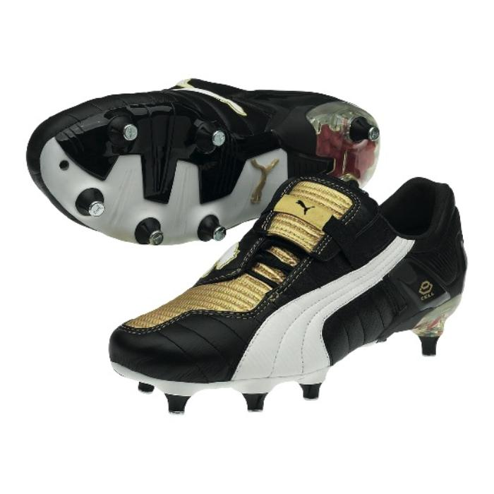
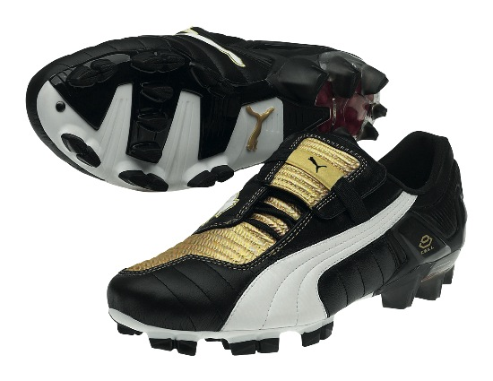

PUMA v-Konstrukt III/Page 2

v-Konstrukt III GCi FG Women’s
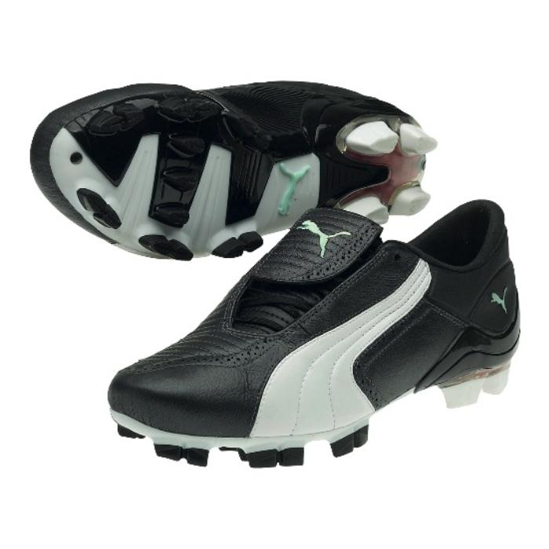
The line also includes a women’s boot. PUMA’s v-Konstrukt III Wn´s is the perfect combination of comfort and aggressive protection for the fast-paced women’s game. The premium full- grain leather and the specifically developed women’s last generate a unique glove-like fit. The scientifically proven stud positioning provides excellent grip whilst the DuoCELL heel unit provides optimal cushioning when running on the firm surfaces.

v-Konstrukt Glove

Known to many as Gianluigi Buffon’s glove, the v- Konstrukt is the top-level competition glove on the market. The lightweight, flexible PUMA FINGER PROTECTION system protects the fingers from hyperextension by locking at 180°, while the revolutionary, patented thumb spine protects the thumb through its full range of movement. In order to allow goalkeepers to customize the glove with the protection level they need, all spines can be removed.
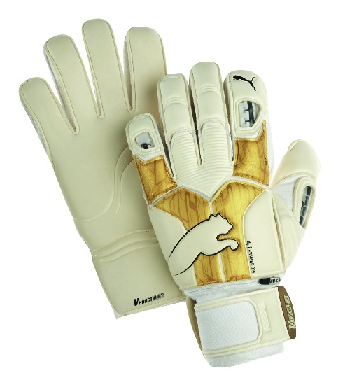

The TWIN WRAP THUMB and CONTROL WRAP TECHNOLOGY maximize the latex-to-ball contact areas without uncomfortable seams and the ANATOMICALLY SPREAD tooling follows the hand's natural shape and contours for total comfort. The 4mm Ultimate Latex provide unrivalled grip in all conditions. Moreover, the glove also extends onto the wrist to provide more latex-to-ball contact when gathering the ball into the chest. The latex wrist strap with rubber tab enables quick, easy and secure adjustments.

To round out the complete football line, the v-Konstrukt III also includes a shinguard and a new v-Konstrukt ball.

v-Konstrukt Shinguard
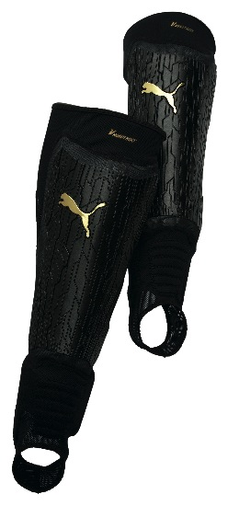
Tasked with creating a shinguard that is rigid and still comfortable enough on the field, the v-Konstrukt tech design team was put to the test. The result is a shinguard that fits like a second skin. The nine direct-injection shell components form an outer shield to protect the player from opponent’s studs and other outer forces, whilst retaining the flexibility to follow the contours of the leg. The lightweight Brock foam layer absorbs the impact of each tackle, and its unique composition enables air and sweat to pass through easily. Further, the body of the shinguard is constructed from a lightweight mesh that provides compression and support. A low-profile integrated ankle and forefoot protection ensures total freedom of movement. The combination of these technical features makes the v-Konstrukt shinguard the perfect on-field protection.

– more –

PUMA v-Konstrukt III/Page 3
v-Konstrukt Ball

PUMA’s v-Konstrukt Ball is a high-performance match ball specially developed for artificial turf and hard natural surfaces. Closed-cell microcellular panel cushioning adds to the ball's playability and also provides protection to the PU surface, reducing wear and prolonging the life of the ball. The hand-stitched construction delivers a professional performance, while the six-wing latex bladder ensures an explosive reaction off the foot. All 32 panels of the ball have the same surface area for optimal roundness.

PUMA’s v-Kat apparel collection is the perfect accompaniment to the v-Konstrukt series and has also been redesigned for 2009. v-kat offers versatile training apparel ideal for all types of weather conditions.

v-Kat LS Protection Tee

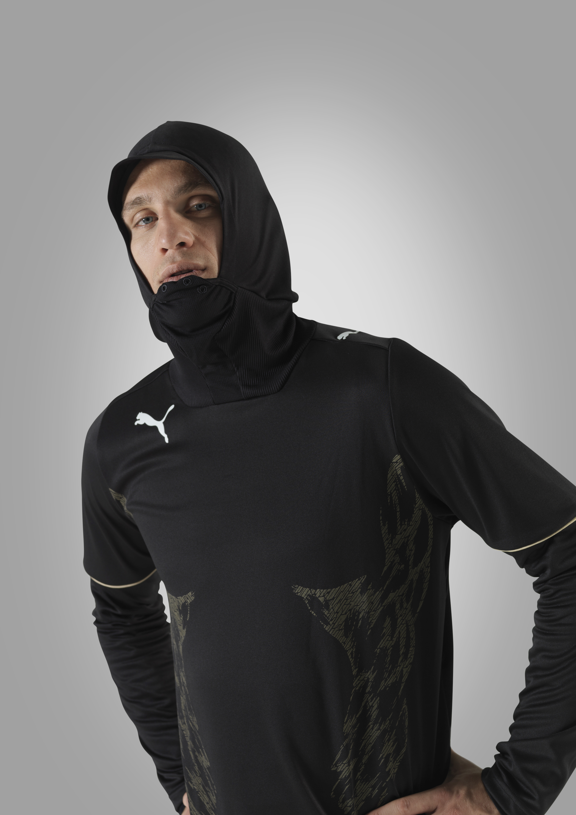
Training has no regard for weather, and the v-Kat Long Sleeve Protection Tee now makes it even easier to train even in the harshest outdoor conditions. Puma’s v-Kat LS Protection Tee protects the face from external forces with its integrated mouth and nose protection layer. The contrasting print on the chest adds definition and helps create an imposing silhouette.

v-Kat Performance Tee
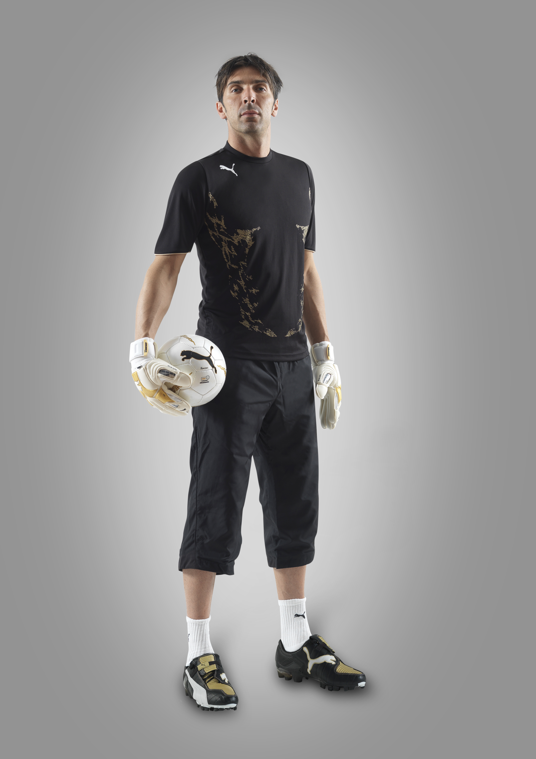
A statement performance training piece, PUMA’s v-Kat Performance Tee exaggerates body shape through its graphic prints and cutlines. Strategically-placed and partly-bonded mesh inserts on the back provide ventilation, which helps regulate body temperature and may help enhance a player’s stamina during hard training sessions.

v-Kat 5/8 Pants

Like the entire v-Konstrukt III statement line, the v-Kat 5/8 Woven Pants are made from extremely lightweight and highly-functional fabric. Freedom of movement is enhanced through the ergonomic cutlines, which also improve the pants’ fit, comfort and durability.

– more –

PUMA v-Konstrukt III/Page 4

PUMA’s new international v-Konstrukt III performance Football collection is now available in-store. For store locations and more information, please visit www.puma.com

###

PUMA is one of the world’s leading sportlifestyle companies that designs and develops footwear, apparel and accessories. It is committed to working in ways that contribute to the world by supporting Peace, Creativity, and SAFE Sustainability, and by staying true to the values of being Fair, Honest, Positive and Creative in decisions made and actions taken. PUMA starts in Sport and ends in Fashion. Its Sport Performance and Lifestyle labels include categories such as Football, Running, Motorsports, Golf and Sailing. The Black label features collaborations with renowned designers such as Alexander McQueen, Yasuhiro Mihara and Sergio Rossi. The PUMA Group owns the brands PUMA, Tretorn and Hussein Chalayan. The company, which was founded in 1948, distributes its products in more than 120 countries, employs more than 9,000 people worldwide and has headquarters in Herzogenaurach/Germany, Boston, London and Hong Kong. For more information, please visit www.puma.com

