

FOR IMMEDIATE RELEASE Contacts:
Cristina Maggetti Please insert your local contact here. PUMA International PR Manager
+49 9132 81 2966
maria-cristina.maggetti@puma.com

PUMA® Launches Evolution of v-Konstrukt Statement Concept

Herzogenaurach, Germany, January 8, 2009 -- PUMA® is proud to announce the launch of the third generation of its statement performance concept with the introduction of the v-Konstrukt III. The latest generation of the v-Konstrukt lives up to its expectations of being one of the most advanced football gears available. First introduced in 2006, the v-Konstrukt has been continuously redesigned with the latest available technologies, in order to make this product the best of its kind. The v-Konstrukt technologies have been improved to combine the best protective features with lightweight materials that improve performance, making the v-Konstrukt the perfect game-day and training solution for anyone practicing football.
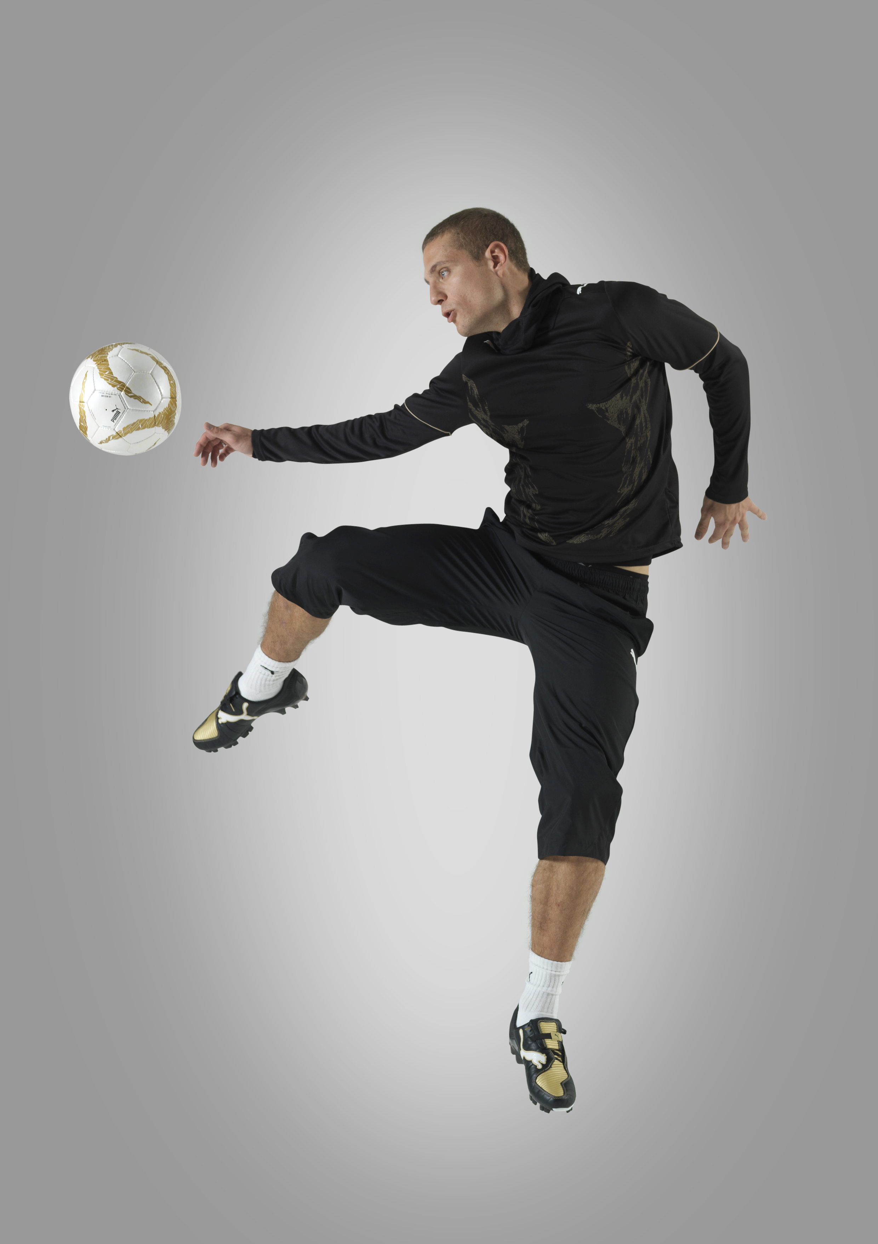
The most prominent international football players have already endorsed the latest v-Konstrukt, which has also been made available to the larger audience starting January 2009. Soon everybody will be able to wear the shoes with which Gianluigi Buffon, or Nemanja Vidic will be playing for the rest of this football season.

The v-Konstrukt III boot is a lightweight performance proposition, which sees a dynamic approach to the product’s benefits by further fine-tuning and improving its protective features. In addition, the newly-designed lightweight performance apparel line employs highly breathable fabrics, advanced ventilation and moisture-management technology, as well as aerodynamic form and body-tuning to make the v-Konstrukt apparel line a perfect combination for the performance boots.

v-Konstrukt III GCi FG
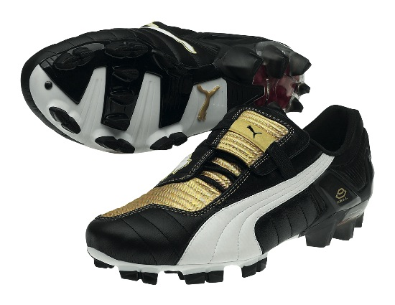
The highlight of the collection is the v-Konstrukt III, which embodies the perfect combination of comfort and aggressive protection with a fresh new design. This comfortable, yet advanced football boot is the perfect choice for any powerful player. The v-Konstrukt technology makes this football boot safe for playing on firm natural surfaces.

The boots safety features revolve around the Ball Impact Guard, which creates a visually striking element on the shoe whilst providing optimum protection to the foot without jeopardizing touch of the ball. The premium full grain leather and the PUMA AptoLast generate a unique glove like fit, which increases the comfort of the footballer’s foot. The combination of the finger shaped external heel counter and the new dual
density EVA creates a snug protective fit around the heel, protecting players from unwanted injuries, whilst the DuoCELL unit provides optimal cushioning when running.

- more -
PUMA v-Konstrukt III/Page 2
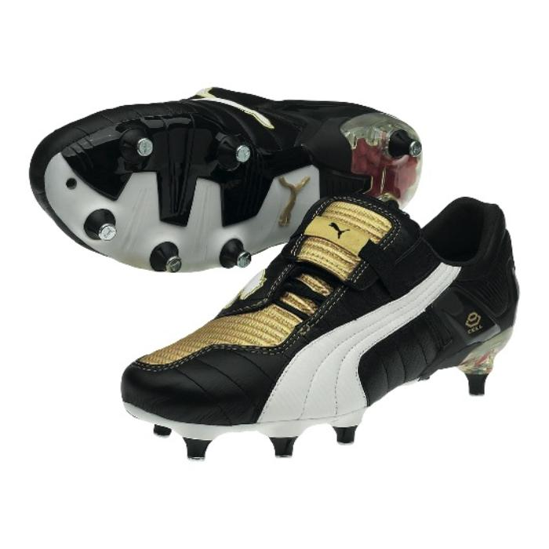
v-Konstrukt III GCi SG
The v-Konstrukt III Soft Ground provides an alternative to the v-Konstrukt III GCi FG. The metal tipped conical studs, suitable for soft natural surfaces, make this product a necessity in certain playing or training conditions.
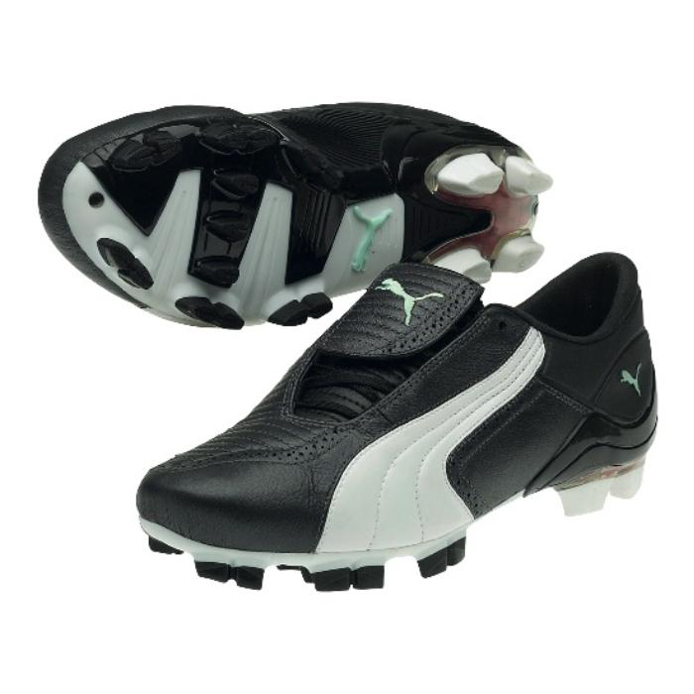
v-Konstrukt III GCi FG Women’s
The line also includes a female version of the female football boot. The v-Konstrukt III Wn´s is the perfect combination of comfort and aggressive protection for the fast paced women’s game. The premium full grain leather and the specifically developed women’s last generate a unique glove like fit tailored to the female specific needs. The scientifically proven stud positioning provides excellent grip whilst the DuoCELL heel unit provides optimal cushioning when running on the firm surfaces.

v-Konstrukt Glove
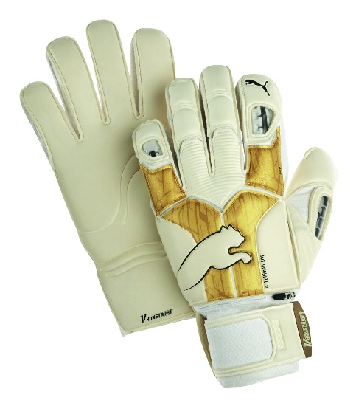
For goalkeepers, the line includes a v-Konstrukt glove that is inspired from the same technological advances as the boots, making this glove a top level competition glove. The lightweight, flexible PUMA FINGER PROTECTION system protects the fingers from hyperextension by locking at 180°, while the revolutionary, patented thumb spine protects the thumb through its full range of movement. In order to allow goalkeepers to customize the glove with the protection level they need, all spines can be removed.

The TWIN WRAP THUMB and CONTROL WRAP TECHNOLOGY maximize the latex-to-ball contact areas without uncomfortable seams and the ANATOMICALLY SPREAD tooling follows the hand's natural shape and contours for total comfort.
The 4mm Ultimate Latex provide unrivalled grip in all conditions. Moreover, the glove also extends onto the wrist to provide more latex-to-ball contact when gathering the ball into the chest. The latex wrist strap with rubber tab enables quick, easy and secure adjustments.

In order to offer a complete football line, the v-Konstrukt III also includes a shinguard and a new v-Konstrukt ball.

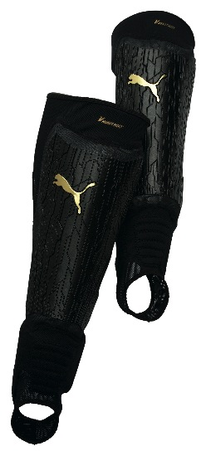
v-Konstrukt Shinguard
Wanting to create a shinguard that is rigid and still comfortable enough on the field, the v-Konstrukt technologies were put to a challenge. The result was a shinguard that fits like a second skin. The nine direct-injection shell components form an outer shield to protect the player from opponent’s studs and other outer forces, whilst retaining the flexibility to follow the contours of the leg. The lightweight Brock foam layer absorbs the impact of each tackle and its unique composition enables air and sweat to pass through easily. The body of the shinguard is constructed from a lightweight mesh that provides compression and support. The low-profile integrated ankle and forefoot protection allows total freedom of movement. The combination of all these technical features makes the v-Konstrukt shinguard the perfect on-field protection, when called upon, but nevertheless practical.

– more –
PUMA v-Konstrukt III/Page 3
v-Konstrukt Ball
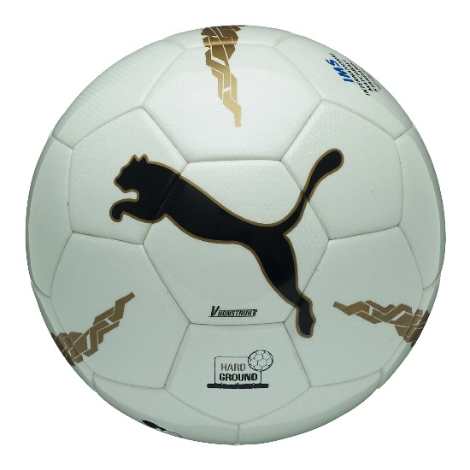
The line is complete with the v-Konstrukt Ball, a high performance match ball specially developed for artificial turf and hard natural surfaces. Closed-cell microcellular panel cushioning add to the ball's playability and also provide protection to the PU surface, reducing wear and prolonging the life of the ball. The hand stitched construction delivers a professional performance and the six wing latex bladder ensures an explosive reaction off the foot. All 32 panels of the ball have the same surface area for optimal roundness.

In order to provide a complete line, the v-Kat apparel collection has also been redesign to suit the v-Konstrukt line, offering the perfect training apparel, regardless of weather conditions.

v-Kat LS Protection Tee
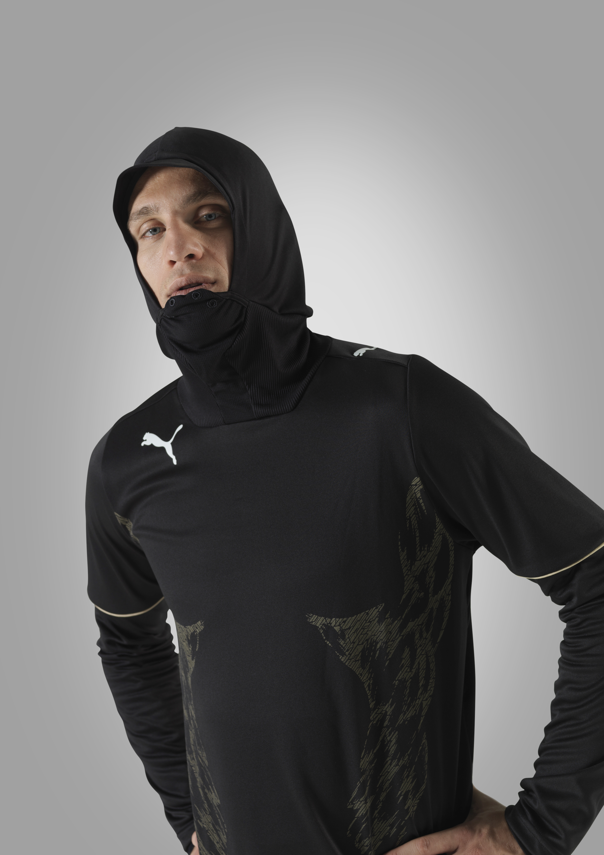
Training has no regard for weather, and the v-Kat Long Sleeve Protection Tee now makes it even easier to train even in harsh weather. The v-Kat LS Protection Tee offers a unique performance proposition as it protects the face from external forces with its integrated mouth and nose protection layer. The contrasting print on the chest exaggerates the player’s body shape, boosting his confidence, and intimidating opponents.

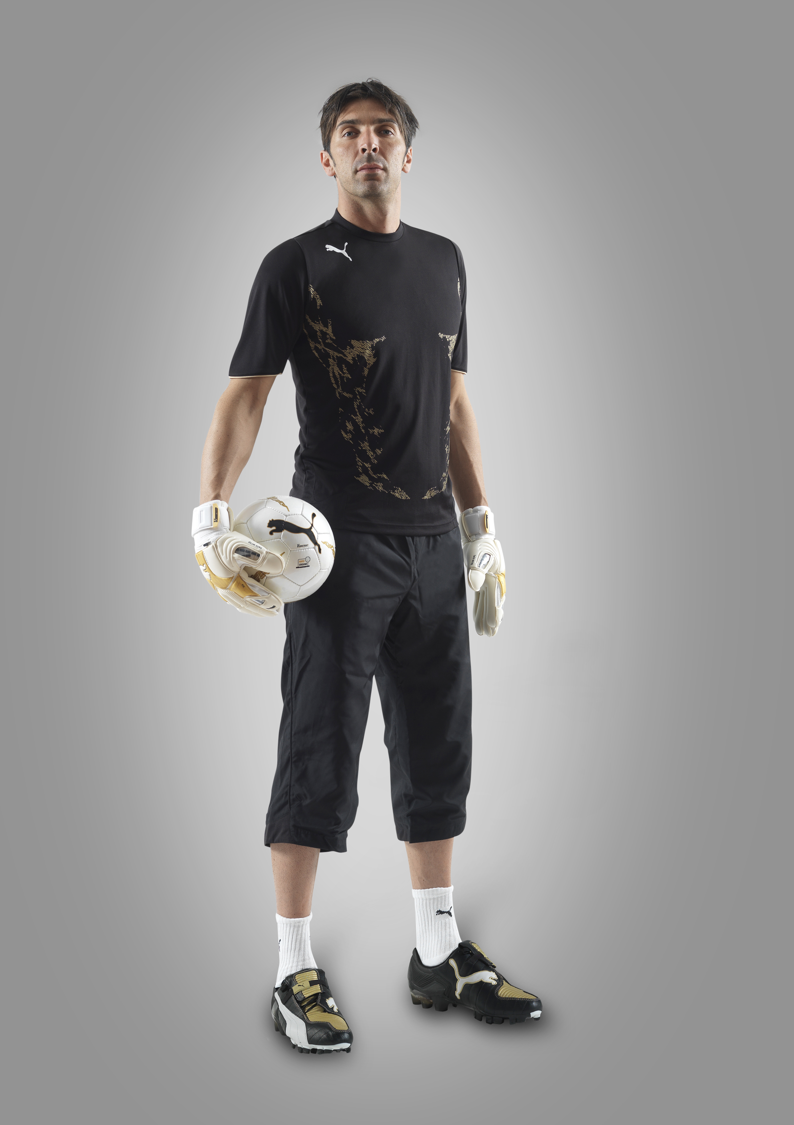
v-Kat Performance Tee
A statement performance training piece, the v-Kat Performance Tee exaggerates body shape through its graphic prints and cutlines thus boosting players’ confidence.
Strategically placed and partly bonded mesh inserts on the back, provide ventilation enhancing the players stamina during hard training sessions.

v-Kat 5/8 Pants
As is true for the entire v-Konstrukt III statement line, the v-Kat 5/8 Woven Pants are made from extremely lightweight and highly-functional fabric. Freedom of movement is enhanced through the ergonomic cut lines, which also improves the pants fit, comfort and durability.

The new international v-Konstrukt III statement performance concept, covering all product segments, will be available in-store January 3, 2009.

###

PUMA is one of the world’s leading sportlifestyle companies that designs and develops footwear, apparel and accessories. It is committed to working in ways that contribute to the world by supporting Peace, Creativity, and SAFE Sustainability, and by staying true to the values of being Fair, Honest, Positive and Creative in decisions made and actions taken. PUMA starts in Sport and ends in Fashion. Its Sport Performance and Lifestyle labels include categories such as Football, Running, Motorsports, Golf and Sailing. The Black label features collaborations with renowned designers such as Alexander McQueen, Yasuhiro Mihara and Sergio Rossi. The PUMA Group owns the brands PUMA, Tretorn and Hussein Chalayan. The company, which was founded in 1948, distributes its products in more than 120 countries, employs more than 9,000 people worldwide and has headquarters in Herzogenaurach/Germany, Boston, London and Hong Kong. For more information, please visit www.puma.com

