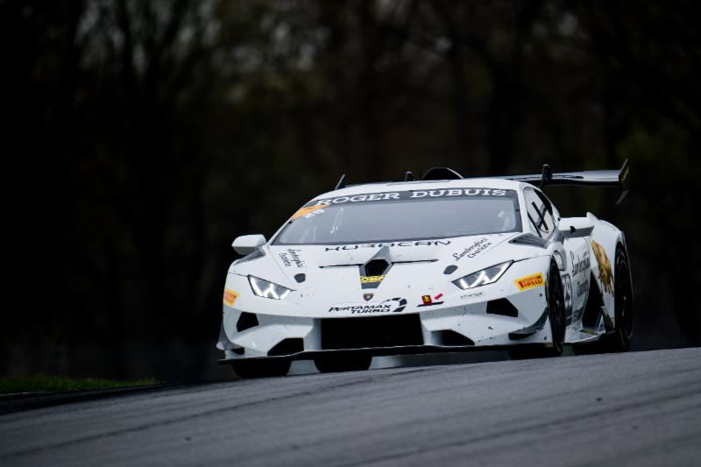

WATKINS GLEN, N.Y. (June 28, 2018) – The long break is finally over for the Lamborghini Super Trofeo North America series as rounds three and four get underway this weekend at historic Watkins Glen International.

It has been 54 days since the Lamborghini Super Trofeo North America teams were last on track at the Mid-Ohio Sports Car Course, where the 2018 season opened, and they are eager to get back racing.

The dynamic duo of Madison Snow and Corey Lewis driving the No. 29 Change Racing Lamborghini Charlotte Lamborghini Huracan Super Trofeo EVO will look to keep the momentum going from Mid-Ohio after sweeping the top step of the Pro class podium in both races.

“Before I get to the track I seem to partially forget about the momentum we had,” said Snow. “Though speaking from experience, once I get back to the track it all comes rushing back once you see the team, the car, and all of your competitors.”

Despite the momentum, neither driver has competed at Watkins Glen in Super Trofeo, so they enter the weekend with a bit of a handicap. Of the 25 drivers entered this weekend, eight of them have at least one class victory at the track.

“Unlike the remainder of the season, I have never driven a Super Trofeo car around this track so I am excited to see what it will be like compared to the GT3 car with the differences both cars have in handling and power,” said Snow. “This is a very fast paced, flowing track so a good setup is a must here, much like Mid-Ohio. It should be an exciting weekend.”

Two other drivers will also be riding the wave of success into the weekend. JC Perez and Loris Spinelli, who co-drive the No. 71 P1 Motorsports Lamborghini Huracan Super Trofeo EVO for Lamborghini Broward bring ProAm class winning momentum from Lamborghini Super Trofeo Europe held at the Misano World Circuit in Italy last weekend. The duo took top honors in the ProAm class in race one of the two race weekends in Europe and continue to lead the points in that series.

The ProAm class will see some familiar faces this weekend as Alex Popow returns to the series for the first time in 2018 for Wayne Taylor Racing/Prestige Performance. Last season, Popow finished on the podium in both races at Watkins Glen driving the same car in the Pro class.

Pippa Mann will also join the ProAm ranks driving the No. 47 Lamborghini for PPM, Lamborghini Palm Beach. Mann has one podium at Watkins Glen coming in 2017 in the ProAm class driving the Prestige Performance, Lamborghini Paramus No. 57.

LB Cup class will also see some new faces with two new entries for the Watkins Glen weekend. Dream Racing/Lamborghini Atlanta will field the No. 21 for Justin Price and GMG Racing/Lamborghini Newport Beach will run the No. 66 with Brett Meredith.

While the long layoff might not have been welcome for some, for Wayne Taylor Racing it has allowed them time to become more familiar with the new Lamborghini Huracan Super Trofeo Evo that debuted at Mid-Ohio.

“Mid-Ohio is all but a distant memory at this point,” said Trent Hindman driver of the No. 1 Wayne Taylor Racing, Lamborghini Paramus. “As much as we had accomplished with the Prestige Performance/Wayne Taylor Racing team throughout that weekend, there’s obviously some parts of it that we would like to forget about.

“Luckily the WTR crew has spent this entire break really getting to grips with the new Huracan Super Trofeo Evo, and we’re absolutely looking forward to proving our progress this weekend.”

Rounds three and four of the 2018 Lamborghini Super Trofeo North America series from Watkins Glen can be streamed on IMSA.TV and squadracorse.lamborghini.com/super-trofeo/north-america starting with Race 1 on Friday at 4 p.m. ET and Race 2 on Saturday at 10:20 a.m. ET

Contact:
Gregg Elkin
Director, Communications
386.310.6566
gelkin@imsa.com

