

Hyundai Motor Group Global PR Team (Tel: +82-2-3464-2128 / 8504)

**Hyundai Motor Group Develops World First Active Shift Control for Hybrids to Enhance Fuel Economy and Joy of Driving**

* The in-house developed, world-first technology improves gear-shift efficiency for hybrid vehicles and is now set for mass production
* Active Shift Control reduces gear-shift times by 30%, adds to driving fun, and improves fuel economy

**SEOUL, July 19, 2019** – Hyundai Motor Group has developed the world’s first Active Shift Control (ASC) transmission technology. The innovation optimizes transmission efficiency by monitoring gear shifts 500 times per second, precisely adjusting the transmission rotation speed to for faster shift times. The new technology will premiere in the upcoming Hyundai Sonata Hybrid and eventually benefit other upcoming Hyundai and Kia hybrids.

ASC applies new control logic software to the Hybrid Control Unit (HCU), which then controls the electric motor to align the rotational speeds of the engine and transmission to reduce gear shift time by 30%. The technology also delivers smoother gear changes despite quicker shift times.

“The development of world’s first ASC technology is a remarkable innovation which incorporates precise motor control to automatic transmission,” said KyoungJoon Chang, Vice President and Head of Powertrain Control System Group of Hyundai Motor Group, “It will not only save fuel but also provide a more fun driving experience for our customers.”

**Innovation: Independently Developed Control Logic Software Applied to the Electric Motor**

Conventional hybrid vehicles do not have torque converters in order to further improve fuel economy as torque converters lose energy during the process of transmission. Although fuel efficient, such a system also requires longer shift times to ensure smoother gear changes.

ASC technology allows the hybrid’s electric motor to also take control of gear shifts by applying new software logic to the Hybrid Control Unit (HCU) to mitigate issues with slower shift time. The HCU monitors the rotational speed of transmission with a sensor installed inside the electric motor at 500 times per second to quickly synchronize the rotational speed with that of engine.

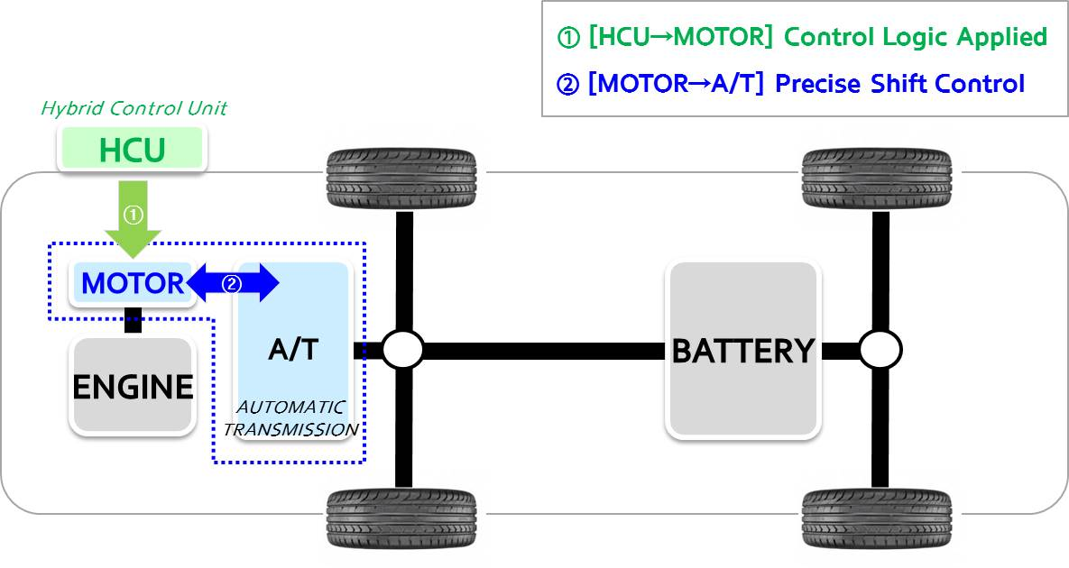

With the synchronization, shift time is reduced by 30% from 500ms to 350ms. This not only improves hybrid vehicle’s acceleration performance and fuel economy, but also durability of the transmission by minimizing friction during gear shift.

- End -

**About Hyundai Motor Group**Hyundai Motor Group is a global corporation that has created a value chain based on automobiles, steel, and construction and includes logistics, finance, IT and service. With about 250,000 employees worldwide, the Group’s automobile brands include Hyundai Motor Co. and Kia Motors Corp. Armed with creative thinking, cooperative communication and the will to take on all challenges, we are working to create a better future for all.   
  
For more information on Hyundai Motor Group, please see: [www.hyundaimotorgroup.com](http://www.hyundaimotorgroup.com/)

**Contact**

Jin ChaGlobal PR Team / Hyundai Motor

[sjcar@hyundai.com](mailto:sjcar@hyundai.com)

+82 2 3464 2128