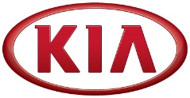
Media Contact:
JH SO
Senior Manager
Tel: +82 2 3464 8505
E-mail: jeonghyun.so@kia.com
NEWS
FOR IMMEDIATE RELEASE

Kia Motors posts global sales of 242,274 vehicles in March

(SEOUL) April 2, 2018 – Kia Motors Corporation announced its March 2018 global sales figures for passenger cars, recreational vehicles (RVs) and commercial vehicles, recording a total of 242,274 units sold, increasing 3.4% from 2017.

In March, sales in Korea totaled 48,540 units, representing an increase of 1.9% compared with the same month last year. The company’s overseas sales also grew by 3.7% compared to the previous year, posting 193,734 units on strong sales of Rio (known as ‘Pride’ in Korea).

Kia’s best-selling model in the overseas markets during February 2018 was the Sportage compact SUV with 41,746 units sold. The Rio was the second best seller with 32,365 units sold, followed by the K3 compact sedan (known as ‘Forte’ in some markets) with 29,778 units sold.

The company expects to gain new momentum with All-new K900, a world class flagship sedan unveiled at 2018 New York International Auto Show.

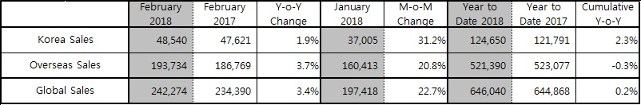

Editor’s note:
* Sales in Korea is based on retail sales while overseas sales (global sales excluding Korea) is based
on wholesale.
* Monthly sales figures provided in this press release are unaudited and on a preliminary basis.

About Kia Motors Corporation
Kia Motors Corporation (www.kia.com) – a maker of world-class quality vehicles for the young-at-heart – was founded in 1944 and is Korea's oldest manufacturer of motor vehicles. About 3 million Kia vehicles a year are produced at 14 manufacturing and assembly operations in five countries which are then sold and serviced through a network of distributors and dealers covering around 180 countries. Kia today has over 51,000 employees worldwide and annual revenues of over US$47 billion. It is the major sponsor of the Australian Open and an official automotive partner of FIFA – the governing body of the FIFA World Cup™. Kia Motors Corporation's brand slogan – "The Power to Surprise" – represents the company's global commitment to surprise the world by providing exciting and inspiring experiences that go beyond expectations.

For more information about Kia Motors and our products, please visit our Global Media Center at www.kianewscenter.com.
###

