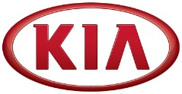
Media Contact:
Michael Choo
General Manager, Overseas PR Team
Tel: +82-2-3464-5663 E-mail: mjc@kia.com

NEWS
FOR IMMEDIATE RELEASE

Kia Motors posts 9.1% rise in global sales in November
- Global sales reach 283,660 units in November for 9.1% year-on-year growth
- Kia records monthly year-on-year sales growth in North America (15.7%), China (12.8%), General Market (9.3%) and Europe (8.2%) in November
- Kia’s best-selling car in overseas markets in September was the C-segment Cerato (Known as ‘Forte’ or ‘K3’ in some markets)

(SEOUL) December 5, 2016 – Kia Motors Corporation announced today its November 2016 global sales figures (export sales, domestic sales and sales from overseas plants) for passenger cars and commercial vehicles, recording a total of 283,660 units sold. This figure represents a 9.1% year-on-year increase compared to the same month of 2015.
In November, Kia posted year-on-year sales increases in North America (15.7% growth with 58,050 units sold), China (12.8% growth with 80,805 units sold), general markets* (9.3% growth with 45,069 units sold), and Europe (8.2% growth with 50,830 units sold).

Cumulatively through the first 11 months of 2016, Kia’s global sales totalled 2,738,214 units for a year-on-year increase of 3.8%. Western Europe (406,670 units sold), China (584,863 units sold), North America (660,713 units sold) and Korea (485,400 units sold) have seen a 13.3%, 7.0%, 3.9% and 2.4% rise in sales, respectively.
Kia's bestselling model in overseas markets during November 2016 was the C-segment Cerato (Known as ‘Forte’ or ‘K3’ in some markets) with 44,607 units sold. The Sportage compact CUV was the second best seller with 44,308 units sold while the B-segment Rio (known as 'K2' in China), Optima midsized sedan and Soul urban crossover followed with 44,024, 24,934 and 17,056 units sold, respectively.

***more***

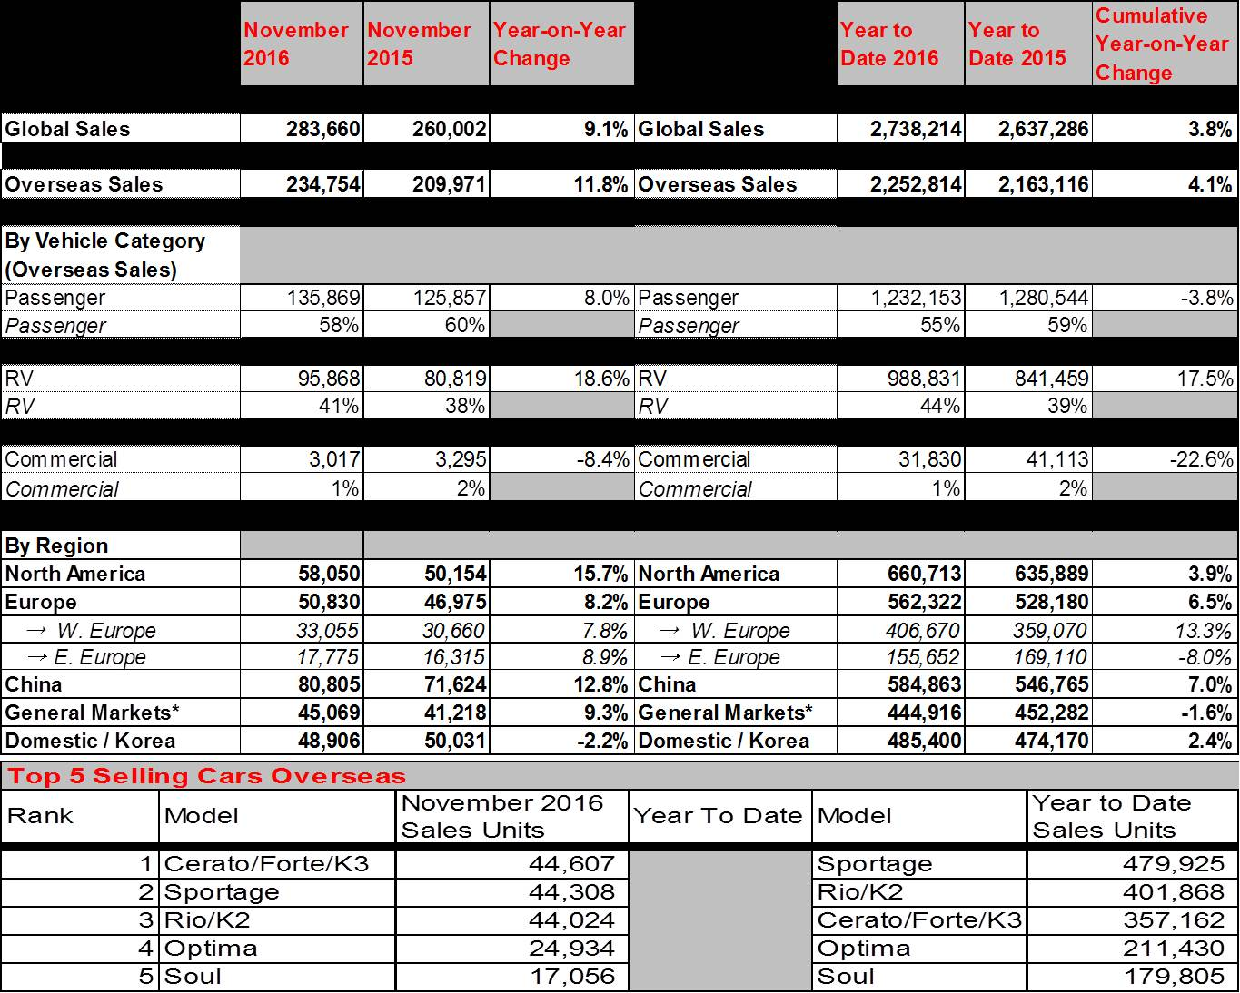
Editor’s notes: *‘General markets’ include the regions of Central and South America, the Caribbean, Asia (excluding China and Korea), the Pacific, Middle East and Africa.

About Kia Motors Corporation
Kia Motors Corporation (www.kia.com) – a maker of world-class quality vehicles for the young-at-heart – was founded in 1944 and is Korea's oldest manufacturer of motor vehicles. Over 3 million Kia vehicles a year are produced at 14 Kia manufacturing and assembly operations in five countries which are then sold and serviced through a network of distributors and dealers covering around 180 countries. Kia today has over 50,000 employees worldwide and annual revenues of nearly US$44 billion. It is the major sponsor of the Australian Open and an official automotive partner of FIFA – the governing body of the FIFA World Cup™. Kia Motors Corporation's brand slogan – "The Power to Surprise" – represents the company's global commitment to surprise the world by providing exciting and inspiring experiences that go beyond expectations.

For more information about Kia Motors and our products, please visit our Global Media Center at www.kianewscenter.com.

