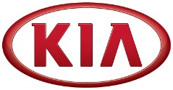
Media Contact:
Michael Choo
General Manager, Overseas PR Team
Tel: +82-2-3464-5663 E-mail: mjc@kia.com

NEWS
FOR IMMEDIATE RELEASE

Kia Motors posts global sales of 268,007 vehicles in March
- Kia records year-on-year sales growth in Korea (19.4%) and Europe (9.4%) in March
- Cumulative sales in 2016 reached 686,887 units, representing a 0.6% year-on-year decrease
- Kia’s best-selling car in overseas markets in March was the Sportage compact CUV

(SEOUL) April 6, 2016 – Kia Motors Corporation announced today its March 2016 global sales figures (export sales, domestic sales and sales from overseas plants) for passenger cars, recreational vehicles (RVs) and commercial vehicles, recording a total of 268,007 units sold. This figure represents 0.6% year-on-year decrease compared to the same month of 2015.
In March, Kia posted year-on-year sales increases in the domestic Korean market (19.4% growth with 50,510 units sold) and Europe (9.4% growth with 63,826 units sold).

Cumulatively through the first three months of 2016, Kia’s global sales totalled 686,887 units for a year-on-year decrease of 0.6%. Korea (128,125 units sold), Europe (145,488 units sold) and North America (160,286 units sold) have seen an 11.9%, 7.9% and 3.0% rise in sales, respectively.
Kia's bestselling model in overseas markets during March 2016 was the Sportage compact CUV with 43,304 units sold. The B-segment Rio (known as 'K2' in China) was the second best seller with 33,524 units sold, while the C-segment Cerato (known as 'Forte' or ‘K3’ in some markets), Optima D-segment sedan and Soul urban crossover followed with 30,591, 21,391 and 16,562 units sold, respectively.

***more***

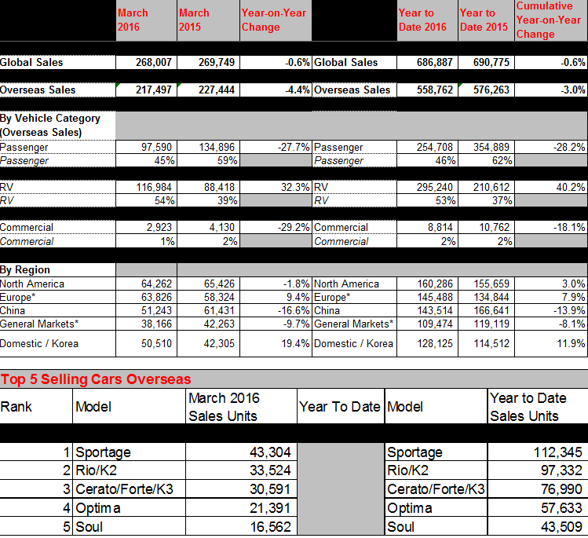

Editor’s notes: * ‘General markets’ include the regions of Central and South America, the Caribbean, Asia (excluding China and Korea), the Pacific, Middle East and Africa. ‘Europe’ includes both Western and Eastern European markets.

About Kia Motors Corporation
Kia Motors Corporation (www.kia.com) – a maker of quality vehicles for the young-at-heart – was founded in 1944 and is Korea's oldest manufacturer of motor vehicles. Over 3 million Kia vehicles a year are produced at 10 manufacturing and assembly operations in five countries which are then sold and serviced through a network of distributors and dealers covering around 180 countries. Kia today has around 50,000 employees worldwide and annual revenues of nearly US$44 billion. It is the major sponsor of the Australian Open and an official automotive partner of FIFA – the governing body of the FIFA World Cup™. Kia Motors Corporation's brand slogan – "The Power to Surprise" – represents the company's global commitment to surprise the world by providing exciting and inspiring experiences that go beyond expectations.

