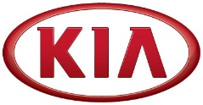
Media Contact:
Michael Choo
General Manager, Overseas PR Team
Tel: +82-2-3464-5663 E-mail: mjc@kia.com

NEWS
FOR IMMEDIATE RELEASE

Kia Motors posts global sales of 214,219 vehicles in February
- Kia records year-on-year sales growth in North America (12.2%), Europe (11.0%) and Korea (10.5%) in February
- Cumulative sales in 2016 reached 418,881 units, representing a 0.5% year-on-year decrease
- Kia’s best-selling car in overseas markets in February is the B-segment Rio (K2)

(SEOUL) March 07, 2016 – Kia Motors Corporation announced today its February 2016 global sales figures (export sales, domestic sales and sales from overseas plants) for passenger cars, recreational vehicles (RVs) and commercial vehicles, recording a total of 214,219 units sold. This figure represents 2.6% year-on-year growth compared to the same month of 2015.
In February, Kia posted year-on-year sales increases in North America (12.2% growth with 54,118 units sold), Europe (11.0% growth with 43,216 units sold) and the domestic Korean market (10.5% growth with 39,110 units sold).

Cumulatively through the first two months of 2016, Kia’s global sales totalled 418,881 units for a year-on-year decrease of 0.5%. Korea (77,615 units sold), Europe (81,662 units sold) and North America (96,024 units sold) have seen a 7.7%, 6.7% and 6.4% rise in sales, respectively.
Kia's bestselling model in overseas markets during February 2016 was the B-segment Rio (known as 'K2' in China) with 33,552 units sold. The Sportage compact CUV was the second best seller with 32,052 units sold, while the C-segment Cerato (known as 'Forte' or ‘K3’ in some markets), Optima D-segment sedan and Soul urban crossover followed with 22,452, 19,548 and 14,761 units sold, respectively.

***more***

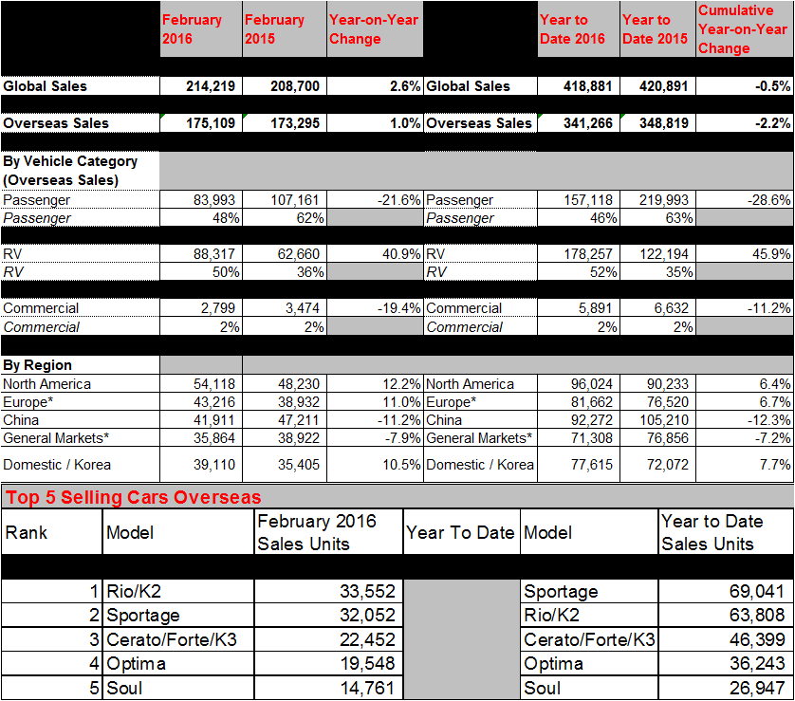

Editor’s notes: * ‘General markets’ include the regions of Central and South America, the Caribbean, Asia (excluding China and Korea), the Pacific, Middle East and Africa. ‘Europe’ includes both Western and Eastern European markets.

About Kia Motors Corporation
Kia Motors Corporation (www.kia.com) – a maker of quality vehicles for the young-at-heart – was founded in 1944 and is Korea's oldest manufacturer of motor vehicles. Over 3 million Kia vehicles a year are produced at 10 manufacturing and assembly operations in five countries which are then sold and serviced through a network of distributors and dealers covering around 180 countries. Kia today has around 50,000 employees worldwide and annual revenues of nearly US$44 billion. It is the major sponsor of the Australian Open and an official automotive partner of FIFA – the governing body of the FIFA World Cup™. Kia Motors Corporation's brand slogan – "The Power to Surprise" – represents the company's global commitment to surprise the world by providing exciting and inspiring experiences that go beyond expectations.

