

**Wynn Las Vegas Outfits Local Students With Donation To Project 150**

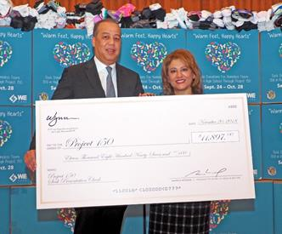

**Wynn Las Vegas President Maurice Wooden with Project 150 Executive Director Meli Pulido**

**Las Vegas** (November 20, 2018) — Wynn Las Vegas announces the donation of 11,897 pairs of new socks and an $11,897 monetary match to Project 150, a local non-profit that provides vital support services to more than 6,000 homeless, displaced and disadvantaged students in Southern Nevada each year. In addition, Wynn donated more than $179,000 worth of new and unused uniform separates in a variety of sizes that are appropriate for everyday wear to school and job interviews, including suit jackets and pants, dresses, track suits, shirts, and slacks.

Wynn Las Vegas President Maurice Wooden presented the donation to Meli Pulido, Project 150 Executive Director, at a special ceremony that included students from area high schools the organization supports. “Project 150 helps the leaders of tomorrow focus on what matters most – their education,” said Wooden. “We are honored to be of service to the bright and capable students of Las Vegas.”

“Socks can seem like such a simple thing, but for the students we serve socks are just as important as hats, scarves, and gloves as they head into the colder winter months,” said Pulido. “Combined with the apparel donation, Wynn is giving hundreds of students more than just outfits, they’re giving them peace of mind.”

Now in its fourth year, Wynn’s annual “Warm Feet, Happy Hearts” sock drive in support of Project 150 is spearheaded by the resort’s Hotel Sales and Marketing Team. During the month long effort in October, every department rallies employees to donate new socks, while dedicated space at Wynn’s booth at the IMEX tradeshow furthers awareness to the global travel and hospitality community, where attendees learn more about Project 150 and are also encouraged to donate to the important cause.

**About Project 150**

Project 150 is a 501(c)3 nonprofit charitable organization, founded in December 2011 by local businessmen Don Purdue and Patrick Spargur. The two heard about 150 homeless high school students at Rancho High School in Las Vegas who were in need of support over the Christmas break. Since that time, Project 150 has expanded and now serves more than 6,300 registered and non-registered homeless, displaced and disadvantaged high-school students in more than 80 schools in Nevada. Project 150 provides these students with food, clothing, school supplies, sports equipment, shoes, college scholarships, workforce readiness, and other needs so they can continue school and be successful in life.