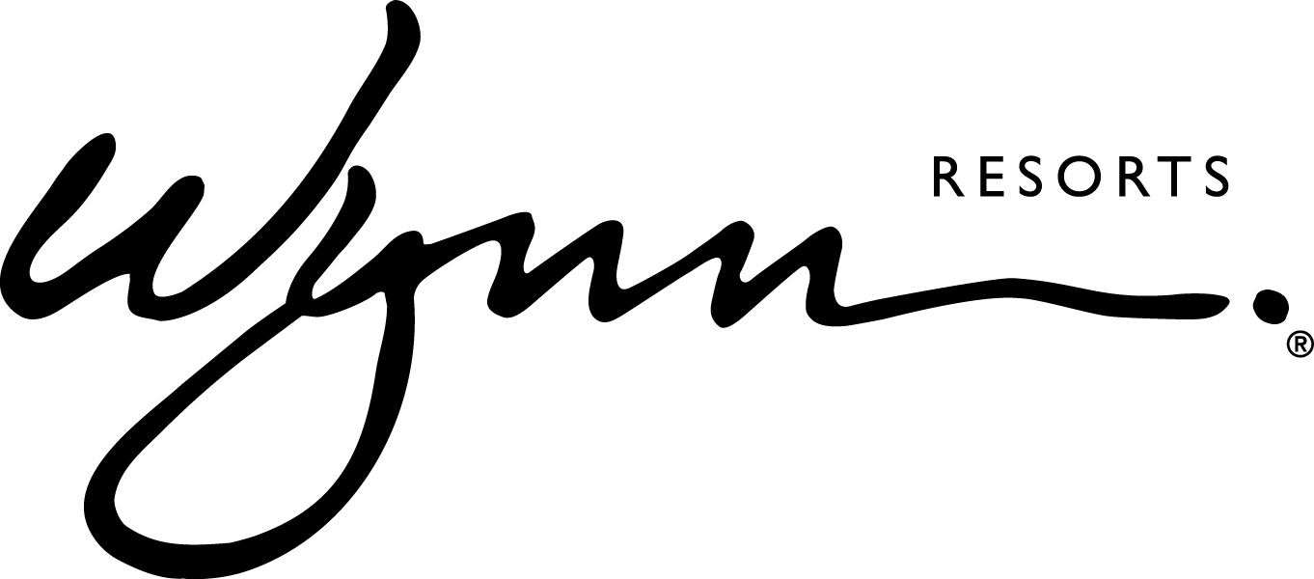
WYNN RESORTS HOLDS SECOND WOMEN’S LEADERSHIP FORUM

Panel Features Female Executives Who Have Achieved Significant ‘Firsts’ In Their Careers

LAS VEGAS (August 9, 2018) – Wynn Resorts recently held its second Women’s Leadership Forum, an empowering event series that brings together female leaders who have trail blazed advancements for women in the workplace. Themed “Women Who Thrive,” the Forum featured four Las Vegas-based women who hold high-ranking positions, and have achieved important “firsts” in their careers in industries historically dominated by men including law enforcement, transportation, college athletics, and casino management. Panelists included:

- Captain Kelly McMahill with the Las Vegas Metropolitan Police Department, a pioneer in creating and implementing groundbreaking reforms related to the use of deadly force by officers that are now counted as best practices around the country.
- Desiree Reed-Francois, Director of Athletics at UNLV, the first Hispanic female and woman of color athletics director at the Football Bowl Subdivision level, who has ushered in a cultural sea change resulting in the highest cumulative GPA among student athletes in the history of UNLV.
- Tina Quigley, General Manager of the Regional Transportation Commission of Southern Nevada, who for decades has overseen the planning and construction of transportation projects that have turned Las Vegas into an efficient and commutable city for millions of residents and tourists.
- Renee West, the first woman to hold the title of President and Chief Operating Officer on the Las Vegas Strip, who during her time as a leader with MGM Resorts International was responsible for every operational aspect of major resorts including Mandalay Bay, Excalibur, Luxor, and more.

The Forum took place on August 8th at the Encore Theater at Wynn Las Vegas, and was moderated by two of Wynn’s top female executives: Chris Flatt, EVP of Hotel Sales and Marketing, and Stacie Michaels, SVP and General Counsel. The event was open to all employees of Wynn Las Vegas and live streamed to employees in Boston and Macau. Key topics discussed included:

- Recognizing unconscious and cultural biases and how to overcome them
- Facing challenges with embracing diversity in the workplace and the power of inclusion
- How working outside of your comfort zone can lead to professional breakthroughs
- Influencing and motivating others when working toward a common goal
- Demonstrating respect and creating transparency when changing the status quo

The Wynn Resorts Women’s Leadership Forum was introduced in May 2018 to support an open dialogue amongst employees, discuss solutions that help close the gender gap in management, and provide career guidance for female employees at all levels. The theme of “Women Who Thrive” will continue with the next Forum installment taking place later this year.

-more-

ABOUT WYNN RESORTS
Wynn Resorts, Limited is traded on the Nasdaq Global Select Market under the ticker symbol WYNN and is part of the S&P 500 Index. Wynn Resorts owns and operates Wynn Las Vegas (www.wynnlasvegas.com), Wynn Macau (www.wynnmacau.com) and Wynn Palace, Cotai (www.wynnpalace.com).

Wynn and Encore Las Vegas feature two luxury hotel towers with a total of 4,750 spacious hotel rooms, suites and villas, approximately 192,000 square feet of casino space, 22 dining experiences featuring signature chefs and 11 bars, two award-winning spas, approximately 290,000 square feet of meeting and convention space, approximately 110,000 square feet of retail space as well as two showrooms; three nightclubs, a beach club and recreation and leisure facilities. A luxury retail Strip-front expansion, Wynn Plaza, is currently under construction and is scheduled to debut in the second half of 2018.

Wynn Macau is a luxury hotel and casino resort located in the Macau Special Administrative Region of the People's Republic of China with two luxury hotel towers with a total of 1,008 spacious rooms and suites, approximately 273,000 square feet of casino space, casual and fine dining in eight restaurants, approximately 31,000 square feet of meeting and convention space, approximately 59,000 square feet of retail space, and recreation and leisure facilities including two opulent spas, a salon and a rotunda show.

Wynn Palace is a luxury integrated resort in Macau. Designed as a floral-themed destination, it boasts 1,706 exquisite rooms, suites and villas, approximately 420,000 square feet of casino space, 11 food and beverage outlets, approximately 37,000 square feet of meeting and convention space, approximately 106,000 square feet of designer retail, SkyCabs that traverse an eight-acre Performance Lake, an extensive collection of rare art, a lush spa, salon and recreation and leisure facilities.

Wynn Resorts is currently constructing Encore Boston Harbor located in Everett, Massachusetts.

MEDIA CONTACT:
Michael Weaver
Wynn Resorts
(702) 770-7501
michael.weaver@wynnlasvegas.com

Deanna Pettit-Irestone
Wynn Las Vegas
(702) 770-2121
deanna.pettit-irestone@wynnlasvegas.com

