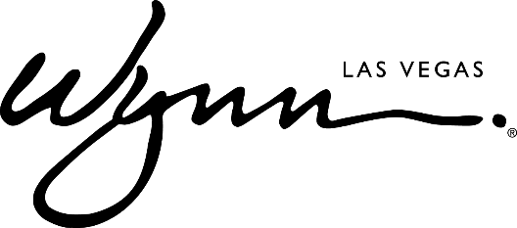

Wynn Las Vegas Announces Exclusive Retailers Joining Wynn Plaza

LAS VEGAS (June 11, 2018) – Wynn Las Vegas is pleased to announce an update to the collection of world-renowned luxury, contemporary, and lifestyle brands joining Wynn Plaza, the resort’s unique new 70,000-square-foot retail destination located directly on Las Vegas Boulevard.
“Wynn Plaza is a dynamic new addition to Las Vegas’ vibrant retail scene, offering many brands that haven’t been available in Las Vegas until now,” said Maurice Wooden, President of Wynn Las Vegas. “With dozens of fashion, dining, and lifestyle options that are exclusively found at Wynn Plaza, we’re giving visitors experiences that are truly one-of-a-kind.”
Brands that can only be found in Las Vegas at Wynn Plaza include Cipriani, Urth Caffé, SoulCycle, Céline, Balmain, Loewe, James Perse, Cotton Citizen, Marie France Van Damme, and Vitra Eyewear, with more to be announced in the coming months. Additional boutiques include Stella McCartney, Kiton, Omega, RIMOWA, Breitling, and Le Labo.
“Consumers today define luxury in a different way than in the past,” commented Haim and Stanley H. Chera, joint venture partners with Wynn in its Las Vegas retail. “The customer is looking for an experience that is not only unique to market, but unique globally, and one that addresses their lifestyle needs. This collection of boutiques provides for a casual, contemporary, luxury mix that exists nowhere else in North America.”
This new group of retailers joins the recently opened boutiques of Bottega Veneta, Saint Laurent, and the only permanent Louis Vuitton Men’s store in the country. Wynn Plaza will complement the existing luxury retail collection currently at Wynn Las Vegas and Encore which includes Chanel, Louis Vuitton, Dior, Hermes, Cartier, Givenchy, Prada, Rolex, Loro Piana, Moncler, Brunello Cucinelli, Christian Louboutin, Alexander McQueen, Watches of Switzerland, and many more.
Wynn Plaza is scheduled to open in October 2018.
ABOUT WYNN LAS VEGAS
Wynn Resorts is the recipient of more Forbes Travel Guide Five Star Awards than any other independent hotel company in the world. Wynn Las Vegas opened on April 28, 2005 and was once again named the best resort in Nevada on Condé Nast Traveler’s 2018 “Gold List,” a title received for the tenth time. Wynn and Encore Las Vegas feature two luxury hotel towers with a total of 4,750 spacious hotel rooms, suites and villas, approximately 192,000 square feet of casino space, 21 dining experiences featuring signature chefs and 11 bars, two award-winning spas, approximately 290,000 square feet of meeting and convention space, approximately 110,000 square feet of retail space as well as three nightclubs, a beach club and recreation and leisure facilities. In addition to two luxury retail esplanades, a Strip-front expansion, Wynn Plaza, is currently under construction and is scheduled to be completed in 2018. For more information on Wynn and Encore Las Vegas, visit www.wynnpressroom.com, and follow on Twitter, Instagram, and Facebook.

# # #

Media Contact:
Deanna Pettit-Irestone / Eric Kreller
Wynn Las Vegas
702-770-2120
pr@wynnlasvegas.com

