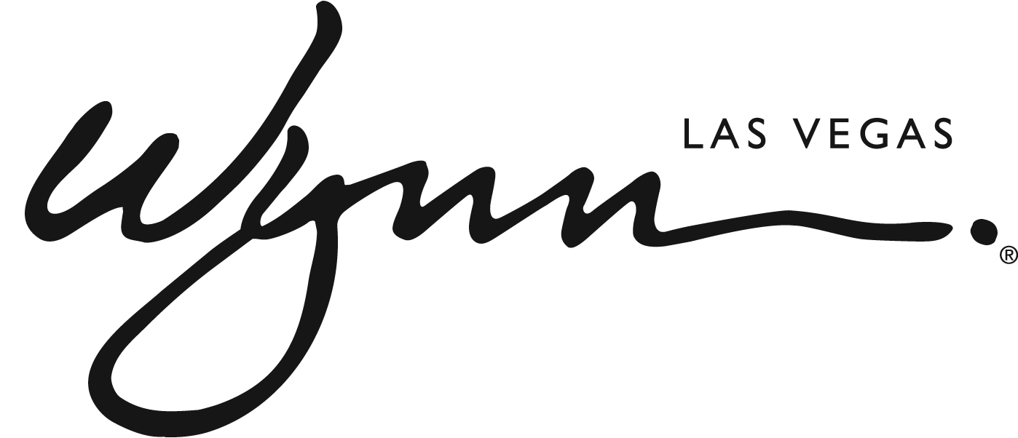

Wynn Las Vegas Announces Free Guest Self-Parking and Valet Parking Programs

Resort to Implement New Validation Policy Beginning July 1, 2018

LAS VEGAS (June 7, 2018) — Wynn Las Vegas announces a new parking program that will allow guests patronizing all resort outlets to self-park or valet park for free. Free parking will also be included as part of the resort fee for all hotel guests. The new program will go into effect on Sunday, July 1, 2018.

“Our guests choose to stay with us because of the attention we give to perfecting every detail of their experience,” said Maurice Wooden, President of Wynn Las Vegas. “We have come to believe that charging additional parking fees is counter to the personalized service we provide. This new policy directly reflects the way we know our guests want and deserve to be treated.”

For non-hotel guests and local residents, self-parking and valet parking at Wynn and Encore will be validated once per day, per vehicle upon receipt of a $50 spend within Wynn or Encore, inclusive of all retail stores in the Wynn and Encore Shopping Esplanades, all restaurants, both entertainment theaters, nightclubs and lounges, and all game play.

The approachable spend amount is designed to ensure that parking remains plentiful for resort guests, while reducing parking overflow from neighboring businesses. Adding further value to the new policy is the ability to divide one total spend among several vehicles. For instance, if four visitors in four separate vehicles spend $200 at a restaurant, all four vehicles will be validated.

For overnight guests of Wynn or Encore, self-parking will be included in the standard resort fee, which will not be increased to accommodate the new policy.

ABOUT WYNN LAS VEGAS
Wynn Resorts is the recipient of more Forbes Travel Guide Five Star Awards than any other independent hotel company in the world. Wynn Las Vegas opened on April 28, 2005 and was once again named the best resort in Nevada on Condé Nast Traveler’s 2018 “Gold List,” a title received for the tenth time. Wynn and Encore Las Vegas feature two luxury hotel towers with a total of 4,750 spacious hotel rooms, suites and villas, approximately 192,000 square feet of casino space, 21 dining experiences featuring signature chefs and 11 bars, two award-winning spas, approximately 290,000 square feet of meeting and convention space, approximately 110,000 square feet of retail space as well as three nightclubs, a beach club and recreation and leisure facilities. In addition to two luxury retail esplanades, a Strip-front expansion, Wynn Plaza, is currently under construction and is scheduled to be completed in 2018. For more information on Wynn and Encore Las Vegas, visit wynnpressroom.com, and follow on Twitter, Instagram and Facebook.

###
Media Contact:
Deanna Pettit / Eric Kreller
702-770-2120
pr@wynnlasvegas.com

