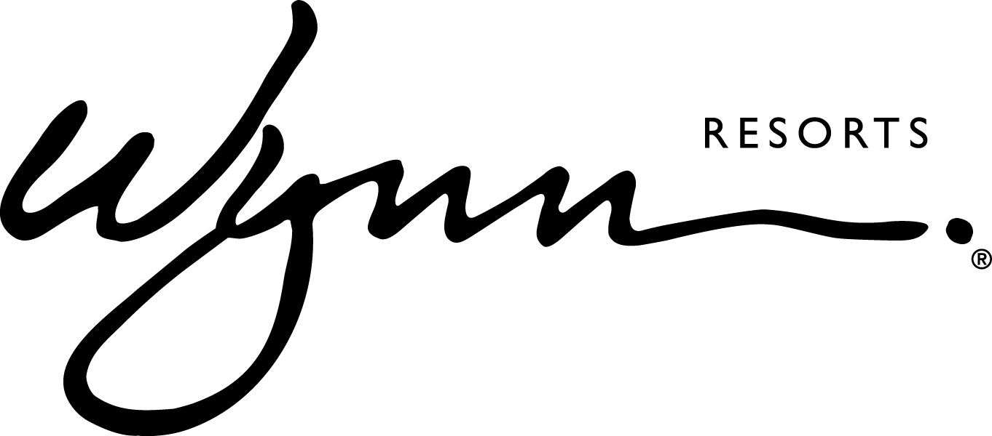

FOR IMMEDIATE RELEASE

Wynn Resorts Launches Women’s Leadership Forum Series with Inaugural
Event at Wynn Las Vegas

LAS VEGAS (May 15, 2018) – Wynn Resorts hosted its first Women’s Leadership Forum on Monday, May 14, featuring a panel discussion with the four female members of the Wynn Board of Directors, all acknowledged experts in their field. Conceptualized by new CEO Matt Maddox, the event was the first in a series of ongoing initiatives that will address gender equality and fair treatment. The event was open to all employees of Wynn Las Vegas and live streamed to employees in Boston and Macau.

Monday’s panel discussion, themed “Women Who Thrive,” welcomed the all-female lineup to the stage to discuss core issues in the workplace, while sharing insights into their professional careers and tips on navigating challenges as female executives. Panelists included Betsy Atkins, Serial Entrepreneur and three-time CEO and Founder of Baja Corporation; Pat Mulroy, Senior Fellow for the Brookings Institute, Former General Manager of the Southern Nevada Water Authority, and Former Member of the Nevada Gaming Commission; Dee Dee Myers, Executive Vice President at Warner Bros. Entertainment and Former White House Press Secretary under President Clinton; and Wendy Webb, CEO of Kestrel Advisors and a 20-year Executive at The Walt Disney Company.

Moderated by Wynn Resorts Executive Vice President & General Counsel Kim Sinatra, key topics discussed during the evening’s panel and Q&A session included:

- Navigating obstacles as a female in the workplace
- Succeeding in typically male-dominated industries
- Recognizing and overcoming gender bias
- Establishing a healthy work-life balance
- Understanding the value of emotional intelligence

Monday’s event was the first of its kind at Wynn Resorts and launches a series of forums that will be available to employees throughout the year. Co-chaired by Chris Flatt, Executive Vice President of Hotel Sales & Marketing and Stacie Michaels, Senior Vice President and General Counsel of Wynn Las Vegas and Encore, the Wynn Resorts Women’s Leadership Forum was introduced to create an open dialogue and discuss solutions to help further close the gender gap in management, provide career growth opportunities for female employees at all levels, create pay and title equity, and ensure a safe workplace.
About Wynn Resorts:
Wynn Resorts, Limited is traded on the Nasdaq Global Select Market under the ticker symbol WYNN and is part of the S&P 500 Index. Wynn Resorts owns and operates Wynn Las Vegas (www.wynnlasvegas.com), Wynn Macau (www.wynnmacau.com) and Wynn Palace, Cotai (www.wynnpalace.com).
Wynn and Encore Las Vegas feature two luxury hotel towers with a total of 4,750 spacious hotel rooms, suites and villas, approximately 192,000 square feet of casino space, 22 dining experiences featuring signature chefs and 11 bars, two award-winning spas, approximately 290,000 square feet of meeting and convention space, approximately 110,000 square feet of retail space as well as two showrooms; three nightclubs, a beach club and recreation and leisure facilities. A luxury retail Strip-front expansion, Wynn Plaza, is currently under construction and is scheduled to debut in the second half of 2018.
Wynn Macau is a luxury hotel and casino resort located in the Macau Special Administrative Region of the People's Republic of China with two luxury hotel towers with a total of 1,008 spacious rooms and suites, approximately 273,000 square feet of casino space, casual and fine dining in eight restaurants, approximately 31,000 square feet of meeting and convention space, approximately 59,000 square feet of retail space, and recreation and leisure facilities including two opulent spas, a salon and a rotunda show.
Wynn Palace is a luxury integrated resort in Macau. Designed as a floral-themed destination, it boasts 1,706 exquisite rooms, suites and villas, approximately 420,000 square feet of casino space, 11 food and beverage outlets, approximately 37,000 square feet of meeting and convention space, approximately 106,000 square feet of designer retail, SkyCabs that traverse an eight-acre Performance Lake, an extensive collection of rare art, a lush spa, salon and recreation and leisure facilities.
Wynn Resorts is currently constructing Encore Boston Harbor located in Everett, Massachusetts.

MEDIA CONTACT:
Michael Weaver
Wynn Resorts
(702) 770-7501
michael.weaver@wynnlasvegas.com

Deanna Pettit-Irestone
Wynn Las Vegas
(702) 770-2121
deanna.pettit-irestone@wynnlasvegas.com

