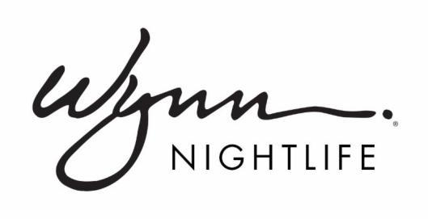

FOR IMMEDIATE RELEASE

Wynn Nightlife Announces RÜFÜS DU SOL
Exclusive 2018 DJ Residency

The trio will make their debut at Encore Beach Club’s NightSwim Pool Party on June 9

LAS VEGAS (April 3, 2018) -- RÜFÜS DU SOL, the indie Australian alternative dance trio comprised of Tyrone Lindqvist, Jon George and James Hunt, brings its signature sound to Wynn Las Vegas with an exclusive 2018 DJ residency. The group’s first three club dates are Saturday, June 9, Saturday, July 7, and Friday, Oct. 5 at Encore Beach Club’s NightSwim pool party.

“We’re excited to welcome RÜFÜS DU SOL to the Wynn Nightlife family of diverse artists,” said Alex Cordova, Wynn Nightlife managing partner. “We've been a fan of the band for quite some time and feel as though the nighttime concert setting of Encore Beach Club is the perfect fit for their sound and audience.”

"As producers who tour and perform as a live band, we don’t often get the chance to DJ in big rooms and push that element of what we do because we’re so focused on touring the full band show,” said James Hunt of RÜFÜS DU SOL. “We started out playing in clubs and so much of what we do is influenced by DJ culture, so it’s exciting to be able to take it back to the clubs and be given a residency to push our style of music. We’re going to have a lot of fun."

Supporting its sophomore album Bloom, which debuted atop the Australian albums chart in early 2016, RÜFÜS DU SOL has performed for and won-over massive crowds with their celestial stage show and music. Relative newcomers to the North American market, RÜFÜS DU SOL quickly found themselves performing at Coachella and the Red Rocks amphitheater. In 2017, they headlined a North American tour and dates abound are scheduled for 2018 featuring its high-profile Wynn Nightlife residency.

For tickets, table, cabana or bungalow reservations, visit www.wynnnightlife.com. Dates are subject to change without notice.

# # #

ABOUT WYNN NIGHTLIFE
Wynn Nightlife consists of the award-winning dayclub and nightclubs at Wynn Las Vegas, the recipient of more Forbes Travel Guide Five-Star Awards than any other independent hotel company in the world. The resort is home to three of the Las Vegas Strip's most luxurious nightlife venues, XS, Intrigue and Encore Beach Club at Night, as well as the acclaimed dayclub, Encore Beach Club. Together, the venues feature a roster of today's most in-demand electronic dance music DJs.

XS Nightclub, one of the most renowned nightlife venues in the world, has continuously been named the top grossing nightclub in the U.S. by Nightclub & Bar's Top 100 list, and was the first venue to ever achieve the honor five times. The 40,000 square foot mega-club features state-of-the-art technology and more than 10,000 individual light sources which illuminate the venue – complementing the intricate décor, large circular dance floor and 170 luxe VIP tables and outdoor cabanas. Intrigue Nightclub's intimate design allows guests a more intimate experience. The 14,000 square foot venue hosts 60 banquette tables, an elevated bottle service experience with tableside mixology, and features a 94-foot waterfall as well as a pyrotechnic fountain show that is supported by the latest advancements in lighting, laser and projection technology.

At Encore Beach Club, guests can enjoy 55,000 square feet of tropical oasis, including three tiered pools, 40-foot palm trees, 32 private bungalows and cabanas, plush daybeds, a showcase DJ booth and top-of-the-line audio system. Once the sun goes down, XS NightSwim and Encore Beach Club at Night are home to popular seasonal pool parties.

For more information, visit www.wynnnightlife.com.

Follow on Twitter,Instagram and Facebook

Media Contacts:
Lisa Long Adler Communications
Jim Havey, jim@llac.com, 646-554-5519

Wynn Las Vegas
Erica Benken, erica.benken@wynnlasvegas.com, 702-770-2126

