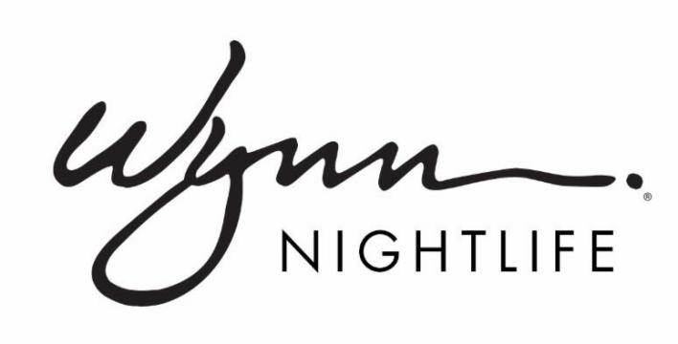
Draft
XS Nightclub Celebrates Nine-Year Anniversary with Nine Nights of Parties

Lineup includes performances by superstar Wynn Nightlife residents over EDC and Memorial Day Weekend

LAS VEGAS (March 13, 2018) -- Top Las Vegas megaclub XS Nightclub in Encore at Wynn Las Vegas marks its nine-year anniversary with fanfare by presenting nine nights of parties commencing on Thursday, May 17.
“XS remains the number one club in Las Vegas and is more successful than ever," said Alex Cordova, Wynn Nightlife's Managing Partner. “Such an accomplishment in this competitive market is deserving of a big celebration.”
Spanning two of the most highly-anticipated weekends in Las Vegas, EDC Weekend and Memorial Day Weekend, XS will present nine nights of anniversary events that will feature appearances by several of Wynn Nightlife’s resident DJs, including:
- Thursday, May 17 - David Guetta
- Friday, May 18 - Kygo
- Saturday, May 19 - Diplo
- Sunday, May 20 - Marshmello
- Monday, May 21 - The Chainsmokers
- Friday, May 25 - The Chainsmokers
- Saturday, May 26 - David Guetta
- Sunday, May 27 - Kygo
- Monday, May 28 - Marshmello
When electronic dance music first exploded onto the Las Vegas nightlife scene, led by Wynn Las Vegas, MTV dubbed XS as "Las Vegas' dance music mecca." XS has since continuously programmed the biggest names in the genre and helped to propel the careers of many of today’s top stars. The 40,000 square foot indoor and outdoor venue has maintained its dominant stature as the city’s top grossing nightclub by offering exemplary service in a stunning environment, presenting world-class talent, and its indefatigable dedication to providing the best customer experience in town.
For tickets, table, cabana or bungalow reservations, visit www.wynnnightlife.com. Dates are subject to change without notice.

ABOUT WYNN NIGHTLIFE
Wynn Nightlife consists of the award-winning dayclub and nightclubs at Wynn Las Vegas, the recipient of more Forbes Travel Guide Five-Star Awards than any other independent hotel company in the world. The resort is home to three of the Las Vegas Strip's most luxurious nightlife venues, XS, Intrigue and Encore Beach Club at Night, as well as the acclaimed dayclub, Encore Beach Club. Together, the venues feature a roster of today's most in-demand electronic dance music DJs.

XS Nightclub, one of the most renowned nightlife venues in the world, has continuously been named the top grossing nightclub in the U.S. by Nightclub & Bar's Top 100 list, and was the first venue to ever achieve the honor five times. The 40,000 square foot mega-club features state-of-the-art technology and more than 10,000 individual light sources which illuminate the venue – complementing the intricate décor, large circular dance floor and 170 luxe VIP tables and outdoor cabanas. Intrigue Nightclub's intimate design allows guests a more intimate experience. The 14,000 square foot venue hosts 60 banquette tables, an elevated bottle service experience with tableside mixology, and features a 94-foot waterfall as well as a pyrotechnic fountain show that is supported by the latest advancements in lighting, laser and projection technology. At Encore Beach Club, guests can enjoy 55,000 square feet of tropical oasis, including three tiered pools, 40-foot palm trees, 32 private bungalows and cabanas, plush daybeds, a showcase DJ booth and top-of-the-line audio system. Once the sun goes down, XS NightSwim and Encore Beach Club at Night are home to popular seasonal pool parties.

For more information, visit www.wynnnightlife.com.

Follow on Twitter,Instagram and Facebook

Media Contacts:
Lisa Long Adler Communications
Jim Havey, jim@llac.com, 646-554-5519

Wynn Las Vegas
Erica Benken, erica.benken@wynnlasvegas.com, 702-770-2126

