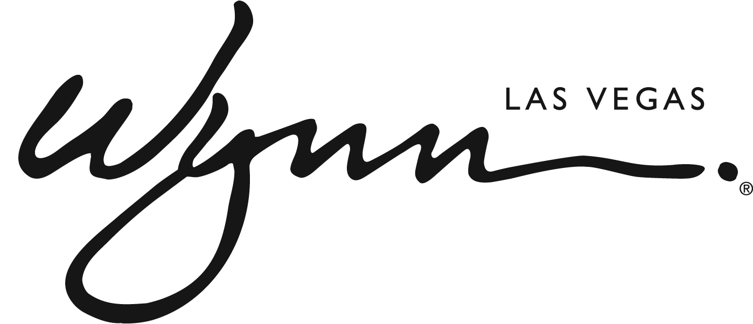

Wynn Collection Debuts at Wynn Las Vegas Featuring a Coveted Selection of Luxury and Emerging Designers in One Boutique
New Store Offers Ready-to-Wear, Exclusive Accessories and Tom Ford Beauty Products

LAS VEGAS (Aug. 12, 2015) – Wynn Las Vegas continues to raise the bar for luxurious shopping experiences with the addition of Wynn Collection located in the Fairway Esplanade across from La Cave—Wine & Food Hideaway. The new 7,000-square-foot boutique features the largest selection of illustrious designers with a discerning selection of women’s and men’s ready-to-wear, sophisticated accessories, and sumptuous makeup and fragrances.

“Wynn Collection sets the bar for luxury boutiques in the retail market place as it houses the most notable and sought after designers in one place,” said Hedy Woodrow, senior vice president of retail for Wynn Las Vegas. “In an effort to continuously elevate our guest experience, we have brought in exclusive styles and collections that can only be found in Las Vegas at Wynn.”

The store’s vibrant and spacious layout is brought to life with cream-textured walls and gold accents to make each guest feel like they are on the runways of Paris and New York. The main entry room highlights some of the most exquisite handbags in the world by Judith Leiber, Analeena and VBH, as well as a variety of classic-contemporary Philip Treacy hats only available in Las Vegas at Wynn Collection.

Beautiful gowns by Indian-American designer Naeem Khan have been worn by the likes of Beyonce, Carrie Underwood and the First Lady Michelle Obama. Guests can explore an assortment of ready-to-wear by Khan, as well as other designers including Alaia, Valentino, Jason Wu, Prada and more. Men may also indulge in styles by John Varvatos, Bugatchi, Ermenegildo Zegna, and more. Stunning stilettos and head-turning sneakers from Louboutin, Valentino, Charlotte Olympia and more offer chic options for a night on the town, or comfortable choices for strolling around the resort.

The complete line of Tom Ford Beauty cosmetics and fragrances tops off the all-encompassing experience. The coveted line includes bold lip color, sophisticated eyeshadow shades, on-trend nail lacquer selections and the complete fragrance line. A dedicated makeup stylist is available to bring it all together.

Wynn Collection is open Sunday through Thursday 9 a.m. to 11 p.m. and Friday and Saturday 9 a.m. to 12 a.m. For additional information about the incredible array of exclusive and unique shopping boutiques at Wynn and Encore, visit www.wynnlasvegas.com.

ABOUT WYNN LAS VEGAS
Wynn and Encore Las Vegas are two luxury hotel and casino resorts on the Las Vegas Strip. The iconic travel destinations are operated by international resort developer Wynn Resorts, recipient of more Forbes Travel Guide Five Star Awards than any other independent hotel company in the world. Wynn Las Vegas opened on April 28, 2005 and has been recognized as the best resort in Nevada on Condé Nast Traveler’s “Gold List” for six consecutive years. The resort features 2,714 lavish guest rooms and suites, more than 111,000 square feet of state-of-the-art casino space, 14 casual and fine dining restaurants, a spa and salon and an on-site Ferrari and Maserati dealership and 18-hole golf course. Wynn Las Vegas is home to Le Rêve – The Dream, the aquatic and aerial theatrical experience named Best Show in Las Vegas for four consecutive years, and Steve Wynn’s ShowStoppers, a production with 35 singers and dancers and a full 31-piece on-stage orchestra composed of quintessential numbers from some of the most celebrated composers and lyricists to ever grace American theater stages. Encore, an expansion of Wynn Las Vegas, opened on Dec. 22, 2008. Featuring an additional 2,034 all-suite accommodations, a 72,000-square-foot casino, five restaurants and a spa and salon, Encore is located adjacent to Wynn Las Vegas. Combined, the two resorts boast four distinct nightlife and day club experiences, approximately 283,000 square feet of meeting space and 98,000 square feet of retail space. For more information on Wynn and Encore Las Vegas, visit www.wynnpressroom.com, follow on Twitter and Instagram at @WynnLasVegas and www.facebook.com/wynnlasvegas.

###

Contact:
Shane Collins, Wynn Las Vegas
702-770-3726
shane.collins@wynnlasvegas.com

