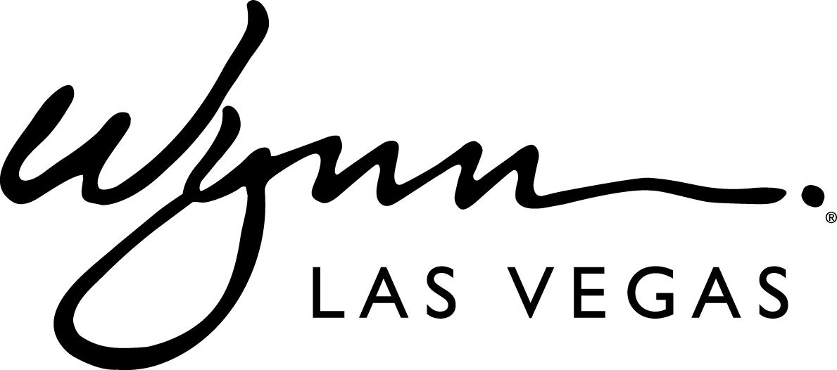

FOR IMMEDIATE RELEASE
November 25, 2013

Steve Wynn Unveils Floral Sculptures by Event Designer, Preston Bailey
A custom-designed hot air balloon and carousel debut at Wynn Las Vegas

LAS VEGAS — November 25, 2013 —As part of the resort’s continued commitment and appreciation of public art, Wynn Las Vegas unveils two floral installations conceptualized by acclaimed event designer, Preston Bailey. The visually stunning hot air balloon and animated carousel will indefinitely reside in the atrium at Wynn Las Vegas.

“All of us in the design and development area of our resorts are always trying to think of new things for the hotel. We love to have this place constantly changing; it makes it much more interesting for all of our guests who come frequently,” said Steve Wynn, Chairman and CEO of Wynn Resorts. “We explore natural things like water, sunshine and beautiful flowers. Preston Bailey is someone who brings life to our ideas and creates new and beautiful things. He is gifted, artistic and one of the most renowned and highly respected designers of floral displays.”
The installations were crafted by Wynn Design and Development and Forte Specialty Contractors. Constructed with a core made of fiber-reinforced plastic, the sculptures are adorned with more than 110,000 flowers, artistically arranged in a vibrant color palette. The hot air balloon stands 20 feet tall and weighs 4,000 pounds, while the carousel is 13 feet tall, 16 feet wide and weighs 6,000 pounds. Both installations feature theatrical lighting and are accompanied by festive music. In total, more than 3,500 hours went into completing the installations.

When developing the concept of the floral sculptures, Bailey looked to childhood inspirations to play upon the existing whimsical theme of the Wynn atrium. Having always been fascinated by the magic of a carousel and the imposing imagery of a hot air balloon, Bailey translated that captivation into floral interpretations that could live forever in the memories of guests visiting Wynn Las Vegas.

“With this installation, I’m excited to expose my work to a much wider public audience for all to enjoy and to find their own inspiration in,” said Bailey. “After being approached by Mr. Wynn to design these sculptures, I thought it would be ideal to create something dramatic out of flowers. I use them as my clay, molding them into something distinctive and awe-inspiring.”

The new floral sculptures complement the existing décor elements within the Wynn atrium, which was designed to create a soft, lush atmosphere that acts as a decompression zone as guests enter the resort. The atrium is home to 50 year old Ficus trees that are surrounded by ten different species of dark and light green base plants. Floral sculpture balls, consisting of nearly 50,000 flowers, hang from the Ficus trees in a combination of colors and sizes. Every three weeks, more than 5,000 seasonal flowering plants are replaced in color palettes matching the season, creating an ever-changing space for guests to enjoy.

About Preston Bailey
Globally-celebrated for his unique ability to transform ordinary spaces into lush, theatrical environments, Preston Bailey is known as the premier event designer for a client roster that includes celebrities, royal families, CEO’s and athletes. Known for his ability to transform the dreams of his clients into reality, Bailey is often sought out to create never-seen-before designs that serve as backdrops for some of the most memorable moments of their lives. In addition to his events, Preston is a sought-after artist who has been commissioned to create public art installations in London, Taipei, Hong Kong, New York, and Jakarta.
Preston Bailey is the author of five bestselling books: Design for Entertaining, Fantasy Weddings, Inspirations, Celebrations and Flowers. He recently published his sixth book Dear Preston: Doing Business With Our Hearts in January of 2013. Preston is currently working on his seventh book, Designing With Flowers, due out in Spring of 2014.

For more information on Preston Bailey, visit www.prestonbailey.com or follow him on Twitter, @prestonrbailey.

Wynn Las Vegas
Wynn Las Vegas, a luxury hotel and destination casino resort located on the Las Vegas Strip features 2,716 luxurious guest rooms and suites, an approximately 111,000 square foot casino, 15 restaurants, a nightclub, spa and salon, an on-site 18-hole golf course, approximately 223,000 square feet of meeting space, an on-site Ferrari and Maserati dealership, and approximately 74,000 square feet of retail space.

Encore, an expansion of Wynn Las Vegas, opened on December 22, 2008. Encore is located immediately adjacent to Wynn Las Vegas and features a 2,034 all-suite hotel, approximately 72,000 square foot casino, 5 restaurants, 2 night clubs, a spa and salon, approximately 60,000 square feet of meeting space and approximately 27,000 square feet of upscale retail outlets.

The resorts feature an array of publicly displayed art, including works by the renowned Colombian artist Fernando Botero, Raoul Dufy, Miriam Schapiro, Frank Owen, Tim Bavington, Viola Frey, Kazumi Yoshida and Jeff Koons. For additional information on the resort, visit www.wynnpressroom.com or www.wynnlasvegas.com.

Photo and Video Assets
To download the HD version of the unveiling footage, Preston Bailey interview and photos of the floral installation, please visit www.wynnpressroom.com.

###
Media Contacts:
Deanna Pettit-Irestone, Wynn Las Vegas
702-770-2121 / deanna.irestone@wynnlasvegas.com

Preston Bailey:
Emily Mendez-Penate, Susan Magrino Agency
212-957-0396 / Emily.mp@smapr.com

