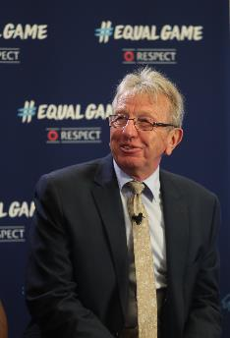
August 2017
Eddie Thomas - Wales

Eddie was born and raised in the town of Merthyr Tydfil in the South Wales valleys. He played for his country in the Welsh veterans’ team. Injuries and a busy work life forced him to quit playing. He has now discovered a new way to stay involved – ‘walking football’, which keeps him fit, active and in touch with friends. He particularly likes the team spirit forged in football.

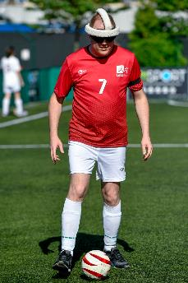
September 2017
Szabó István – Hungary

As a young blind boy from a small Hungarian village, István refused to let his limitations affect his love of football. Later in life he started, with a group of friends, a blind football team called Lass Budapest. He is the captain, while his wife is the team’s ‘mother’ – a caring, committed volunteer and coordinator who brings along the equipment, washes the kit and makes the players’ head protectors and eye masks by hand. A proud father, István eagerly awaits the day that he can teach his little boy all about football and why it means so much to him.

October 2017
Zehra Badem – Germany

Zehra, from Berlin, lives and breathes football, and says she can’t exist without it. Zehra plays for local club Türkiyemspor Berlin. She feels a sense of belonging there, and enjoys the family atmosphere. Her school studies are going well, and she hopes to go to university, perhaps to study law, achieve good results and enjoy a fulfilling life.

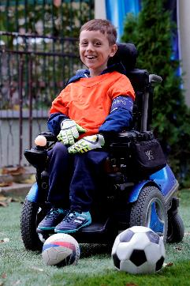
November 2017
Jane Velkovski – FYR Macedonia

Jane lives and breathes football. He plays the game whenever he gets the chance, whether it is at home or at school, and his eyes light up whenever he talks about his favourite sport. Jane’s determination to play football is even more impressive given the fact that he uses a wheelchair, having been diagnosed with spinal muscular atrophy. Jane, who lives in Skopje, the capital of FYR Macedonia, relishes every opportunity he gets to play the game, and is his team’s last line of defence in goal.

December 2017
Liam Davis – England

Liam plays in midfield for Cleethorpes Town, a Northern Premier League club in the eastern English county of Lincolnshire. He has loved football all his life, and came out as gay at the age of 18. He is the first openly male gay player to have played at Wembley Stadium. Coming from a loving, caring family, he has received a lot of warm support from his club, teammates, and supporters.

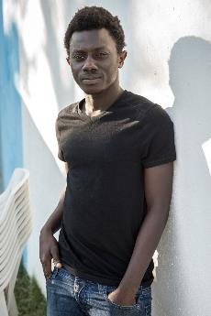
January 2018
Abubacarr Konta – The Gambia

Abubacarr left his African home in The Gambia to seek a fresh start in Europe. ‘Abu’ arrived in Sicily in February 2016, but to do so he had to face a tragic journey. He was relocated to the SPRAR centre in the town of Giammoro, on the northern Sicilian coast. The centre is home to a small group of youngsters who are attending Italian language classes and learning additional life skills like tree-planting, watering and cooking. However, there is also time to play football, an overriding passion since Abu’s childhood.

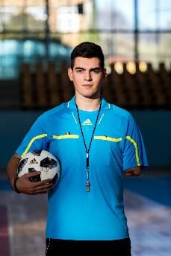
February 2018
Ljubomir Moravac – Slovenia

Football has been etched on Ljubo’s heart since he first played with a ball as a five-year-old in a village in his native Serbia.
Ljubo showed promise as a goalkeeper.
However, his young life was to change dramatically as he got involved in a car accident. Ljubo was seriously injured and lost part of his left arm. On his path to recovery, Ljubo has found relief in football. He has taken up refereeing, and is relishing the new challenge.

March 2018
Ramutė Kartavičienė – Lithuania

Ramutė is a natural-born leader who has always been fond of football. The sport plays a big part in family life and, inspired by her grandchildren, Ramutė is now sharing her love of the game with other women like her, having set up a grandmothers’ football team in the Lithuanian town of Keturvalakiai, some 170km from the capital, Vilnius. Ramutė has found her path in football and urges other people of all ages to do the same.

