|  |  |  |
| --- | --- | --- |
| sie_logo_black_rgb | Press | |
|  |
|  | Nuremberg, November 15, 2018 | |
| SPS IPC Drives 2018, Hall 11 | |

|  |  |
| --- | --- |
| Siemens AG  Communications  Head: Clarissa Haller | Werner-von-Siemens-Straße 1  80333 Munich  Germany |
| Reference number: PR2018110046PDEN | |

Industrial Security Appliances with extended functionality for even better network protection

* Bridge Firewall to protect flat networks
* Protection of Service Bridge and other applications
* User-specific firewall for individual protective measures
* Configuration now also possible in the new Sinec NMS management software

Siemens has extended the Scalance SC-600 Industrial Security Appliances to include more functionality for even better and simpler protection of production networks. The devices now have a Bridge Firewall, support redundant network structures, and allow user-specific firewalls. This enables users to increase the availability of their production while also reducing the procurement costs of network components.

The Bridge Firewall allows devices to be used in flat networks. Furthermore, not only Layer 3 but also Layer 2 data can now be filtered. This enables users to securely access automation components in Profinet cells for maintenance purposes, for example. Industrial Security Appliances can be used with the Service Bridge (a correspondingly configured Industrial Ethernet switch from the Scalance XC-200 product line) as well as with other applications.

The devices can also be integrated into redundant network infrastructures. Supporting two redundancy protocols for Layer 2 and Layer 3 eliminates the need for additional switches on the security transitions. The Media Redundancy Protocol (MRP) enables the SC-600 to be integrated on the Layer 2 level as Profinet devices in the Profinet ring redundancy without needing an additional managed Industrial Ethernet switch. In the event of a ring break, all network components in the ring switch to the redundant path within 200 ms and thus avoid a production stoppage in the event of a fault. Furthermore, the support of the Virtual Router Redundancy Protocol (VRRP) allows redundancy on Layer 3. This enables users to group the Scalance SC-600 together with other routers in the network in one logical group. If the router defined as the master fails, another router in the logical group takes over the function of the default router. The network consequently continues to communicate reliably.

The third innovation is support for user-specific firewalls. Specific firewall rules allow not only device-specific but also user-specific filtering of the data. This enables users to assign differing rights. Users consequently benefit from easier access management for network components.

Support of all device versions in the new Sinec NMS network management software allows the complete, uniform configuration of all the Scalance network components on a management platform. Use of the digital input together with the signaling contact allows, for example, the activation and deactivation of the VPN tunnel via the management platform for remote networks, Sinema Remote Connect.

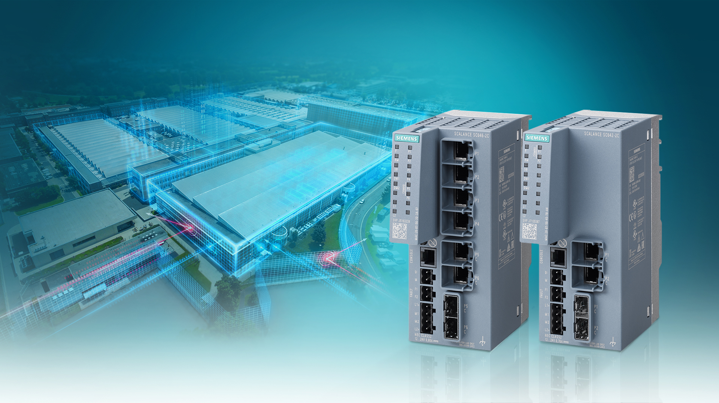

Siemens has extended the functions of the firmware of the new Scalance SC-600 Industrial Security Appliances. They now have a Bridge Firewall, support redundant network structures and allow user-specific firewalls.

You will find this press release and a press photo at [www.siemens.com/press/PR2018110046PDEN](http://www.siemens.com/press/PR2018110046PDEN)

Additional information on the topic of Industrial Security Appliances is available at: [www.siemens.com/scalance-s](http://www.siemens.com/scalance-s)

Additional information about Siemens at SPS IPC Drives 2018 is available at [www.siemens.com/sps-ipc-drives](http://www.siemens.com/sps-ipc-drives) and [www.siemens.com/press/sps2018](http://www.siemens.com/press/sps2018)

**Contact for journalists:**

Dr. David Petry  
Phone: +49 (9131) 72-6616; E-mail: [david.petry@siemens.com](mailto:david.petry@siemens.com)

Follow us on **social media**:

**Twitter**: [www.twitter.com/siemens\_press](http://www.twitter.com/siemens_press) and [www.twitter.com/SiemensIndustry](http://www.twitter.com/SiemensIndustry)

**Blog**: <https://blogs.siemens.com/mediaservice-industries-en>

.

**Siemens AG** (Berlin and Munich) is a global technology powerhouse that has stood for engineering excellence, innovation, quality, reliability and internationality for more than 170 years. The company is active around the globe, focusing on the areas of electrification, automation and digitalization. One of the largest producers of energy-efficient, resource-saving technologies, Siemens is a leading supplier of efficient power generation and power transmission solutions and a pioneer in infrastructure solutions as well as automation, drive and software solutions for industry. With its publicly listed subsidiary Siemens Healthineers AG, the company is also a leading provider of medical imaging equipment – such as computed tomography and magnetic resonance imaging systems – and a leader in laboratory diagnostics as well as clinical IT. In fiscal 2018, which ended on September 30, 2018, Siemens generated revenue of €83.0 billion and net income of €6.1 billion. At the end of September 2018, the company had around 379,000 employees worldwide. Further information is available on the Internet at [www.siemens.com](http://www.siemens.com).