2017 SIEMENS COMPETITION IN MATH, SCIENCE & TECHNOLOGY
National Finalists
INDIVIDUAL WINNERS:
- Brian Huang – Senior from Hunter College High School in New York, NY, resides in Fresh Meadows
Project: “On Sufficient Conditions for Trapped Surfaces in Spherically Symmetric Spacetimes”

- Kenneth Jiao – Senior from Indian Springs School in Indian Springs Village, AL, resides in Birmingham
Project: "Retain CHD7, an Epigenetic Regulator, in the Nucleus to Combat Breast Cancer Metastasis"

- Andrew Komo – Senior from Montgomery Blair High School in Silver Spring, MD, resides in Bethesda
Project: "Cryptographically Secure Proxy Bidding in Ascending Clock Auctions”

- Sriharshita Musunuri – Senior from Henry M. Jackson High School in Mill Creek, WA, resides in Mill Creek
Project: “Computational and Experimental Design of MIP Nanoparticles: A Novel Theranostic Solution to Detect and Neutralize Endotoxins”

- Franklyn Wang – Senior from Thomas Jefferson High School for Science & Technology in Alexandria, VA, resides in Falls Church, VA
Project: “Monodromy Groups of Indecomposable Rational Functions”

- Neil Wary – Senior from Illinois Mathematics and Science Academy in Aurora, IL, resides in Elmhurst
Project: “Connecting the Chromatin Remodeler CHD7 in the Regulation of CHARGE Syndrome and Autism”

TEAM WINNERS:

- Gabrielle Liu – Junior from Ravenwood High School in Brentwood, TN, resides in Nashville and Allen Liu – Senior from The McCallie School in Chattanooga, TN, resides in Chattanooga
Project: “Neural Networks without Multiplications”

- Jillian Parker – Junior at Half Hollow Hills High School West in Dix Hills, NY, resides in Dix Hills, Arooba Ahmed – Junior at Half Hollow Hills High School East in Dix Hills, NY, resides in Melville and Jiachen Lee – Junior at Half Hollow Hills High School East in Dix Hills, NY, resides in Dix Hills
Project: “The Cilium and Centrosome Associated Protein CCDC11 is Required for Cytokinesis via Midbody Recruitment of the ESCRT-III Membrane Scission Complex”

- Katherine Tian – Junior at The Harker School in San Jose, CA, resides in Cupertino and Swapnil Garg – Senior at The Harker School in San Jose, CA, resides in Sunnyvale
Project: "Automated Clear Cell Renal Carcinoma Grade Classification with Prognostic Significance"

- Chelsea Wang – Senior at Fossil Ridge High School in Fort Collins, CO, resides in Fort Collins, Rachel Li – Junior at Spackenkill High School in Poughkeepsie, NY, resides in Poughkeepsie and Jainil Sutaria – Senior at Ardsley High School in Ardsley, NY, resides in Ardsley
Project: "Synthesizing and Characterizing Novel Gelatin and Pluronic F127 Hybrid Hydrogels as a Barrier Membrane for Guided Bone Regeneration Following Periodontitis”

- Anlin Zhang – Senior at Canyon Crest Academy in San Diego, CA,
Rachana Madhukara – Sophomore at Canyon Crest Academy in San Diego, CA, and
Kevin Ren – Senior at Torrey Pines High School in San Diego, CA, all reside in San Diego
Project: “Epidemic Dynamics on Symmetric Networks”

- Brandon Zhu – Senior at Herbert Henry Dow High School in Midland, MI, and
Daniel Zhang – Senior at Herbert Henry Dow High School in Midland, MI, both reside in Midland
Project: " Release of Active Pharmaceuticals Using Capped Hyperbranched Polyesters”

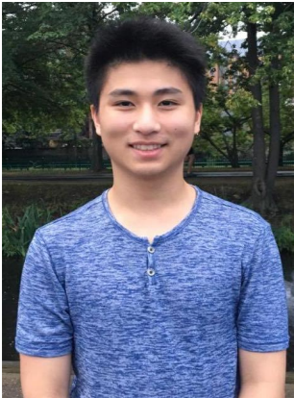
BRIAN HUANG
SCHOOL: Hunter College High School, New York, NY
YEAR: Senior
HOMETOWN: Fresh Meadows, NY
PROJECT: “On Sufficient Conditions for Trapped Surfaces in Spherically Symmetric Spacetimes”
FIELD: Mathematics
MENTOR: Dr. Marcus Khuri, Stony Brook University

“Math is an art form to me, and creating theorems upon theorems in order to build intricate logical structures within a field of mathematics is akin to constructing a philosophical theory, or creating the defining works of a literary or musical genre.”

Brian found new geometrical conditions under which a spacetime—the fusion of time and three-dimensional space—with spherical symmetry may form a trapped surface, an indicator of evolution into a black hole. Brian has been interested in mathematics since elementary school. His father, a mathematics Ph.D., installed a whiteboard in the living room that was used for countless family experiments. One Sunday morning, Brian’s father spurred him and his sister to ponder why any fraction had a terminating or repeating decimal, a question the they collectively solved on their whiteboard with numerical calculations. These experiments led Brian to want to explore mathematics at a young age.

For his Siemens Competition project, Brian explored an unsolved problem in general relativity called the Trapped Surface Conjecture which states that trapped surfaces can form in a spacetime from concentration of matter in a small enough volume. Trapped surfaces "seal the fate" of a spacetime into forming a black hole. This research progress on the Trapped Surface Conjecture is important because it sheds light on physical phenomena in extreme conditions of matter and gravity, and it ultimately helps us better understand the physical laws guiding the universe.

Brian attended the Program in Mathematics for Young Scientists (PROMYS) at Boston University for two years where he had a chance to learn college-level mathematics and conduct his first math research experiment.

Brian is also passionate about music composition due to its theoretical nature and has a deep appreciation for how something so mathematical can be abstracted through layers of timbre, texture, structure, dynamics, and rhythm to create an undefinable aesthetic piece. He enjoys playing golf because of the extreme technical difficulty of the swing as well as the slow strategic thinking required on the course.

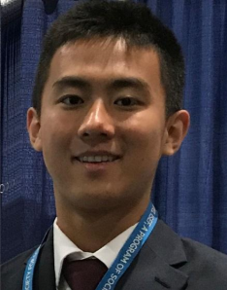
KENNETH JIAO
SCHOOL: Indian Springs School, Indian Springs Village, AL
YEAR: Senior
HOMETOWN: Birmingham, Alabama
PROJECT: “Retain CHD7, an Epigenetic Regulator, in the Nucleus to Combat Breast Cancer Metastasis”
FIELD: Biology
MENTOR: Lizhong Wang, Ph.D., University of Alabama at Birmingham School of Medicine

“The thing that excites me the most about STEM is the rapidly increasing number of new research techniques that are more time and cost efficient. For example, in my research, I got to use the CRISPR/Cas9 gene editing technique that was invented only a few years ago.”

Ken discovered a new gene which can be targeted to reduce breast cancer cells from spreading to other parts of the body. He decided to study breast cancer metastasis after hearing stories of lives ripped apart by the vicious disease and having his own family experience a breast cancer scare a few years ago. His mom was diagnosed with a breast tumor, and while he and his family were waiting for the test results to come back, he “felt the patients’ vulnerability and their families’ desperation. Luckily for Ken’s family, the tumor was benign but the experience inspired him to want to help create a future where nobody is vulnerable from breast cancer.

With his innate curiosity for figuring out how things worked which led him to the laboratory, Ken says that his thirst for research stems from his desire to make a positive impact on humanity through medicine.

At school, his favorite subject is Multivariable Calculus because it forces him to think about concepts in new abstract ways. He serves on student government and founded his school’s Science Olympiad Team where he has serves as co-captain.

Ken is most proud of receiving 3rd Place Grand Prize at the Intel International Science and Engineering Fair and guiding his school’s chess team as its captain to first place at the Alabama Scholastic State Championships twice.

Outside of the classroom and laboratory, Ken is an avid chess player ranked 28th in Alabama. He has run cross country for his high school’s varsity team all four years, qualifying three times for the state championship. Ken plays basketball and football with friends, listening to rapper Kendrick Lamar’s music, and he devours books, especially Agatha Christie novels. Ken is a fan of University of Alabama’s Crimson Tide football team. He would like to be a physician scientist so he can take his research in laboratories and directly apply it to patients.
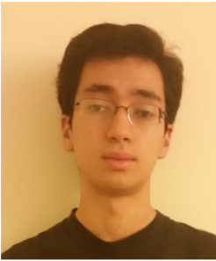
ANDREW KOMO
SCHOOL: Montgomery Blair High School, Silver Spring, MD
YEAR: Senior
HOMETOWN: Bethesda, MD
PROJECT: “Cryptographically Secure Proxy Bidding in Ascending Clock Auctions”
FIELD: Computer Science MENTOR: Lawrence Ausubel, Ph.D., University of Maryland

“I really like puzzles -- the more complex, the better. Cryptography in many ways is just a very complex and large puzzle.”

Growing up, Andrew Komo always liked puzzles -- the more complex and convoluted, the better. So, when he discovered cryptography, the field of creating and deciphering secret codes, he knew he wanted to pursue it.

Using cryptography, Andrew developed a coded system that protects online auction sellers from threats, such as cheating and fraud. His project is at the intersection of his favorite fields -- computer science, economics, and the study of human interaction.

Outside of his research, Andrew is the captain of his school’s computer team and economics club and is an avid tennis player. He was a finalist in the 2017 Moody's Mega Math Challenge, a national team-based math modeling competition, and came in third in the 2016 High School Forensics Challenge, one of the largest high school cybersecurity events.

Andrew hopes to pursue a career in designing new computer algorithms and protocols that will make the world a better place.

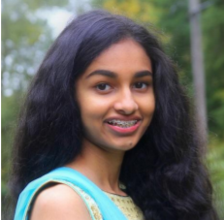
SRIHARSHITA MUSUNURI
SCHOOL: Henry M. Jackson High School, Mill Creek, WA
YEAR: Senior
HOMETOWN: Mill Creek, WA
PROJECT: “Computational and Experimental Design of MIP Nanoparticles: A Novel Theranostic Solution to Detect and Neutralize Endotoxins”
FIELD: Chemistry
MENTOR: Christopher Lausted, Institute for Systems Biology

“I strongly believe that most advances we make in the future will rely on the cross-pollination between wildly-different fields, and I'd love to be a part of that.”

Sriharshita designed a new polymer nanoparticle that captures bacterial toxins that could potentially treat and diagnose a deadly form of sepsis caused by gram-negative bacterial infections.

Curiosity was the initial draw for Sriharshita’s interest in science, which sparked her affinity for answering different questions she had about the world. Her interest in STEM was originally stimulated by a book called “Why is Snot Green?”, which introduced her to the breadth of knowledge that scientists could pursue.

Sriharshita is very active in school activities, leading the Technology Student Association, Science Research and Engineering, and Math Honor Society at her school. Through these clubs, she has had the chance to further develop her interests.

Sriharshita volunteers her time as the curriculum director of an organization called Girls Rock in Science and Math that aims to spark an interest in STEM amongst 3rd-5th grade girls. She is also the founder of a non-profit organization dedicated to raising sepsis awareness called InflammAid. Sriharshita had the amazing opportunity to work at the NASA Jet Propulsion Laboratory on their Advanced Thermal Energy Conversion team for an entire summer. She is also a Davidson Fellow Laureate which gave her the chance to speak with senators and representatives in Washington D.C. about her research.

Outside of science, Sriharshita has been learning and performing Bharatanatyam, a form of Indian classical dance, for the past 9 years. Sriharshita also speaks Telugu.

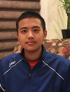
FRANKLYN WANG
SCHOOL: Thomas Jefferson High School for Science & Technology, Alexandria, VA
YEAR: Senior
HOMETOWN: Falls Church, VA
PROJECT: “Monodromy Groups of Indecomposable Rational Functions”
FIELD: Mathematics
MENTOR: Professor Michael Zieve, University of Michigan

“My favorite kind of mathematical result is one which claims to deduce a lot of information from very little. These results never fail to captivate me, since they are genuinely surprising and their proofs are often delicate works of art.”

Franklyn became interested in math in the 7th grade when he participated in the MATHCOUNTS National competition. To this day, his MATHCOUNTS coach, Mrs. Clark, remains an inspirational role model in Franklyn’s life as she is a dedicated and hardworking volunteer, spending countless hours with students.

Franklyn’s interest in math led him to address a problem that has puzzled mathematicians for almost 100 years. Building on several previous results, Franklyn’s work brings this problem near completion. His findings have a wide range of potential applications, from creating faster, more secure algorithms for telecommunication to designing safer infrastructure, like bridges resistant to strong winds.

Franklyn has participated in many math and science competitions. He was recognized as a finalist at the 2017 USA Computing Olympiad, placing him in the top 26 among all high school competitors in the country. Franklyn also serves as captain of his school’s National Science Bowl team, which placed 2nd at the national competition in 2017. He has participated on his school’s Physics team, where he has competed nationally, winning a USA Physics Olympiad Gold Medal in 2017.

Outside of math and science, Franklyn enjoys watching the New England Patriots and listening to Taylor Swift’s music. He hopes to be a researcher in math, computer science or economics, using artificial intelligence and machine learning to solve problems facing mankind.
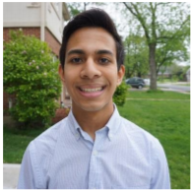
NEIL WARY
SCHOOL: Illinois Mathematics and Science Academy, Aurora, IL
YEAR: Senior
HOMETOWN: Elmhurst, IL
PROJECT: “Connecting the Chromatin Remodeler CHD7 in the Regulation of CHARGE Syndrome and Autism”
FIELD: Biology MENTOR: Kishore Wary, Ph.D., University of Illinois at Chicago

“STEM has the capacity to change the world. Why can't students be the ones to change the world?”

Neil’s project involved creating a new model using cutting-edge genome editing technology (CRISPR/Cas9) to research potential treatments for CHARGE syndrome (a rare genetic disorder that causes life-threatening birth defects), autism and cardiovascular diseases (CVD). He was particularly interested in exploring the less-understood causes of CVD and understanding the connection between other diseases and CVD.

Neil is passionate about biology and says “studying biology unquestionably helps us learn more about ourselves and how to live a better life. There are a lot of things we can't control in our lives, but our own health and body shouldn't be one of them.” One of his proudest accomplishments is having his research on epigenetic/regenerative biology published in the peer-reviewed scientific journal, PLOS ONE. When he grows up, Neil hopes to become a physician and scientist.

Neil is the director of his school’s STEM outreach program. The program has developed a mentoring program and created curriculum for workshops and summer camps. Members of the program volunteer to teach elementary and middle school students during workshops and in summer camps.

Outside of school, Neil plays the violin in the Chicago Youth Symphony Orchestra.

TEAM COMPETITORS

GABRIELLE LIU, Ravenwood High School, Brentwood, TN
ALLEN LIU, McCallie School, Chattanooga, TN
PROJECT: “Neural Networks without Multiplications”
FIELD: Computer Science
MENTOR: Peter Lowen, Ravenwood High School

Gabrielle and Allen developed a neural network architecture that runs faster than traditional neural networks by replacing multiplications with simpler operations. Neural networks are interconnected computer systems that use machine learning to progressively learn patterns and relationships in data. The research could lead to improvements in data processing speed and make artificial intelligence more accessible.

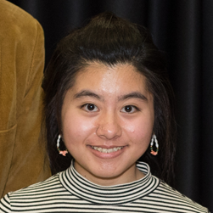
GABRIELLE LIU
YEAR: Junior
HOMETOWN: Nashville, TN

“The beauty of mathematics fascinates me, and I love to look for patterns among numbers. I also love the diversity of mathematics – there is always another problem to think about, another challenge to conquer.”

Gabrielle is most passionate about mathematics and artificial intelligence. She’s always enjoyed the process of discovery – testing her interests and theories through the scientific process. She has been sharing her research at science fairs since sixth grade. Gabrielle was named a Broadcom MASTERS semifinalist and won the Grand Prize at the Middle Tennessee Science and Engineering Fair. In 2017, she was recognized as a semifinalist at the USA Biology Olympiad and a finalist at the Intel International Science and Engineering Fair.

Gabrielle is a member of her school’s Forensics/Speech and Debate Team. In fact, one of her proudest accomplishments is her perseverance in advancing from last place in her very first speech tournament to placing top five in the statewide competition a year later. Gabrielle is also the founder and president of the Computational Biology Club, a volunteer in the Amateur Radio Emergency Service, and a member of the Nashville Fencing Club. In her spare time, she enjoys playing the violin/fiddle and tinkering with fashion.

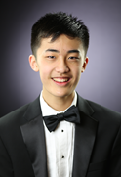
ALLEN LIU
YEAR: Senior
HOMETOWN: Chattanooga, TN

“I’m passionate about scientific research, but it all began with math competitions. The thousands of hours practicing problems and studying proofs endowed me with the passion for inquiry. Asking the ‘what if?’ and ‘why?’ questions, through the application of fundamental ideas, lead me to electrifying epiphanies.”

For Allen, math and music have always been connected pillars of his life. In fact, Allen first learned of the Siemens Competition while at a summer music program. Allen is a classically trained violinist and has performed at Carnegie Hall with the National Youth Orchestra. He has also served as concertmaster of the Tennessee All-State Symphony Orchestra, and he regularly organizes concerts and community projects as an intern with String Theory, a chamber music concert series based in Chattanooga that has performed across the country.

Allen’s interest in science has led him to placing in the Top 150 in the United States National Chemistry Olympiad. He is also the captain of his school’s Science Olympiad team and a founder and coach of a MATHCOUNTS team at a local middle school.

Outside of the classroom when he isn’t playing violin or listening to Tchaikovsky, his favorite composer, Allen serves as the President of his school’s Young Democrats Club and has volunteered for several local campaigns. He’s also a co-captain of the Mock Trial team, which placed 7th in the state of Tennessee.

TEAM COMPETITORS

JILLIAN PARKER, Half Hollow Hills High School West, Dix Hills, NY
AROOBA AHMED, Half Hollow Hills High School East, Dix Hills, NY
JIACHEN LEE, Half Hollow Hills High School East, Dix Hills, NY
PROJECT: “The Cilium and Centrosome Associated Protein CCDC11 is Required for Cytokinesis via Midbody Recruitment of the ESCRT-III Membrane Scission Complex”
FIELD: Biology
MENTOR: Dr. Ken-Ichi Takemaru, Stony Brook University

Jillian, Arooba and Jiachen discovered that when a particular protein is dramatically decreased in cells, cell division will not carry out properly which may have implications in different neurodegenerative diseases.
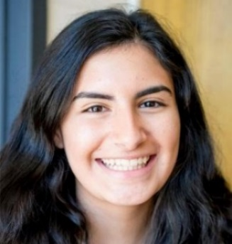
JILLIAN PARKER
YEAR: Junior
HOMETOWN: Dix Hills, NY

“I’ve been interested in science since age nine, when I used to watch ‘Grey’s Anatomy’ with my mom. Today, I’m most passionate about the area of cell division because of the role it plays in cancer and hope to be a doctor or researcher one day, too”

Jillian has been interested in the sciences since she started watching “Grey’s Anatomy” with her mom at the age of nine. It was being accepted into her school’s research program that solidified that passion for biology—specifically for the area of cell division and the role it plays in cancer. She hopes to be a doctor or researcher one day.

Jillian also has been dancing competitively individually and with her team since the age of 9 and is a member of her school’s community service club. Jillian also enjoys golfing and has been doing so from around the age of 7. She is also a member of her school’s Women in Science and Engineering (WiSE) Club, which she joined because of the underrepresentation of women in STEM fields and the encouragement and opportunities the club offers to young women. Jillian hopes through her exploration of the STEM field, she can become a role model to other young girls and encourage them to take interests in science or math as well.

Jillian’s Colombian culture also plays a large role in her life. She recently received a Hispanic Heritage award from her town which recognized her for her academic success as well as culture. Jillian also has a strong passion for community service and is a Girl Scout. Last year, Jillian and two of her peers earned their Silver Award, which was awarded after 50 hours of community service. Together, Jillian and her team worked to make young children’s hospital experiences more comfortable by spending time with them, creating decorations, and donating toiletries for their stays.

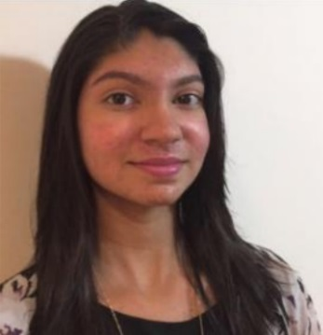
AROOBA AHMED
YEAR: Junior
HOMETOWN: Melville, NY

“I love biology, but I also love debate. They seem like opposites but are both really important and make me who I am. Discourse is very interesting and when it’s about science; I really get involved.”

Arooba was introduced to the sciences by her parents, who used to take her to numerous museums both near and far. As a child, she devoured National Geographic on TV and nonfiction books, and in school, her favorite subjects were always science because of the “real world applications and the natural phenomena.” One day, she’d like to be a cardiologist or researcher and loves the idea of working with others.

Arooba was an octo-finalist in the New York State Debate Tournament and is also in the Speech and Debate Club. She also draws and runs cross-country.

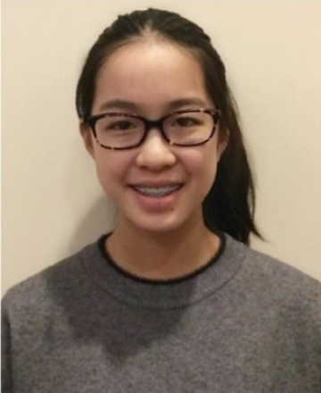
JIACHEN LEE
YEAR: Junior
HOMETOWN: Dix Hills, NY

“I have always been intrigued by the complicated puzzle that is life. And ever since I was told as a child that if the brain were as large as the sun, it would contain more energy than the sun, I’ve been captivated by the workings of the human body.”

Jiachen has been fascinated by the way the world works since she was a young child and overwhelmed with “the infinite opportunities to fuel my curiosities and discover new things.” She’s particularly interested in molecular biology and the vital molecules composing life and their roles in the formation of diseases.

Jiachen also runs track, does martial arts and plays the cello in her school orchestra.
TEAM COMPETITORS
KATHERINE TIAN, The Harker School, San Jose, CA
SWAPNIL GARG, The Harker School, San Jose, CA
PROJECT: “Automated Clear Cell Renal Carcinoma Grade Classification with Prognostic Significance”
FIELD: Bioinformatics
MENTOR: Jan Heng, Ph.D., Beth Israel Deaconess Medical Center, Harvard Medical School

Using computational techniques and machine learning, Katherine and Swapnil developed a way to classify kidney cancer tumors as high- or low-grade—an important indication of how fast the cancer might spread. This provides an extremely valuable second opinion for pathologists, helping them make more accurate diagnoses and thus better treatment plans.

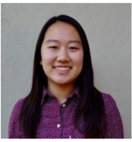
KATHERINE TIAN
YEAR: Junior
HOMETOWN: Cupertino, CA

“I’m really passionate about using STEM concepts to figure out how the world works—from proving abstract theory to understanding real-world phenomena.”

Ever since she was a young child, the creative insights and rigorous logic required of the science, technology, engineering and math subjects have fascinated Katherine. She began participating in math competitions in elementary school, and eventually used what she calls her “mathematical mindset” to branch out into programming, algorithms, physics and biology in middle and high school.

But it was the opportunity to attend a summer program in artificial intelligence (AI) at Stanford University that solidified her interest in scientific research—particularly the way she learned she could combine seemingly disparate areas like AI algorithms and classifying leukemia tumors.

When cancer struck both her great uncle and a beloved family friend, she was inspired to join scientists working to combat the disease—channeling her interest in programming and AI to help make cancer diagnosis more accurate and efficient.

Someday, Katherine would like to pursue a career in applied math, machine learning and AI. Katherine has competed in the platinum level in the USACO (USA Computing Olympiad), qualified for the USAJMO (USA Junior Mathematical Olympiad) and the USAPHO (USA Physics Olympiad). She is co-president of the programming club, vice president of the math club, and a research mentor. She also plays violin, dances, swims and runs.
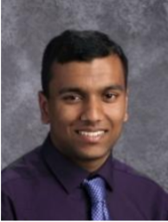
SWAPNIL GARG
YEAR: Senior
HOMETOWN: Sunnyvale, CA

“I’m most passionate about math—what’s really cool about it is that you can use it to find patterns, and what often starts out as complicated problems can be reduced to simple formulas.”

Swapnil was inspired to pursue this research when he saw how dependent cancer treatment was on something as prone to human error as the type of tumor classification. He wanted to develop an automated way to determine what type of treatment to pursue, and used his lifelong love of math to guide the way.

Swapnil has been passionate about math since he joined the MATHCOUNTS club in middle school. Today he is fascinated with its patterns, formulas and theories and generally just finds that it “clicks” with him. Indeed, he received an honorable mention on the USA Math Olympiad and coaches his math club’s Princeton University’s math competition team. He would like to be a math researcher one day.

Swapnil also cofounded the Science Competitions Club, is the co-president of the Quiz Bowl, a member of the Science Bowl, the Programming Club, the Linguistics Club, the Philosophy Club, and was a top 10 finalist for the USA Computing Olympiad. He also plays trumpet in his high school orchestra and tennis.
TEAM COMPETITORS

CHELSEA WANG, Fossil Ridge High School, Fort Collins, CO
RACHEL LI, Spackenkill High School, Poughkeepsie, NY
JAINIL SUTARIA, Ardsley High School, Ardsley, NY
PROJECT: “Synthesizing and Characterizing Novel Gelatin and Pluronic F127 Hybrid Hydrogels as a Barrier Membrane for Guided Bone Regeneration Following Periodontitis”
FIELD: Materials Science
MENTOR: Miriam Rafailovich, Ph.D., Stony Brook University

Chelsea, Rachel and Jainil developed a novel gel compound that can be used to help regenerate the bone surrounding the root of teeth that has been damaged or degraded due to periodontitis, an infection of the gums that damages and destroys soft tissue and bone.

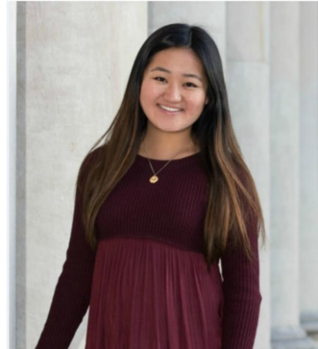
CHELSEA WANG
YEAR: Senior
HOMETOWN: Fort Collins, CO

“My favorite part about STEM is the power it gives to us as individuals. STEM doesn't discriminate on the grounds of background or age; it gives every person an equal ability to discover something that could change our world, as long as that person has the creativity to find a new solution to the problem.”

As a young kid, Chelsea’s fascination with science began with making baking soda and vinegar volcanoes and her favorite days were the ones spent at the science museum. As she’s grown, she has seen her family members suffering from periodontitis, the painful infection of the gums that damages teeth and she saw an opportunity to apply her love of science to a problem that afflicted those close to her.

Chelsea is the president of her school’s Science Olympiad team and a two-time national medalist, finishing 3rd and 4th at the Science Olympiad National Tournament, and she works actively to engage elementary and middle school-aged kids involved in STEM. She serves as secretary of the Science National Honor Society and secretary of the Future Business Leaders of America and won the State competition for Global Business.

Chelsea plays the violin and is on her high school’s golf team. Her favorite book is The Great Gatsby, and she enjoys listening to the music of American rapper Kendrick Lamar. She looks up to Malala Yousufzai for her strength and courage in the face of adversity. She hopes to pursue a M.D./Ph.D. degree in college and become a neurologist.
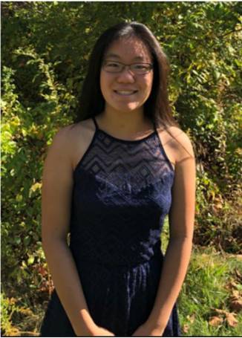
RACHEL LI
YEAR: Junior
HOMETOWN: Poughkeepsie, NY

“What I like most about STEM is that it is everywhere around us; the opportunities are bountiful and the possibilities endless. With research in particular, I’m excited by the continuous quest towards understanding and improving the world.”

From middle school biology to AP chemistry class to college-level computational neuroscience courses she takes at the Columbia Science Honors Program, Rachel has always been fascinated learning about everything from biological processes to molecular interactions, and deep neural networks. She recognizes science’s ability to solve problems in the world around her and to end people’s suffering. Because her uncle suffered tooth loss from dental disease, Rachel was inspired to research ways to help people with periodontitis.

Rachel is actively involved in her school’s Science Olympiad team since the 7th grade, placing in events such as Materials Science, Chemistry Lab, Rocks and Minerals, and Invasive Species at both the state and invitational levels. Apart from her scientific endeavors, Rachel enjoys playing the violin, piano, and tennis as well as volunteering in her local community. She has been accepted into Area All-State and AllState Orchestras and was selected as Junior High All-County Concertmaster two years in a row.

Rachel is also on her school’s varsity tennis team, winning second place in the Mid-Hudson Athletic League Singles Championship. She helps organize and lead a team to host her local community’s Annual Chinese New Year Celebration, with the goal to give back to her community and promote Chinese culture. Rachel looks up to her older brother, Vincent, who inspires her to always be the best version of herself.

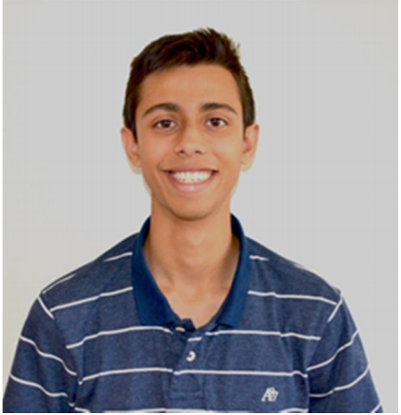
JAINIL SUTARIA
YEAR: Senior
HOMETOWN: Ardsley, NY

“I'm drawn to STEM because of its endless nature. STEM symbolizes the multiple levels of infinite, where there's always an infinite number of things to learn about the infinite topics that are out there.”

Jainil has been involved in STEM and doing research his entire life. His first project was an invention in his elementary school’s “Young Inventors” program, where he created a pen with ink, pencil graphite and an eraser all in one tool. He has followed his interest in STEM and has twice won silver medals at the International Genius Olympiad. He also founded, and is president of, his school’s robotics club, and is a co-president of “Ardsley Innovates,” a club aimed at teaching the novelties of technology to students.

Jainil plays percussion in his school’s jazz band and wind ensemble and has played in the All-County and Area All-State bands. He has also earned All-League and All-Section honors for fencing, and he competed at the Junior Olympics for fencing in 2017.

He speaks Gujarati, French and Hindi, enjoys watching the Yankees play and looks up to his mother, father and older sister.
TEAM COMPETITORS

ANLIN ZHANG, Canyon Crest Academy, San Diego, CA
RACHANA MADHUKARA, Canyon Crest Academy, San Diego, CA
KEVIN REN, Torrey Pines High School, San Diego, CA
PROJECT: “Epidemic Dynamics on Symmetric Networks”
FIELD: Mathematics MENTOR: Dr. Laura Schaposnik, University of Illinois at Chicago

Anlin, Rachana, and Kevin created a new mathematical model to more precisely analyze the spread of infectious disease.

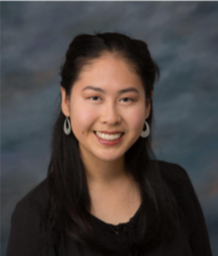
ANLIN ZHANG
YEAR: Senior
HOMETOWN: San Diego, California

“My parents discussed their work in computer science and biology at the dinner table when I was a child. They mentioned different enzyme pathways and algorithms behind their programs, which left me fascinated.”

Anlin loves math. Her 9th grade math teacher sealed the deal for her when he exposed her to the endless possibilities behind every math problem. She qualified for the USA Math Olympiad, and she also mentors local elementary and middle school students in the Science Olympiad programs.

Anlin is the president of her high school’s Girls @ Expii, an initiative to encourage girls’ growth in math. She is also president of the Linguistics club and an officer of the Math Team, Girls Learn International, and Human Rights Club. Anlin enjoys dancing, playing piano and drawing.

She hopes to pursue a career in applied math, such as statistics, biomathematics and computational math because she wants to use her math skills to make a real-world impact.

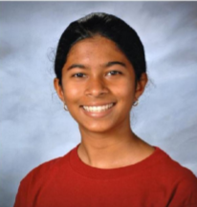
RACHANA MADHUKARA
YEAR: Sophomore
HOMETOWN: San Diego, California

“What I like most about mathematics is that it teaches you problem solving skills. No matter how difficult the problem, there’s always a (clever) way to solve the problem.”

Rachana wants to be a math pioneer just like her role model, Sophie Germain, one of the first women mathematicians. For her Siemens competition project, she used numerous number theory and complex analysis techniques to improve the way to model the spread of infectious diseases.

Besides her interest in math, she is an avid fencer, plays the violin, sings Indian Classical Carnatic music, and works with children who are disabled. She took first place and received a scholarship in the Mathematics Senior Division of the California State Science Fair, and she was a Broadcom Masters semifinalist. She speaks Kannada, Spanish, and reads Braille.

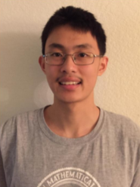
KEVIN REN
YEAR: Senior
HOMETOWN: San Diego, California

“Math is beautiful. One of the reasons why I gave up video games was because math problems were more fun and numerous. Once you beat all the levels of a game, you are finished; once you solve all the problems of a math contest, you can move on to the next year of the contest.”

Kevin’s first exposure to STEM was from his grandmother who is a driving force in his life. They used to sit together for hours doing math problems from Chinese textbooks ranging from elementary school math to calculus. She trained his critical thinking and problem-solving abilities in ways, he says, were not tested in the classroom.

Kevin says you need a certain ingenuity and depth of thought to solve a Math Olympiad problem. He says that once you solve it, the feeling of satisfaction is “richly rewarding, just like the feeling of exhilaration and conquest one gets from climbing Mount Everest.” After being friends for years, he teamed up with Anlin and Rachana over the summer for their research project. He liked the idea of using graph theory tools to attack a problem with real-world applications.

His middle school teacher, Mr. Vaughn, inspired his math talent and motivated him to give back to the community. Kevin has become a teacher giving younger students the gift of passion for math. Kevin also enjoys physics, Quiz Bowl, chess, piano, swimming, and basketball. One day, he hopes to be a mathematics professor.

TEAM COMPETITORS

BRANDON ZHU, Herbert Henry Dow High School, Midland, MI
DANIEL ZHANG, Herbert Henry Dow High School, Midland, MI
PROJECT: “Release of Active Pharmaceuticals Using Capped Hyperbranched Polyesters”
FIELD: Chemistry
MENTOR: Patrick Smith, Ph.D., Michigan State University

Daniel and Brandon developed a method for releasing drugs at a controlled rate into the body, which could increase the effectiveness of many pharmaceuticals.

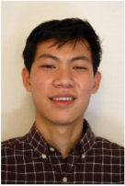
BRANDON ZHU
YEAR: Senior
HOMETOWN: Midland, MI

“I'm most passionate about leaving a positive impact on the community around me. One reason I think we were successful in our research was because we knew what a great thing it could be for the people around us.”

Brandon grew up surrounded by STEM and becoming a scientist always seemed natural to him. He remembers as a child listening to his father talk about his latest research and thinking that someday he would do the same. Brandon is fascinated by chemistry and thinks there is so much to learn it cannot possibly become boring. As a career, Brandon is drawn to the human aspect of working as a physician but also wants to make new scientific discoveries that will change the world for the better.

Brandon found his research interesting because it was easy to see its clear applicability to the pharmaceutical industry. Many of the active pharmaceuticals used during their research were extremely common including naproxen, salicylic acid, and hydrocortisone.

With a strong passion for helping others, Brandon spends his time volunteering with his student council, Big Brother Big Sister, and Key Club. One of his proudest moments was winning the prestigious A.H. Nickless Innovation Award, bringing $20,000 to his high school for STEM. He also helped win the District Chairman's Award for his school’s robotics team in the international FIRST Robotics Competition.

In his spare time, Brandon also plays competitive soccer and basketball. His favorite sports team is the Detroit Pistons and his personal role model is basketball player Jeremy Lin.

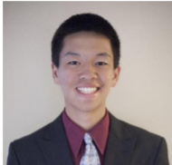
DANIEL ZHANG
YEAR: Senior
HOMETOWN: Midland, MI

“What's important to me is that I'm always doing something to improve the world.”

For as long as he can remember, Daniel has had a passion for STEM subjects, ranging from chemistry to biology to math to computer science. He enjoys the challenge and feels that there’s always something new he can learn.

As a high school senior, Daniel is an AP Scholar with Distinction and top honor roll student. He has played varsity tennis for four years and recently won state individual and team titles for his school. He is also a member of his school’s robotics team and plays the violin.

Daniel’s favorite athlete is tennis player Rafael Nadal because of the energy he puts into every match and his will to win. His role model is his older brother, Steven, who has always been hardworking, kind, and never afraid to try new things like dancing.

