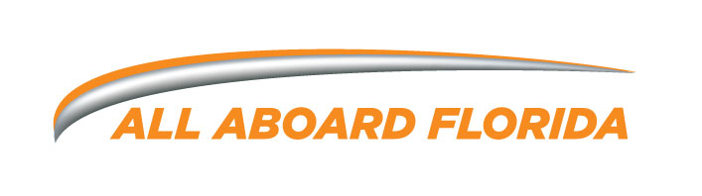
FACT SHEET

WHAT: All Aboard Florida will be the nation’s first privately owned, operated and maintained intercity passenger rail service operating between Miami and Orlando with intermediate stations in Fort Lauderdale and West Palm Beach. This more than $3 billion infrastructure and real estate project will transform the way Florida’s visitors and residents travel between two of the state’s most populated and visited regions by providing an excellent customer experience and using advanced, conventional technology.

WHO: All Aboard Florida – Stations LLC and All Aboard Florida – Operations LLC are wholly-owned subsidiaries of Florida East Coast Industries, LLC (FECI). All Aboard Florida – Operations LLC owns the easement right to develop and operate passenger rail service in the existing rail corridor owned by the Florida East Coast Railway.

WHEN: Service between Miami and West Palm Beach will be operational by the end of
2016. The extension to the Orlando International Airport will be operational by
early 2017.

WHERE: The service will utilize 195 miles of the existing Florida East Coast Railway Corridor between Miami and Cocoa and approximately 40 miles of new infrastructure will be constructed paralleling the State Road 528 right of way between Cocoa and the Orlando International Airport. The service will stop in the downtowns of Miami, Fort Lauderdale and West Palm Beach, with the Central Florida station to be located at the Orlando International Airport’s new Intermodal Terminal.

WHY: For more than 20 years, there has been a growing demand for express rail service connecting South and Central Florida. All Aboard Florida will meet that need and offer a product and guest experience that is a no-compromises alternative to flying or driving. The corridor is home to almost 50 percent of Florida’s 19 million residents, and more than 50 million annual trips occur between the four major cities where stations will be located. All Aboard Florida and the planned transit oriented development will catalyze growth, revitalize local economies, spur tourism and generate tens of thousands of new construction and permanent jobs.

HOW
MUCH: The pricing structure is still under development, but tickets will be competitive
with other types of transportation traveling the same corridor.

ABOUT THE SERVICE

TRAVEL
TIME: Service between Miami and Orlando will take just less than three hours, representing a time savings of 25 to 30 percent compared with existing travel options.

SCHEDULE: All Aboard Florida will offer hourly scheduled service, starting in the early morning and ending in the evening to meet travelers’ transportation needs. All Aboard Florida will also schedule service to coincide with special events.

STATIONS: The planned route will include stations in the downtowns of Miami, Fort Lauderdale and West Palm Beach and the new Intermodal Station at the Orlando International Airport. Stations will be designed to serve as destinations within a destination, with retail, dining, hotel and entertainment experiences. All Aboard Florida is developing approximately 4 million square feet of transit oriented development around the south Florida stations that will include office, commercial and residential components.

Each station will also have intermodal connectivity options, like connections to existing and future transit systems, rental cars and car sharing programs.

AMENITIES
& SERVICES: The new passenger rail service will provide premium amenities, including reliable Wi-Fi, high quality meal and beverage offerings and multiple seating options. Additionally, each train will be fully equipped with easy-on/easy-off baggage compartments. The passenger coaches, will be state-of-the-art, ADA compliant and designed for comfort, featuring special ergonomic seating. The train sets will also be level boarding, which allows for the ease of boarding without steps and provides easier access for bikes, walkers, strollers and wheelchairs.

TRAIN
OFFERINGS: Siemens, a major provider of rail in the U.S. since the 1980’s, will build the locomotives and passenger coaches for the All Aboard Florida passenger rail project. The five initial trainsets will consist of two diesel-electric locomotives, one on each end of four passenger coaches. These diesel-electric locomotives will meet the highest emissions standards set by the federal government. The train sets will be expanded with the extension to the Orlando International Airport, consisting of seven coaches and the purchase of five expanded train sets.
About Siemens: Siemens designs and manufactures globally, across the entire spectrum of rolling stock including commuter and regional passenger trains, light rail and streetcars, metros, locomotives, passenger coaches and high-speed trainsets. Siemens employs over 362000 people globally and more than 4,800 in the state of Florida.
Media Contacts:
Ali Soule
Public Affairs Manager, All Aboard Florida
305-520-2105 or ali.soule@allaboardflorida.com

Rosalie Hagel
Senior Partner, M Silver // A Division of Finn Partners
954-765-3636 or AllAboardFlorida@FinnPartners.com

