NEWS RELEASE

2016 Rotary International Convention
opens with 50,000 registrants from 160 nations

Ban Ki-moon UN Secretary-General, Hwang Kyo-ahn Prime Minister deliver opening plenary address
GOYANG CITY, Korea (29 May 2016) Ban Ki-moon, United Nations (UN) Secretary-General addressed nearly 50,000 Rotary members from more than 160 countries at the open of the humanitarian service organization’s 107th annual international convention at KINTEX.
Ban Ki-moon, UN Secretary-General said, “Rotarians do remarkable work around the world. Our two organizations have a long productive history. Rotarians even helped with the founding of the United Nations.” He also thanked Rotary members for their contributions to eradicating polio – Rotary’s top humanitarian goal, and said, “The United Nations is proud to be a partner in ending this debilitating disease.”

Often described as a “mini-United Nations” because of its global scope and cultural diversity, the Rotary convention has transformed KINTEX, Goyang, into a kaleidoscope of energy, color and excitement with member registrants engaging in a full agenda of plenary sessions, workshops and a lineup of world class keynote speakers, including:
- PSY, K-POP superstar
- Ranil Wickremesingne, Prime Minister of Sri Lanka.
- Gary Knell, President and CEO, National Geographic Society
- Dananjaya Hettiarachichi, Toastmasters International World Champion of Public Speaking
- Dr. Rebecca Martin, PhD, Director of the Center for Global Health at the US Centers for Disease Control and Prevention on the effort to end polio worldwide.
Rotary clubs address community needs at home and connect with clubs around the world to tackle humanitarian challenges abroad, including; fighting disease, providing clean water, supporting education, growing local economies, saving mothers and children and promoting peace. On display in Rotary’s “House of Friendship” in KINTEX will be hundreds of service projects that demonstrate Rotary’s commitment to improving lives and creating lasting positive change worldwide.
Organized by Rotary International in conjunction with the Seoul Host Organization Committee comprised of local Rotary members, and with significant support from the Central Government as well as local governments, the convention will provide registrants with ample opportunities to savor Korea’s myriad attractions, including an expansive number of parks, museums, shopping centers, restaurants, and the now-famous Gangnam district. Most popular tourist attractions to be visited by the Rotary convention participants include DMZ, World Heritage Palace, and Gangnam Fashion Street.
The Korea Tourism Organization estimates that the Rotary convention will bring KRW 292.5 (₩292,492,284,583) to the local economy and create 1,800 jobs.
Seoul is home to the first Rotary club established in Korea, chartered in 1927. Today, Korea is the fourth largest Rotary club country with 1,625 clubs and 64,149 members who support an array of local and international service initiatives, including; health programs for infants and toddlers with critical illness and chronic conditions, a multilingual library for children to help bridge local cultures, and environmental projects to help reduce the adverse health effects of Yellow Wind dust storms.
Rotary clubs in Korea also continue to support the organization’s top philanthropic goal of eradicating polio. Since 1985, Rotary has contributed more than KRW 1.4 trillion (US$1.5 billion) and countless volunteer hours, with Korean Rotary clubs donating more than KRW 146 million (US$ 14.6 million) to polio eradication. In addition to contributing funds, Korean Rotary members have traveled at their own expense to immunize children against polio in India.
About Rotary
Rotary brings together a global network of volunteer leaders dedicated to tackling the world’s most pressing humanitarian challenges. Rotary connects 1.2 million members of more than 35,000 Rotary clubs in over 200 countries and geographical areas. Their work improves lives at both the local and international levels, from helping families in need in their own communities to working toward a polio-free world. To access broadcast quality video footage and still photos go to: The Newsmarket.
###
Contacts:
Howard Chang (U.S.A.): +1 847-866-3408, howard.chang@rotary.org
Katie In (Korea): +82 2 2022 8271, katie.in@edelman.com
Kate Yun (Korea): +82 2 2022 8271, kate.yun@edelman.com

PHOTO RELEASE
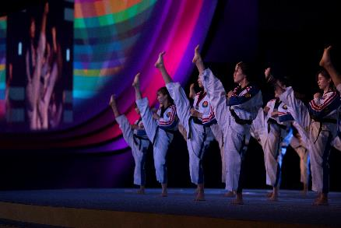
[Photo 1] May 29th, 2016 – Korean traditional performance Taekwondo is shown to the 2016 Rotary International Convention. Ban Ki-moon, UN Secretary-General, Prime Minister Hwang Kyo-ahn and the President of Rotary International K.R. Ravindran also delivered remarks. The 2016 Rotary convention - May 28 to June 1 at KINTEX, Goyang City – is attended by 50,000 Rotary members from 160 nations - making it the most multi-cultural (non-profit) gathering in Korea.
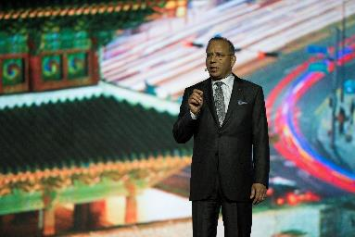
[Photo 2] May 29th, 2016 – President of Rotary International K.R. Ravindran is giving congratulatory remarks at the Opening Plenary of 2016 Rotary International Convention. Ban Ki-moon, UN Secretary-General, and Prime Minister Hwang Kyo-ahn delivered keynote remarks. The 2016 Rotary convention - May 28 to June 1 at KINTEX, Goyang City – is being attended by 50,000 Rotary members from 160 nations, making it the most multi-cultural (non-profit) gathering in Korea.

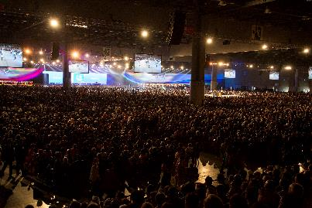
[Photo 3] May 29th, 2016 – Opening Plenary of 2016 Rotary International Convention was held on May 29th at KINTEX, Goyang City. Rotary International President K.R. Ravindran, UN Secretary-General Ban Ki-moon and Prime Minister Hwang Kyo-ahn delivered keynote remarks. The 2016 Rotary convention - held from May 28 to June 1 at KINTEX, Goyang City - is being attended by 50,000 Rotary members from 160 nations, making it the most multi-cultural (non-profit) gathering in Korea.

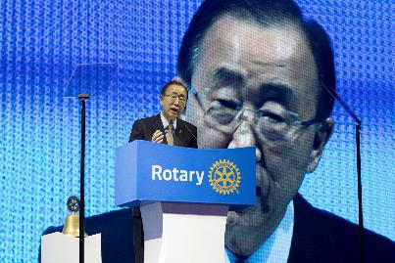
[Photo 4] May 29th, 2016 – Ban Ki-moon, UN Secretary-General delivered keynote remarks at the opening plenary of 2016 Rotary International Convention. Rotary International President K.R. Ravindran and Prime Minister Hwang Kyo-ahn also delivered remarks. The 2016 Rotary convention - May 28 to June 1 at KINTEX, Goyang City - is being attended by 50,000 Rotary members from 160 nations, making it the most multi-cultural (non-profit) gathering in Korea.

