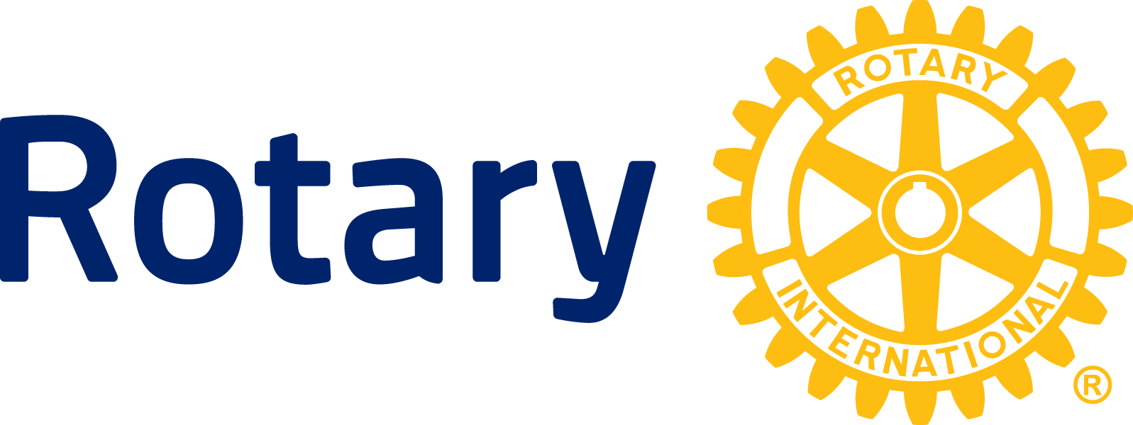

NEWS RELEASE

Rotary, Aga Khan University announce first graduating class in scholarship program aimed at reducing infant and maternal deaths in East Africa

NAIROBI, Kenya. (February 12, 2014) — With more than 50 percent of women in the developing world delivering babies without the assistance of skilled health personnel, Rotary, a global humanitarian service organization; and Aga Khan University (AKU), a private non-denominational university; are together increasing access to trained health professionals for mothers and infants in East Africa.

The first class of 24 Rotary-sponsored scholars will graduate this month from AKU’s campuses in East Africa, in Kenya, Tanzania and Uganda with Bachelor of Science degrees in Nursing, or Diplomas in General Nursing.

“In rural Kenya, having a nurse or midwife present during childbirth can mean the difference between life and death,” said Geeta Manek Rotary member from Nairobi. “This class of highly trained nurses will help ensure that mothers and their infants receive the best health care possible.”

Having worked as a nurse at the Kenyatta National Hospital before joining the AKU, graduate Annet Kiring’wa of Kenya said she entered the nursing program to “enhance my academic and professional abilities and learn new technologies and innovations in health care to better serve my clients”.

In sub-Saharan Africa, a woman’s risk of maternal death is 1 in 30, compared to 1 in 5,600 in developed countries according the United Nations. The same region records the highest childhood mortality rates, with 1 in 7 dying before their fifth birthday. Worldwide, more than 9 million children under 5 die each year.

Nurses and midwives are critical to the delivery and quality of health care in Africa. From rural villages to urban slums, nurses and midwives are able to serve large numbers of women, often without the assistance of doctors. They are at the front line of the battle against HIV/AIDS, infant and maternal mortality, infectious diseases, and other treatable and preventable medical problems that, unaddressed, can destroy lives, disrupt families and hold back the economic growth of entire communities.

To help, The Rotary Foundation – the charitable arm of Rotary International – began a strategic partnership with AKU in 2011, providing grants to Rotary clubs to establish volunteer teams to support the professional development of nursing faculty at AKU’s East Africa campuses in Kenya, Tanzania and Uganda. The teams work with local Rotary clubs and AKU to carry out community service projects linking the classroom lessons to the real-life conditions in local clinics and health care programs. Rotary grants also fund nursing and midwifery scholarships for students admitted to AKU’s School of Nursing and Midwifery program. Scholarship recipients also have the opportunity to be mentored through the program by local Rotary clubs.

About Aga Khan University

Aga Khan University (AKU) is a private, nonprofit university that promotes human welfare and development through research, teaching, and community service initiatives. AKU operates 11 campuses and teaching sites in eight countries across East Africa, the Middle East, south and central Asia, and Europe. The university’s curriculum in nursing, medicine, and educational development reflects the unique needs of the communities and countries where the university operates.

About Rotary

Rotary brings together a global network of volunteer leaders dedicated to tackling the world’s most pressing humanitarian challenges. Rotary connects 1.2 million members of more than 34,000 Rotary clubs in over 200 countries and geographical areas. Their work improves lives at both the local and international levels, from helping families in need in their own communities to working toward a polio-free world. For more information, visit Rotary.org. For images and video, visit www.thenewsmarket.com/rotaryinternational.

###

Contacts: Stéphanie Tobler Mucznik (Switzerland) - Stephanie.Tobler@rotary.org
41-44-387-7116

Joe Otin (Kenya) - joe.otin@outlook.com
+254 72-2701530

Kimberly Dunbar (US) – Kimberly.dunbar@rotary.org
(847) 866-3469

