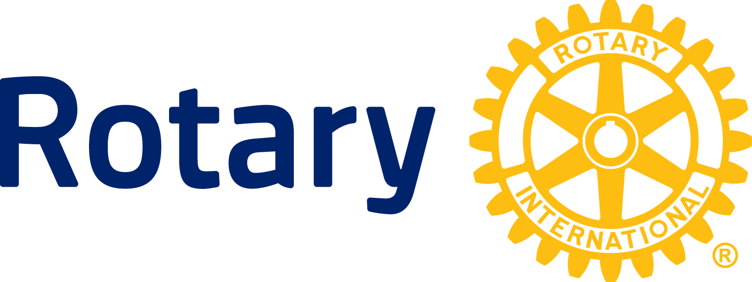

NEWS RELEASE

Rotary celebrates India’s third straight polio-free year

Humanitarian organization says disabling virus now must be stopped in neighboring Pakistan; as well as Afghanistan and Nigeria

EVANSTON, Ill. (10 Jan. 2014) — Rotary members worldwide are celebrating a major milestone in the global effort to eradicate polio: India, until recently an epicenter of the wild poliovirus, will mark the third anniversary of its last recorded case of the paralyzing infectious disease on 13 Jan.

On the same day in 2011, a two-year old girl suffered polio paralysis in Howrah district of West Bengal. Since then, India has not reported any new cases of wild poliovirus.

Leaders of the humanitarian service organization see the 13 Jan. milestone as a testament to the determination of its international membership of 1.2 million men and women – and especially the 122,000 Rotary members in India – to eradicate polio through the mass immunization of children, a goal Rotary took on in 1985.

In celebration of the decades-long battle and ultimate victory over this disabling disease in India, Rotary clubs throughout the country will illuminate landmarks and iconic structures on Jan. 13. India Gate in Delhi and Red Fort in Delhi and Agra are among the structures that will carry Rotary’s dramatic message – ‘India is Polio Free’.

The three-year achievement also sets the stage for the polio-free certification of the entire South East Asia Region of the World Health Organization in the first quarter of 2014 by the Regional Certification Committee. The Indian government also plans to convene a polio summit in February to mark the occasion.

Rotary says the challenge now is to replicate India’s success in neighboring Pakistan (which is in a different WHO region), one of three remaining polio-endemic countries. Afghanistan and Nigeria are the others. Collectively, they create a reservoir from which the opportunistic disease can emerge to re-infect areas where it had been previously stopped. So-called “imported cases” are occurring now in Syria and several African countries. In 2013, imported cases in non-endemic countries outnumbered the total in the endemic countries 224 to 145, underscoring the importance of stopping the virus where it remains endemic.

“We must now stop polio in Pakistan to both protect Pakistani children and to safeguard our success in India and other countries where we have beaten this terrible disease,” says Deepak Kapur, who chairs Rotary’s India National PolioPlus Committee. “Until polio is finally eradicated globally, all unvaccinated children will remain at risk of infection and paralysis, no matter where they live.”

Rotary leaders in India are working with their Pakistani counterparts to share best practices and lessons learned during India’s successful anti-polio campaign. Rotary was particularly effective in obtaining the support of influential religious leaders in India’s Islamic communities, and Pakistani Rotary leaders are playing a similar role in efforts to counter rumors and misinformation about polio vaccinations that keep some Muslim parents from allowing their children to be immunized.

Meanwhile, National Immunization Days – during which Rotary volunteers join with health workers in an effort to reach every child under age five with the oral polio vaccine -- continue in both countries. In India alone, more than 172 million children receive the vaccine during these mass immunization campaigns.

Rotary launched its polio immunization program PolioPlus in 1985 and in 1988 became a spearheading partner in the Global Polio Eradication Initiative (GPEI) with the World Health Organization, UNICEF, and the U.S. Centers for Disease Control and Prevention. Since the global initiative began in 1988, the incidence of polio has plummeted by more than 99 percent, from about 350,000 cases a year to 369 confirmed so far for 2013.

Rotary’s main responsibilities within the initiative are fundraising, advocacy, and social mobilization. To date, Rotary has contributed more than US$1.2 billion and countless volunteer hours to fight polio. Through 2018, every dollar Rotary commits to polio eradication will be matched two-to-one by the Bill & Melinda Gates Foundation up to $35 million a year.

About Rotary

Rotary brings together a global network of volunteer leaders dedicated to tackling the world’s most pressing humanitarian challenges. Rotary connects 1.2 million members of more than 34,000 Rotary clubs in over 200 countries and geographical areas. Their work improves lives at both the local and international levels, from helping families in need in their own communities to working toward a polio-free world. For more information, visit Rotary.org.

###

Contact: Kimberly Dunbar (847) 866-3469
Kimberly.dunbar@rotary.org

