THE PROJECT: IMMERSIVE FITNESS
REEBOK AND LES MILLS
BIOGRAPHIES

REEBOK
Matt O’Toole: Reebok Brand President

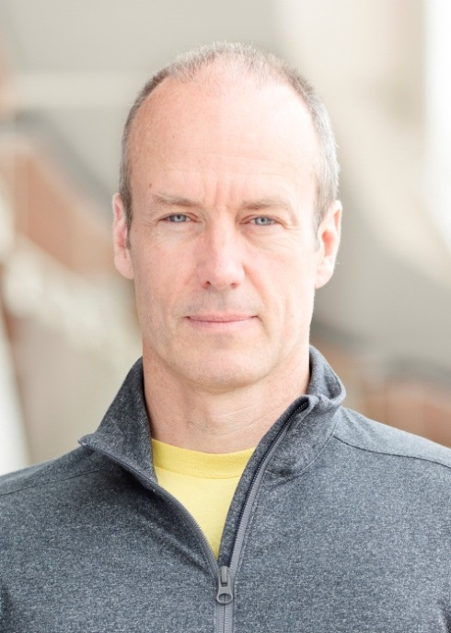
Matt O’Toole is Reebok Brand President. Matt oversees the Reebok Global Marketing group, which includes global product, brand marketing and fitness and entertainment marketing. In addition, as Reebok Brand President, Matt has overseen the development, launch and marketing of some of Reebok’s most successful product and marketing concepts in decades including ZQuick, ZigTech and Real Flex. Matt has also been instrumental in forging Reebok’s groundbreaking partnerships with CrossFit, Reebok Spartan Race and Les Mills.

Prior to assuming his current role, Matt was president of Reebok North America, the brand’s largest business unit. He was responsible for all of the region’s brand operations, including marketing, product merchandising, sales, finance, operations and owned retail stores.

Matt has a long and successful track record in the sports industry. Before coming to Reebok’s Canton headquarters as president of Reebok North America, he was president and CEO of Reebok-CCM Hockey (formerly The Hockey Company) and Reebok Canada. At Reebok-CCM, he was responsible for creating the industry’s market leader through creative marketing, innovative products, strong customer relationships, and an unparalleled partnership with the National Hockey League and hockey’s top players. As president of Reebok Canada, Matt was responsible for the management of the Reebok brand’s business in Canada.

In June 2004, Reebok International acquired The Hockey Company for $330 million and soon after, under Matt’s direction, launched a new line of innovative hockey products under the Rbk brand name. In 2005, Reebok Canada and The Hockey Company were integrated and Matt was chosen to head the combined company. In 2007, The Hockey Company became Reebok-CCM Hockey. Today, ninety-nine percent of all NHL players use at least one piece of Reebok-CCM Hockey equipment.

Matt is a 25-year veteran of the sporting goods industry. Prior to joining The Hockey Company, he served as vice-president of worldwide marketing and sales for the Tommy Armour / Odyssey Golf Company, a division of US Industries. Previously, Matt also spent ten years in marketing and sales management at Wilson Sporting Goods Company.

REEBOK
John Lynch: Vice President, Reebok Emerging Business

John Lynch is Vice President, Emerging Business at Reebok. Appointed to this position in February 2013, John is responsible for Reebok’s Walking, Studio and Kid’s Business Units as well as the brand’s Licensing business, ‘ReebokONE’ platform, and Business Development.

In 2013, John was instrumental in developing and launching Reebok’s partnership with Les Mills, the worldwide leading provider of group fitness classes. The global partnership aims to re-define the Studio category through innovative programming and products.

John also oversaw the launch of Reebok’s innovative online platform ReebokONE in 2013. ReebokONE enables fitness instructors from around the globe to promote themselves, connect with their peers, find and share interesting content and get discounts on Reebok fitness products.

Prior to his current role, John was Brand Director for the Reebok brand in North America, which included merchandising responsibilities. In this position John helped to kick-start Reebok’s clear positioning as THE fitness and training brand in the market, which included major product launches such as RealFlex, Reebok CrossFit Nano and ZigTech.

John first joined Reebok in 1999 and has held various positions in Marketing Communications and Sports Marketing. In August 2006, he was appointed Head of Global Marketing Communications, bringing each of Reebok’s marketing disciplines together to ensure one consistent integrated message is conveyed to Reebok consumers.

Before joining Reebok, John was director of marketing for Polaroid Corporation.

John received his undergraduate degree from the University of Massachusetts in 1986 and a M.B.A. from Duke University in 1990. He lives in Melrose, MA with his wife, Mimi, and three children, Abby, Jack and Tim. He’s an active CrossFitter and runner, but loves all fitness and sports.

REEBOK
Barbara Ebersberger: Vice President, Reebok Studio Business Unit
Barbara Ebersberger is the Vice President of Reebok’s Studio Business Unit. Appointed to this position in 2013, Barbara is responsible for leading and steering the execution of marketing, product, and go-to-market strategies for the Reebok’s Studio category.
Reebok’s Studio category includes Yoga, Dance, Group Exercise and other studio-based fitness activities. In addition to her strategic business and marketing focus, Barbara also works in close co-operation with Reebok product and advanced innovation teams to develop long-term strategies to create the best, most innovative fitness products on the market.
In addition, Barbara oversees Reebok’s groundbreaking partnership with Les Mills, which was announced in August 2013. The largest provider of group exercise programming in the world, Les Mills is one dominant force in the global fitness industry, with more than 100,000 instructors and one of the world’s most advanced instructor training systems.
Prior to her current role, Barbara held a number of key roles for adidas in several global women’s categories.

A twenty-year industry veteran, Barbara began her career at Reebok where she worked as a Category Manager for Reebok Germany before becoming Director of Consumer Marketing in Women’s Sport and Training in the Netherlands.

Barbara also spent two years at FILA Sports in a marketing capacity before joining adidas.

REEBOK
Aly Raisman: Reebok Brand Partner
Aly Raisman is a London 2012 Olympian from Needham, Mass, who helped the women’s gymnastics team capture its first gold medal in the team event since the 1996 Games. U.S. gymnastics team captain, Raisman won an individual gold medal on floor exercise – the first-ever for a U.S. gymnast – as well as a bronze medal on balance beam. She also tied for third in the all-around, but finished fourth due to a tiebreaker.
Following the 2012 Games Raisman took a year-long hiatus from training and was featured on “Dancing with the Stars,” among other activities. Then, this September, she announced her full return and commitment to the sport and is currently training under longtime coach, Mihai Brestyan, with sights set on competing in Rio in 2016.

LES MILLS
Les Mills Jnr: LES MILLS GRIT™ SERIES Program Director and Director of ‘The Project’

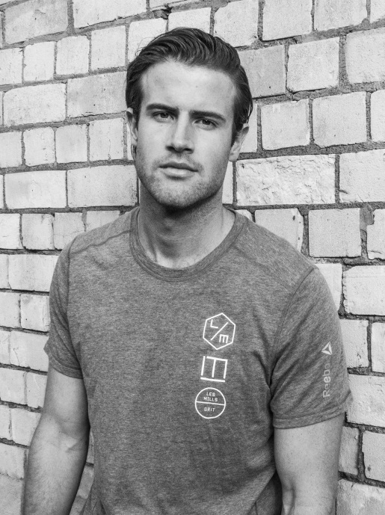
As grandson of the original Les Mills, Les Jnr is the right guy to re-imagine group exercise. Les Jnr and his good buddy Adam Lazarus are all about revolutionizing the industry by creating experiences that appeal to their generation. ‘The Project’ creation is the future of studio fitness, combining a 3D visual experience with music and exercise. The result is total immersion.
Les Jnr says he never thought of working for the family company, until he came back from the United States on summer vacation and worked at Les Mills International for a few months. “That was a total buzz. It opened my eyes, making me realize and appreciate how positive the industry is.”
Since then, Les Jnr has gone on to create the popular LES MILLS GRIT™ SERIES, but his instinct always told him a visual experience could take workouts to the next level. It hasn’t been an easy or short road to create immersive fitness, Les admits there has been “many sleepless nights and some seriously testing times. But now we’re finally here I can see that it will revolutionize fitness. And we’re only just getting started.”
Les Jnr has nothing but good things to say about his collaborator Adam Lazarus. Describing him as “fiercely loyal and an overwhelmingly intelligent dude. He pushes harder than anyone else. None of this would have been possible without him.”

LES MILLS
Adam Lazarus: Director of ‘The Project’

Adam stuck chewing gum in Les Jnr’s hair on the school bus when they were five. They worked out their differences and have been best friends for the 20 years since. A former head boy of the prestigious King’s College in Auckland, Adam left his University of Melbourne Arts/Commerce degree in 2012 to take a job at Les Mills International.
“I have a measured disrespect for conventional thinking, authority and an obsession with the word ‘innovation’. Real innovation comes from not being restrained by the paradigm you are in, and Les Mills International is an organisation that backs free thinking and being brave,” says Adam.
The idea for Immersive Fitness came to Adam while watching a ‘BBC Click’ segment on immersive tents at music festivals. Adam and Les Jnr began to vibe on the idea and after seeing the emergence of boutique gyms on a visit to New York, the pair began the challenging process of taking the idea from pipe dream to reality.
“Les is the type of guy who steps up and puts his ego on the line, and that was required in the initial testing phases of this concept … in reality we had no idea what we were doing.”
The pair ran a less than successful immersive concept trial back in Auckland, but seeing its potential they pushed on. After 12 months of research and development, IMMERSIVE FITNESS™ is making its global debut as ‘The Project’ in London.

LES MILLS
Phillip Mills: Chief Executive Officer, Les Mills™ International
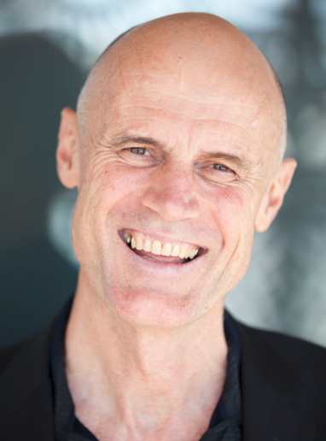
Managing a rock and roll band trying to crack the United States market is an unlikely first job for a pioneer of international fitness. Phillip Mills managed iconic Kiwi outfit ‘Hello Sailor’ for a year, but left the “unhealthy” music industry to marry the worlds of sports and performing arts in 1980. He started with aerobics classes in his father’s Les Mills New Zealand gym, and has since taken the LES MILLS™ brand of exercise-to-music programs to the world.
“I wanted to make going to the gym interesting for me and everyone else,” says the typically understated New Zealander. His leadership and vision has built a tribe of 100,000 instructors that deliver Les Mills classes to millions of people every week.
Truly driven by the health of our planet and its people, Phillip and his wife Jackie co-wrote the book ‘Fighting Globesity’ in 2007 for idealistic reasons. He admits to having big dreams for the future of immersive fitness with ‘The Project’ but sees it all as part of the LES MILLS™ mission to create a fitter planet.

LES MILLS
Dr. Jackie Mills: Group Fitness Director

A former national gymnast and aerobics champion, Jackie Mills is responsible for the development of all LES MILLS™ programs, which are found in 15,500 gyms and clubs across the world. Jackie is also the creator of Les Mills’ popular strength, mind and body program, BODYBALANCE™/ BODYFLOW ®.
Originally an obstetrician and general medical practitioner, Jackie is a specialist in nutritional medicine and is tertiary qualified in Physical Education. She’s married to Phillip Mills and is the mother of Diana Mills and Les Mills Jnr.

LES MILLS
Rachael Newsham: BODYCOMBAT™ Program Co-Director

An inspiring educator, Rachael is passionate about up-skilling fitness instructors, and devoted to working with the worldwide tribe of LES MILLS™ people.
From three years old to the (youthful) age she is now, Rachael has always been active in sports and dance. The multi-talented Rach has attended a Wing Chun Kung Fu school, gone through extensive Muay Thai training in Thailand and been tutored in various other martial arts. She has an Honors degree in Sports Management as well as qualifications in Drama, and Classical and Contemporary Dance.
Rachael’s creative background has had a profound influence on the choreography in BODYCOMBAT™, one of the most successful group fitness programs in the world. Her love of music, movement, freedom and fun is shared through all of her creative, yet easy to follow workouts.

LES MILLS
Marcus Benson: LES MILLS GRIT™ SERIES Presenter

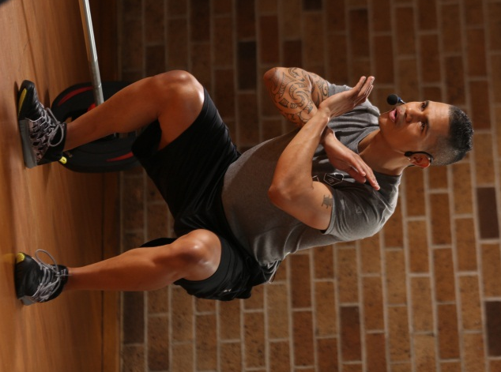
Marcus began his Les Mills journey in 2008 as a BODYATTACK™ instructor and quickly branched into teaching other Les Mills classes like BODYPUMP™. Before long he was “totally addicted” to group fitness and is now a master trainer for BODYPUMP™, LES MILLS GRIT™ SERIES and CXWORX™.
A former England U-15 and u-17 football representative, Marcus says it’s the intensity, challenge and music combination of group exercise that keeps him hooked. “It’s a great social thing, gets people into exercise that may not bother otherwise … and it gets results.” Marcus still loves his football and gets down to the park for a knockabout at his Norfolk (UK) base whenever he gets the chance.

LES MILLS
Erin Maw: LES MILLS BODYJAM™ Presenter

Erin Maw has been moving for as long as she can remember. She’s built a reputation as a fitness rockstar in her hometown of Dunedin (NZ), where she presents and instructs for Les Mills. A woman of many talents, Erin (somehow) finds time to DJ, coach aerobics, and eat chocolate. She also travels New Zealand as part of the BODYATTACK™ and BODYJAM™ Les Mills Training Squad. Erin’s fitness mantra is “it’s not how you start the workout; it’s how you finish it” (especially when it finishes with a bowl of pesto pasta).

