Press release

Date | 23 July 2014
Contact  Pages | Hilary Eastman  Email: hilary.s.eastman@uk.pwc.com  Jennifer Sisson  Tel: +44 20 7804 8644  Email: jennifer.sisson@uk.pwc.com  2

Investors say they want more clarity on adjusted
performance measures

95% of investment professionals would like management teams to provide clearer descriptions of the items they have adjusted when calculating their ‘underlying performance’ measure, as well as why they thought it appropriate to make the adjustments.

This is just one of the insights revealed in a survey of 85 investment professionals on the disclosure of adjusted performance measures (APMs). The findings show that the investment community highly values APMs, but that their value could be enhanced substantially by changes in how these measures are reported.

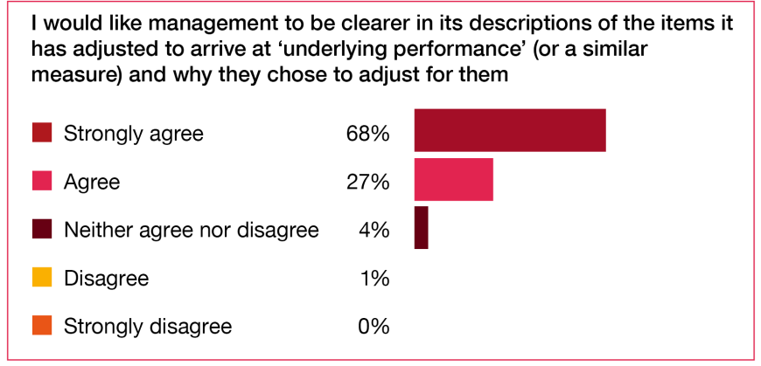

Other insights investment professionals reveal in this survey include:

- They are sceptical about the balance management teams display in reporting APMs. This is a concern because a lack of balance in APM reporting could damage management’s credibility with investment professionals: 81% of investment professionals say that if management’s adjustments to GAAP numbers seem aggressive or unusual, their evaluation of the riskiness of management increases.
- Investment professionals would find it helpful to know that companies were applying some basic ‘ground rules’ to their APM reporting. This would give them greater comfort in the relevance and reliability of the data they use in their own performance analysis.
- There is a case for considering assurance of APMs where not already obtained. Only 22% of investment professionals think that the measures that move markets (including APMs) are sufficiently reliable.
This is the first report in a series that covers investment professionals’ views on corporate reporting. Future editions will focus on their opinions on integrated reporting and financial statement note disclosures. The series aims to help management understand the needs and opinions of investment professionals, which is crucial if they are to prepare truly useful financial reports and accounts.

Notes to editors:

To view the report, click here or visit pwc.com/corporatereporting

About Adjusted Performance Measures
When investment professionals analyse a company, their goal is to understand the quality and sustainability of its ‘underlying’ or ‘core’ performance. They want insight into what drives profits year on year and the measures that management teams consider to be market moving. They want to understand the impact on company performance of management actions relative to general market conditions. They also seek a clear line of sight into any potential challenges.

While generally accepted accounting principles (GAAP) such as International Financial Reporting Standards (IFRS) or US GAAP form the bedrock of corporate reporting, they may not always be enough. Many management teams now identify measures of business performance in addition to the GAAP-based net income or profit or loss figure. These adjusted performance measures (APMs) are seen by management as providing helpful additional information for users of financial statements – telling a clearer story of how the particular business has performed.

Frequently used measures include ‘underlying earnings’, ‘core earnings’, ‘adjusted EBITDA’ or other management performance measures such as ‘sales per square foot’, ‘all in cash costs’ or ‘production rates’.

About PwC
PwC helps organisations and individuals create the value they’re looking for. We’re a network of firms in 157 countries with over 184,000 people who are committed to delivering quality in assurance, tax and advisory services. Tell us what matters to you and find out more by visiting us at www.pwc.com.

PwC refers to the PwC network and/or one or more of its member firms, each of which is a separate legal entity. Please see www.pwc.com/structure for further details.

©2014 PwC. All rights reserved

