Press release

Date | 14 February 2014
Contact  Pages | Sebastian di Paola  Tel: +41 58 792 9603  Email: Sebastian.di.paola@ch.pwc.com  Bas Rebel  Tel: +31 88 792 3824  Email: Bas.rebel@nl.pwc.com  2

SEPA saves €22 billion and unlocks €227 billion in liquidity

SEPA (Single Euro Payments Area) will potentially lead to €21.9 billion in annual savings and the cancellation of 9 million bank accounts in the European Union. In addition, SEPA may unlock €227 billion in liquidity and credit facilities. These are the key findings of an economic analysis of SEPA that PwC was asked to perform for the European Commission.

With effect from 1 February, standardised domestic payment products, such as credit transfers and direct debits, have replaced throughout Europe by SEPA-compliant products. This created a single, integrated payments market in Europe.

An integrated payments market is particularly interesting for businesses. Of the €21.9 billion in potential savings, the corporate sector will account for €16.1 billion annually. SEPA will help businesses to save on processing costs as well as on operating expenses. Gone is the need to keep separate bank accounts in different European countries.
What’s more, the single payments area will facilitate the efficient use of available cash resources. The study found that SEPA may unlock €227 billion in liquidity and credit facilities. The standardisation will also make businesses more flexible in their choice of bank. In the banking sector, a reduction in operating expenses and external clearing costs may well more than compensate for the loss of processing and account-related income.

PwC based its study on a situation in which SEPA has been fully embraced. “After years of investing, the new SEPA infrastructure is now in force ,” says Bas Rebel, treasury expert at PwC. “Whether or not SEPA will deliver on its promises is now largely up to businesses and banks, although politicians also have a say in its success by mandating farther-reaching standardisation.”

The study shows that not everyone will benefit from SEPA in equal measure. It is mostly the corporate sector, but banks too, that will reap the economic rewards. Consumers will mainly benefit from better protection thanks to SEPA; they will have the option to cap collection mandates and to whitelist and blacklist creditors.

In addition, SEPA will encourage competition in the internal market and allow faster adoption of e-billing, mobile payment systems and the single standardisation approach XML ISO 20022, to be used by all financial standards initiatives. The benefits of these aspects were not quantified in the study.

Breakdown of direct/quantifiable savings by stakeholder and benefit driver

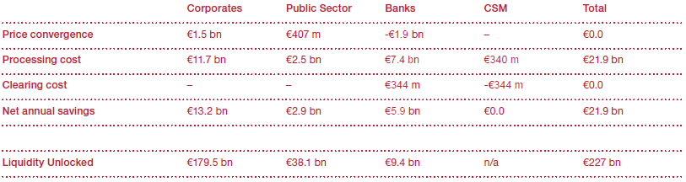

Notes to editors:

About SEPA –Single Euro Payment Area
Under the SEPA project for a common European payments, all ACH and direct debit instructions within in the EU and the European Economic Area denominated in euros have to comply with the SEPA standard.
This 2014 milestone brings an end to an era of dual-payment infrastructure for banks and clearing houses, which started on 28 January 2008 when the first SEPA credit transfers were processed. While 28 January 2008 was important for the payments industry itself, it had little impact on businesses and consumers. The deadline of 1 February 2014 will be different. As of that day, domestic clearing transactions within EU Member States – more than 90% of all transactions in Europe – will have to be provided to banks in SEPA format. This means that transactions will no longer be processed automatically when the Basic Bank Account Numbers (BBAN) and clearing numbers or branch codes are provided. Instead, the payer will have to provide the IBAN and often also the BIC. SEPA also provides a common standard for Direct Debit Mandate Management, which as of 1 February 2014 will be mandatory for direct debit transactions. Local file formats will become obsolete or, at best, will have to be updated to capture the new data elements.
Despite being a major milestone, the deadline does not complete the common European Payments Market. Most Member States have been granted an exemption for one or more local electronic payment products that are not highly compatible with the current SEPA Standards for Credit Transfer (SCT) or Direct Debit (SDD). In the next few years, these exempted products will be replaced by a SEPA-compatible scheme.

About PwC – PwC helps organisations and individuals create the value they’re looking for. We’re a network of firms in 157 countries with over 184,000 people who are committed to delivering quality in assurance, tax and advisory services. Tell us what matters to you and find out more by visiting us at www.pwc.com.

PwC refers to the PwC network and/or one or more of its member firms, each of which is a separate legal entity. Please see www.pwc.com/structure for further details.

©2014 PwC. All rights reserved

