Contacts:

 | Kristin McCallum Ritter  PwC Global & US  +1 (313) 394-6349  kristin.m.ritter@us.pwc.com | Katura Hudson  PwC US  +1 (973) 236-5807  katura.j.hudson@us.pwc.com

For IMMEDIATE RELEASE

Body Suppliers Ranked Top Performers as a Result of Widespread Automotive Restructuring in North America, According to PwC North American Automotive Supplier Supply Chain Performance Study

Suppliers perform better on effectiveness than efficiency

DETROIT, 28 February, 2013 – North American automotive suppliers are poised for growth and profitability as a result of restructuring efforts, according to North American Automotive Supplier Supply Chain Performance Study, a new report released today by PwC. Among the six supplier segments studied (exterior, interior, body, powertrain, electrical and chassis), automotive body suppliers ranked the highest in overall efficiency. Overall body suppliers ranked first in revenue growth, realizing 23 percent revenue growth from 2010 to 2011.

The majority of the suppliers evaluated performed better on effectiveness (revenue) over efficiency (cost).
While body suppliers ranked highest in overall efficiency, there is opportunity for all segments to improve (size of bubble is average 2011 North America sales by each segment [$B]).

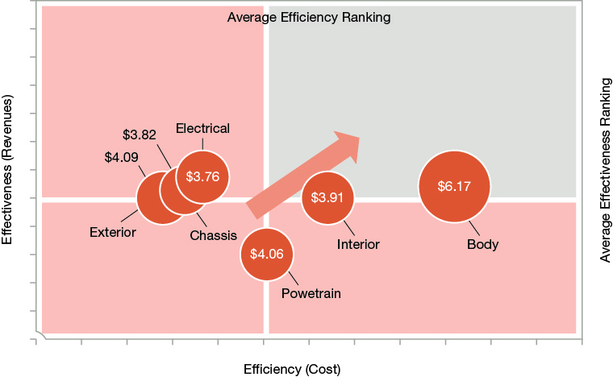
Sources: PwC analysis, “Automotive News Top 100 North American Suppliers,” May 21, 2012
Notes: Rankings were developed based on weighting of the key metrics in this study. Divisions between quadrants suggested cross-segment average

“Automotive suppliers who swallowed a bitter pill by restructuring operations during the downturn following the financial crisis are seeing the payoff today,” said Rajiv Jetli, principal, PwC automotive consulting practice. “North American automotive suppliers still have room for performance improvement within their supply chain, specifically in the areas of more cost-cutting, inventory management, customer responsiveness and supply chain flexibility.”

Automotive suppliers with an efficient and effective supply chain will be better positioned to meet PwC’s Autofacts global automotive production forecast of more than 100 million units by 2017. As the automotive industry continues to stabilize, suppliers have the opportunity for growth, specifically around the ability to generate revenue and their ability to minimize costs.

According to the report, there are six key findings that speak to leading supplier categories:
- Body suppliers lead the way in both supply chain effectiveness and efficiency, scoring first in three effectiveness measures and in seven efficiency measures. Body suppliers also rank first in revenue growth (23 percent from 2010 to 2011).
- Interior suppliers finish second overall, and cash and working capital improvements appear to be high priorities. As a whole, interior suppliers lag in revenue growth, profit margins and COGS performance in relation to other segments.
- Electrical component suppliers rank first in overall effectiveness yet third in overall efficiency, which may indicate that cost improvement is a near-term focus. Inventory turns rank among the best when compared across segments, but improvement in turns from 2010 to 2011 lags other segments.
- Chassis suppliers finish fourth overall, and rank among the highest in gross profit margin (15 percent) relative to other segments in 2011.
- Powertrain suppliers capture fifth in effectiveness, but rank in the middle in efficiency. Overall, powertrain suppliers’ inventory turns are the lowest of all the sectors, implying improvement potential.
- Exterior component suppliers finish sixth overall, falling behind their peers in supply chain performance. Exterior component suppliers did excel at raw material stability, indicating that improved planning capabilities or inventory replenishment strategies are in place.
About the Study
This year’s North American Automotive Supplier Supply Chain Performance Study examines the top 60 North American suppliers’ ability to generate revenue/cash (effectiveness), and their capacity to minimize cost (efficiency). The full report on the survey can be found at www.pwc.com/auto.

About PwC's Automotive Practice
PwC's global automotive practice leverages its extensive experience in the industry to help companies solve complex business challenges with efficiency and quality. One of PwC's global automotive practice's key competitive advantages is Autofacts®, a team of automotive industry specialists dedicated to ongoing analysis of sector trends. Autofacts provides our team of more than 4,800 automotive professionals and our clients with data and analysis to assess implications, make recommendations and support decisions to compete in the global marketplace.

About PwC’s Global Automotive Management Consulting Practice
PwC’s automotive management consulting practice is helping create a competitive advantage for its clients by changing the way companies operate. PwC’s management consultants work with senior automotive executives to help develop and implement innovative operational strategies that deliver breakthrough results. The practice is a leader in operational strategy, supply chain, product development, strategic sourcing, and manufacturing. PwC has automotive resources in every automotive market around the world. For more information, visit www.pwc.com/auto.

About the PwC Network
PwC firms help organizations and individuals create the value they’re looking for. We’re a network of firms in 158 countries with more than 180,000 people who are committed to delivering quality in assurance, tax and advisory services. Tell us what matters to you and find out more by visiting us at www.pwc.com.

Learn more about PwC by following us online: @PwC_LLP, YouTube, LinkedIn, Facebook and Google +.

© 2013 PwC. All rights reserved. PwC refers to the PwC network and/or one or more of its member firms, each of which is a separate legal entity. Please see www.pwc.com/structure for further details. This content is for general information purposes only, and should not be used as a substitute for consultation with professional advisors.

