Press release
Date | 30 January 2013
Contact  Pages | Sebastian di Paola  Tel: +41 58 792 9603  Email: Sebastian.di.paola@ch.pwc.com  Bas Rebel  Tel: +31 88 792 3824  Email: Bas.rebel@nl.pwc.com  3

____________________________________________________

Companies underestimate effort and impact of SEPA deadline

Companies in Europe underestimate the scope and effort of complying with the new Single Euro Payments Area (SEPA) requirements by 1 February 2014. Responses to a recent PwC survey suggest that 55% of organisations are at risk of missing the SEPA deadline next February.
With one year to go before the payments markets in Europe integrate, PwC surveyed 293 respondents about their organisations’ readiness for the integration of payments markets in Europe.
It appears that, for many organisations, there is a lot of work still to be done, and yet there remains an unawareness of the scale of the task.
Major findings of the survey, ‘SEPA Readiness Thermometer - State of play with one year to go’, include:
- 21.6% of respondents have yet to define and plan their SEPA readiness activities;
- Few organisations have a comprehensive scope defined – for example, fewer than 30% of respondents include review and update of master data in their scope, and fewer than 20% involve HR, legal and sales departments in their projects. These statistics are even worse for those organisations that have yet to plan their SEPA-readiness activities.
- 43.5% of respondents that have planned their readiness expect to complete their project uncomfortably close to the deadline of 1 February 2014.
- 43% of respondents are not confident that the majority of their customers will be ready for SEPA in time.
- 92% of respondents mention ‘systems readiness’ as their number one concern.

“All findings combined lead us to believe that some 55% of all organisations will miss or are at an increased risk of missing the 1 February 2014 milestone”, said Bas Rebel, senior director treasury advisory at PwC in the Netherlands. “Without an increased focus and effort, corporates and all other stakeholders should brace themselves for a major hiccup in payment processing in the period immediately after 1 February 2014.
“Companies should not only focus on their own readiness, but also understand their clients’ and suppliers’ readiness effort. If on Monday 3 February 2014 companies discover they are not ready, they may have a hard time paying due invoices. At the same time, suppliers that are not ready may have serious issues with their physical supply chain. And the payment industry may be confronted with a backlog of issues that need fixing. We believe that all companies and stakeholders should prepare for a worst-case scenario,” concluded Bas Rebel.

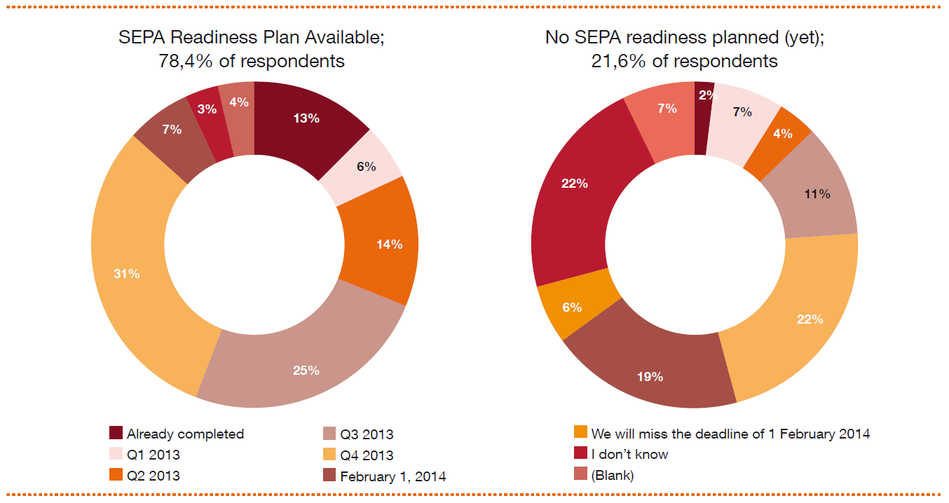
You can find the full report, ‘SEPA Readiness Thermometer - State of play with one year to go’, under ‘Research and insights’ at pwc.com/corporatetreasurysolutions or by clicking here.

SEPA: Single Euro Payment Area
The SEPA project for a common European payments market is rapidly approaching an important milestone. As of 1 February, 2014 all ACH and direct debit instructions within in the EU and the European Economical Area denominated in euros have to comply with the SEPA standard.
This 2014 milestone brings an end to an era of dual-payment infrastructure for banks and clearing houses, which started on 28 January 2008 when the first SEPA credit transfers were processed. While 28 January 2008 was important for the payments industry itself, it had little impact on businesses and consumers. The deadline of 1 February 2014 will be different. As of that day, domestic clearing transactions within EU Member States – more than 90% of all transactions in Europe – will have to be provided to banks in SEPA format. This means that transactions will no longer be processed automatically when the Basic Bank Account Numbers (BBAN) and clearing numbers or branch codes are provided. Instead, the payer will have to provide the IBAN and often also the BIC. SEPA also provides a common standard for Direct Debit Mandate Management, which as of 1 February 2014 will be mandatory for local direct debit transactions. Local file formats will become obsolete or, at best, will have to be updated to capture the new data elements.

Despite being a major milestone, 1 February 2014 does not complete the common European Payments Market. Most Member States have been granted an exemption for one or more local electronic payment products that are not highly compatible with the current SEPA Standards for Credit Transfer (SCT) or Direct Debit (SDD). In the next few years, these exempted products will be replaced by a SEPA-compatible scheme.
About PricewaterhouseCoopers:
PwC helps organisations and individuals create the value they’re looking for. We’re a network of firms in 158 countries with over 180,000 people who are committed to delivering quality in assurance, tax and advisory services. Tell us what matters to you and find out more by visiting us at www.pwc.com.

©2013 PwC. All rights reserved

PwC refers to the PwC network and/or one or more of its member firms, each of which is a separate legal entity. Please see www.pwc.com/structure for further details.

