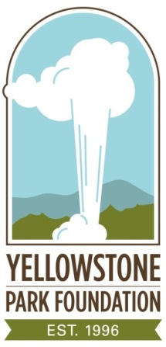

OLD FAITHFUL HAYNES PHOTO SHOP
BIOGRAPHIES

Frank Jay Haynes
1853 – 1921

Frank Jay Haynes was an adventurer and entrepreneur who journeyed west from Fargo, North Dakota in the late 1800s as the official photographer for the Northern Pacific Railroad. In travels overland by train, horseback or skis, he took over 2,400 “stereoviews”, an optical technique where two images of the same object are blended into one, giving a three-dimensional appearance to the single image. In addition, he produced tens of thousands of hand-tinted photographs.

In 1881, only nine years after Congress created Yellowstone National Park, Haynes spent two months photographing the Park’s major attractions. In August, 1883, he was selected as the official photographer for U.S. President Chester A. Arthur’s two-week visit to Yellowstone.

By 1884, he had secured a license to operate his first photo ‘concession stand’ at Mammoth Hot Springs. During an epic 29-day, 200-mile ski and snowshoe trip that nearly cost him his life in 1887, Haynes took the first-ever winter photos of Yellowstone.

He began selling picture postcards soon after the Post Office first issued them in 1897. He returned to Yellowstone every year until his death in 1921.

Jack Ellis Haynes
1884 – 1962

Jack Ellis Haynes worked at his father’s photo shops from the age of 12, and took over the family business in 1916. He spent 76 of his 78 summers at the Park, where he was known as “Mr. Yellowstone.”

- more -
His postcards and guidebooks captured the area’s plants and trees, its maps and natural history. He kept up with changing photo technology, and was one of the first to offer overnight developing services, with prints delivered to visitors staying anywhere in the Park.

At the time of his death in 1962, Jack ran 13 Haynes Photo Shops in Yellowstone, at all major locations.

###

