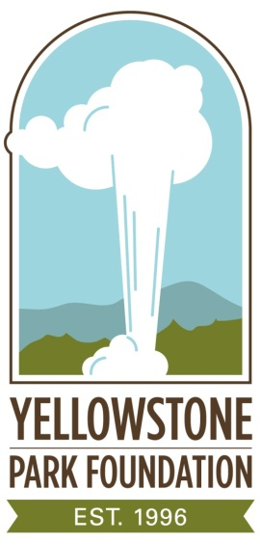

OLD FAITHFUL HAYNES PHOTO SHOP
TIMELINE HISTORY

March 1, 1872 President Ulysses S. Grant establishes Yellowstone as the world’s first
national park.

1881 Frank J. Haynes spends two months photographing Yellowstone National Park’s major attractions.

August 1883 Frank J. Haynes selected as the official photographer for U.S. President Chester A. Arthur’s two-week visit to Yellowstone.

1884 Secures license to operate his first photo ‘concession stand’ at Mammoth
Hot Springs.

1887 Takes the first-ever winter photos of Yellowstone during an epic 29-day, 200-mile ski and snowshoe trip that nearly costs him his life.

1897 Begins selling picture postcards when the Post Office first issues them in 1897.

1900 Produces hand-colored postcards of Yellowstone, selling them along
with photos, guidebooks and souvenirs at several Haynes Picture Shop locations.

1916 Son Jack Ellis Haynes assumes ownership of Haynes, Inc.

March 10, 1921 Frank J. Haynes dies.

1920’s Jack E. Haynes films “Magic Yellowstone”, a black and white “moving” picture to promote tourism for the Northern Pacific Railroad.

1927 Old Faithful Haynes Photo Shop is built.

June 1962 Jack E. Haynes dies, after spending 76 of his 78 summers in Yellowstone.

- more -
March 1968 Jack’s widow, Isabel Haynes, sells Haynes, Inc. to Hamilton Stores, Inc.,
ending a continuous 84-year presence in Yellowstone National Park.

1993 Yellowstone memorabilia collectors Jack and Susan Davis attend Haynes
estate auctions, and acquire the most complete privately-held collections of Yellowstone memorabilia known.

2001 The Yellowstone Park Foundation acquires the Davis’ collection through
purchase and donation by the Davis family, then presents it to Yellowstone National Park.

June 22, 2013 Restored by the Yellowstone Park Foundation and the National Park
Service, the Old Faithful Haynes Photo Shop opens.

####

