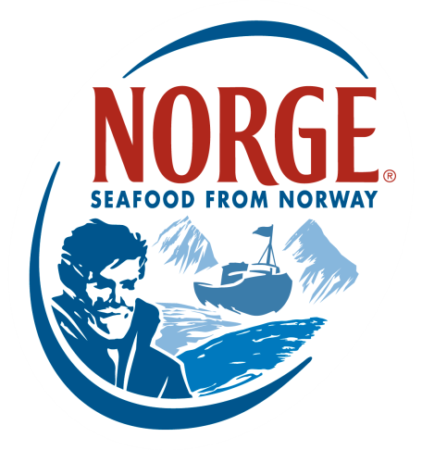
CONTACT:
Jessica Butera
The Food Group
212-329-6273
Jessica.Butera@thefoodgroup.com
NORWEGIAN HALIBUT
The Fish of the Gods

Norway’s long coastline, which includes islands and deep fjords, extends more than 51,500 miles, allowing Norway to export some of the best seafood in the world. Norwegian aquaculture makes it possible to offer seafood independently of seasonal variations that limit traditional fisheries, like halibut, which has become a high-demand species and is vulnerable to overfishing. Since pioneering the development of responsible ocean salmon farming in the early 1970s, Norway has led the world in quality food safety management and accountability, leveraging the skills and expertise of researchers, marine biologists and dedicated fish farmers. The cold, clear Norwegian fjords are ideal for achieving optimal conditions for farming halibut.

Norwegian Halibut is a flatfish that is often served as a substantial fillet with an even thickness throughout. Its firm white flesh has a distinctive flaky structure and its large bones are easy to remove, allowing for easy preparation and consistent results. Rich in protein, vitamins and omega-3 fatty acids, Norwegian Halibut’s firm, flaky flesh pairs well with a variety of ingredients and can be prepared in multiple ways. Due to its high quality, steady supply and versatility, Norwegian Halibut has secured a place among chefs worldwide.

NORWEGIAN HALIBUT KEY INFORMATION
- The life cycle of Norwegian farmed halibut is approximately 5 years.
- The farming of Norwegian Halibut is a demanding task because the fish is very different from other species. Norwegian Halibut spends the first part of its life in protected conditions with large volumes of fresh seawater where each individual fish has its own “living area.”
- In the beginning of their lives, the fertilized halibut eggs are kept in dark tanks for 13–20 days until they hatch.
- Once the metamorphosis starts with one eye beginning to move so that both eyes are located on the same side of the head, the fish then become flatter and start to migrate to the bottom of the tank. During this time the halibut are given dry feed and moved to a land-based nursery. This is the start of a long series of events in which the halibut goes through a production process that has been designed to achieve optimal health and growth.
- The feed used consists exclusively of marine raw materials from sustainable stocks.
- When the halibut reach 350–400 grams, they are moved to an open land-based facility with more space. Here they grow to about 1.5–2 kg (about 3.5-4.5 lbs.), when they are ready to be moved to an open sea-based facility.
- Gradually the fish are moved to open pens at selected fjord locations. The living area is extended as the halibut increase in size, giving them ample space to move and rest.
- The fish live in this protected area for about 2 years until the average weight is 6 kg (about 13.2 lbs.). At this time, they are ready to be harvested.
- Ocean-farmed halibut are closely monitored to ensure full traceability and food safety.

INTERESTING FACTS
- Halibut has always been highly regarded in Norway. In fact, there are Stone Age settlements that have rock carvings dating back as far as 10,000 years that illustrate the importance of halibut in Norwegian culture.
- It was regarded as a holy fish and was called “the fish of Gods.”
- Halibut was seen as the personification of the wise and kind Balder—the blond Norse god.
- Halibut is traditionally served on special occasions such as weddings and Christmas.

About the Norwegian Seafood Council
Founded in 1991 by the Ministry of Fisheries, the Norwegian Seafood Council (NSC) builds awareness of and educates the public on seafood from Norway. Headquartered in Tromsø, Norway, with a U.S. branch in Boston, Mass., the NSC carries out Norwegian Seafood promotional, media, marketing and public relations campaigns and is a resource for market information in more than 20 different markets. Its efforts are financed by the Norwegian seafood industry itself. As the world’s second-largest exporter of seafood, Norway provides quality, nutrient-rich seafood to over 150 different countries and is the world's largest joint marketer of seafood. For more information on the NSC, visit www.salmonfromnorway.com.

