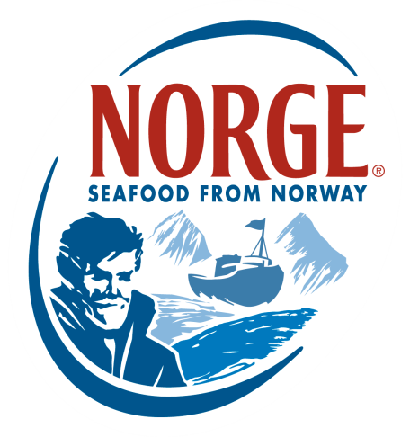
CONTACT:
Jessica Butera
The Food Group
212-329-6273
Jessica.butera@thefoodgroup.com

Norwegian Seafood Council Announces Winners of the Inaugural Global Sushi Challenge

The Norwegian Seafood Council along with the World Sushi Skills Institute is thrilled to present the winners of the Global Sushi Challenge US preliminary. Takatoshi Toshi, chef of Sushi Ran in Sausalito, CA, took home first place and the title of US Country Challenger. In addition to a $1,000 cash prize and a state-of-the-art sushi knife from Korin, Chef Toshi also won a trip to Tokyo, where he will compete at the Grand Final on Wednesday, November 25.

The US preliminary competition was held on May 17 from noon to 4 PM at Kendall College in Chicago, Ill. Among the eight contestants, Brent Koshu, chef of Sushi Koshu in Diamond Bar, CA, was awarded second place and Jorge Dionicio, chef of O Ya Restaurant in New York City was awarded third place. The chefs competed in both an Edomae competition and an original sushi competition, which were judged by the World Sushi Skills Institute and three local judges. Not only did this one-of-a-kind contest allow North American sushi chefs to showcase their talent, but it also provided a forum for them to network, exchange ideas and expand their knowledge of safe, high-quality sushi.

“We were thrilled with the outcome of the US preliminary Global Sushi Challenge,” said Egil Sundheim, US Director of the Norwegian Seafood Council. “The chefs really raised the bar during this competition. Everyone had their own signature style and handled the fish with a great amount of care, allowing the clean flavor and delicate flesh to come through in every bite. The chefs did a great job demonstrating why Norwegian Salmon is the preferred sushi topping.”

Today, sushi is one of the most popular Japanese foods in the world and has successfully integrated into many global food cultures. Norwegian Salmon plays a key role in expanding the popularity of sushi because of its global recognition and wide availability. Long considered the original salmon sushi, Norwegian Salmon is recognized as the preferred salmon for raw consumption because of the safety measures in place.

The country preliminaries will continue through October to determine who will earn the title of Country Challenger and have the opportunity to represent his country in the Grand Final. For more information on the Global Sushi Challenge, visit sushichallenge.global. For more information on Norwegian Salmon, visit salmonfromnorway.com.

###

About the Norwegian Seafood Council
Founded in 1991 by the Ministry of Fisheries, the Norwegian Seafood Council (NSC) builds awareness of and educates the public on seafood from Norway. Headquartered in Tromsø, Norway, with a U.S. branch in Boston, Mass., the NSC carries out Norwegian Seafood promotional, media, marketing and public relations campaigns and is a resource for market information in more than 20 different markets. Its efforts are financed by the Norwegian seafood industry itself. As the world’s second-largest exporter of seafood, Norway provides quality, nutrient-rich seafood to over 150 different countries and is the world's largest joint marketer of seafood.

About the World Sushi Skills Institute
The World Sushi Skills Institute (WSSI) is part of All Japan Sushi Association endorsed by the Ministry of Agriculture, Forestry and Fisheries (MAFF) in Japan. WSSI conducts sushi skills seminars and workshops around the world, promoting hygiene and the art of sushi, and aims to increase knowledge about sushi. The WSSI also teaches trainers to demonstrate correct sushi skills, with a special focus on hygienic and safe handling of seafood for raw consumption, to raise the quality of sushi chefs abroad.

