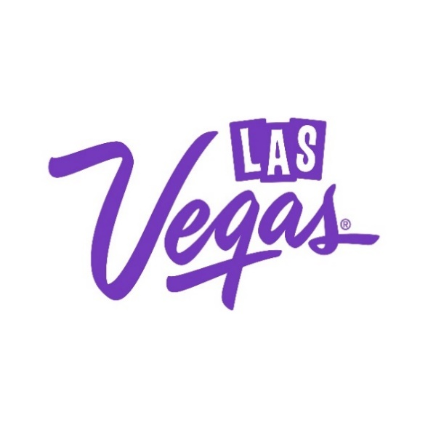

December 9, 2024 | Press Contact:  Sidney Schauer, R&R Partners  702.423.7940  sidney.schauer@rrpartners.com  Kristin Weddingfeld, LVCVA  702.892.7422  kweddingfeld@lvcva.com

Las Vegas Welcomes 2025 with Unforgettable
Entertainment and a Glittering Fireworks Display

The Destination will Close Out 2024 in Spectacular Style

Images available at press.lvcva.com

LAS VEGAS – New Year’s Eve in Las Vegas is a show-stopping celebration, with fireworks lighting up the desert sky and the biggest names in entertainment performing at iconic venues throughout the city.

Fireworks Fun

Las Vegas knows how to ring in the New Year with fireworks illuminating the sky from the rooftops of these legendary landmarks throughout the Strip and downtown Vegas, which will follow a countdown on the exterior of Sphere, known as the Exosphere:

- ARIA Resort & Casino
- Caesars Palace
- Fontainebleau Las Vegas
- MGM Grand Hotel & Casino
- Planet Hollywood Resort & Casino
- Plaza Hotel & Casino
- Resorts World Las Vegas
- The STRAT Hotel, Casino & Tower
- TI – Treasure Island Hotel & Casino
- The Venetian Resort Las Vegas

Exciting Entertainment
From the music industry’s finest to world-class illusionists and hilarious comedians, the destination promises an impressive lineup to cap off an exceptional year of entertainment:

Following a sold-out North American tour, multi-platinum and GRAMMY-winning rock band CREED will ring in the New Year with two exclusive performances at The Colosseum at Caesars Palace on Monday, Dec. 30 and Tuesday, Dec. 31, 2024, marking their first performance in Las Vegas in over 12 years.

Jimmy Kimmel’s Comedy Club, nestled in the vibrant heart of The LINQ Promenade, announces a New Year's Eve performance from America’s Got Talent top 10 finalist Vicki Barboak on Tuesday, Dec. 31, 2024.

Ole Red Las Vegas will host a free New Year’s Eve celebration on Tuesday, Dec. 31, 2024, featuring performances by Dez Hoston and Ryan Whyte Maloney on the main stage, along with DJ sets on the GHOST rooftop.

Bruno Mars lights up Dolby Live at Park MGM this New Year’s Eve with electrifying performances on Monday, Dec. 30 and Tuesday, Dec. 31, 2024.

50 Cent: In Da Club performs at PH Live inside Planet Hollywood Resort & Casino on Monday, Dec. 30 and Tuesday, Dec. 31, 2024, for an unforgettable New Year’s celebration.

Janet Jackson will kick off New Year's Week in Las Vegas with her highly anticipated debut residency, Janet Jackson: Las Vegas at Resorts World Theatre inside Resorts World Las Vegas on Monday, Dec. 30 and Tuesday, Dec. 31, 2024. These exclusive performances promise an unforgettable celebration with one of pop music's biggest icons.

Afterlife presents Anyma ‘The End of Genesis’ at Sphere from Friday, Dec. 27 through Tuesday, Dec. 31, 2024.

Award-winning Las Vegas band Imagine Dragons will ring in 2025 with a special hometown performance at The Venetian Theatre inside The Venetian Resort Las Vegas on Tuesday, Dec. 31, 2024.

Global magic icon David Blaine returns to Encore Theater at Wynn Las Vegas on Sunday, Dec. 29 to Tuesday, Dec. 31, 2024, for three special performances. This intimate show brings audiences up close to the legendary illusionist and stunt artist.

Noteworthy Nightlife

Nightlife in Las Vegas sets the bar for the ultimate nightclub experience, with the biggest names in the game consistently gracing the destination’s best-in-class venues with their famed talents—and the lineup gets even better the evening of New Year’s Eve:

TYGA takes the stage at JEWEL Nightclub at ARIA Resort & Casino.

OMNIA Nightclub at Caesars Palace presents sets by Steve Aoki.

Marquee Nightclub at The Cosmopolitan of Las Vegas showcases a set by Alesso.

Tiesto will ring in 2025 from LIV Las Vegas at Fontainebleau Las Vegas.

Hakkasan Nightclub at MGM Grand Hotel & Casino will feature a set by DJ Pauly D.

Celebrate New Years Eve with O.T Genesis at TAO Nightclub at The Venetian Resort Las Vegas.

XS Nightclub at Wynn Las Vegas presents sets by The Chainsmokers.

Fabulous Fêtes

Visitors will ring in 2025 at rooftop parties with prime views of the midnight fireworks and unique celebrations with only in Vegas flair.

The Beverly Theater presents a special showing of When Harry Met Sally to ring in the new year, complete with concessions packages and a post-show reception with live jazz, charcuterie and a champagne toast.

AREA15 transforms into a realm of mystery and excitement for the 2025 Masquerade Ball, where immersive themed ballrooms pulse with music, roaming performers, and hidden surprises.

Legacy Club at Circa Resort & Casino presents Countdown in the Clouds, an unforgettable New Year’s Eve celebration 60 floors above the Las Vegas skyline. The evening features an open bar, electrifying beats with a live DJ, and a champagne toast at midnight, all with panoramic views of the fireworks. Barry’s Downtown Prime will also feature an exclusive specialty menu, inviting guests to indulge in delicious creations such as a Lobster Potato Pierogi, Steak Tartare, and Colorado Lamb Chops, among other options from Chef Barry S. Dakake.

The Ice Rink at The Cosmopolitan of Las Vegas presents its annual New Year’s Eve Fireworks Viewing Party, which features an open bar, DJ set, skate rentals and a complimentary midnight champagne toast.

The Foundation Room Lounge at Mandalay Bay Resort and Casino offers sweeping views of the fireworks from the resort’s 63rd floor. The venue offers several general admission and bottle service packages. S Bar puts on A Lavish Affair featuring live entertainment, food and beverage, a champagne toast and “surprises” throughout the evening.

Ring in 2025 at Beer Park with a panoramic view of the Las Vegas Strip, Bellagio Fountains, and fireworks, while enjoying a resident DJ and all-inclusive food and drinks under the stars and at the Eiffel Tower at Paris Las Vegas, including a champagne toast at midnight.
Ghostbar at Palms Casino Resort offers views from the 55th floor of the resort, indoor and outdoor seating and music from a local resident DJ.
Cabo Wabo Cantina at Miracle Mile Shops at Planet Hollywood Resort & Casino rings in 2025 with premium beverage packages and panoramic views of the Las Vegas Strip from its patio and loft.
Rouge Room at Red Rock Casino, Resort & Spa offers the ultimate New Year’s Eve experience with an open bar, gourmet appetizers, live music, and a midnight toast in a chic, festive setting.
Take your NYE celebration to new heights at VooDoo Lounge at the Rio Hotel & Casino, 51 floors above the Strip, featuring an open bar, hors d’oeuvres, live entertainment, and a midnight champagne toast.
Celebrate New Year's Eve at Delmonico Steakhouse in the Grand Canal Shoppes at The Venetian Resort, featuring a special menu by Chef Ivan Rojas, available exclusively from 5-10 p.m.
Caspian’s Cocktails & Caviar at Caesars Palace, the exclusive caviar lounge and speakeasy, will redefine New Year’s Eve with a high-energy celebration , featuring live rock music, bold cocktails, and an electrifying atmosphere that lasts well past midnight.
Honor the arrival of 2025 at Eight Cigar Lounge at Resorts World Las Vegas, where an exclusive evening of gourmet bites, craft cocktails, premium cigars, and live DJ tunes ends with breathtaking views of the Strip’s fireworks from the luxe patio.

Gatsby's Cocktail Lounge at Resorts World Las Vegas will host a vibrant New Year's Eve celebration with signature cocktails, high-energy DJ sets, and a glamorous atmosphere. DJ Nico Oso will perform from 9 p.m. to 2 a.m., followed by Kid Funk spinning until 5 a.m.
The STRAT Hotel, Casino & Tower hosts a New Year’s Eve “Party in The Tower” at the indoor Observation Deck, complete with views of the fireworks, party favors, and live entertainment from a local DJ.
Hofbräuhaus Las Vegas’ Midnight in Munich celebration features live entertainment, authentic German cuisine, and a festive balloon drop at 3 p.m., timed to Munich’s midnight.
Say "I do" as the clock strikes midnight with Vegas Weddings’ exclusive CELEBRATE 2025 package, offering an unforgettable all-inclusive experience complete with a limousine, fresh floral arrangements, a photo shoot, and live internet broadcast.
The Composers Room Showlounge & Restaurant offers a day of live music, delicious food, and unbeatable fireworks views, all without the inflated holiday prices. From Mid-Day Mid-Night to free performances and a lively party with Down South Jukers, it’s the perfect spot to welcome 2025.
Kick off 2025 East Coast-style at Glittering Lights at Las Vegas Motor Speedway with a 9 p.m. New Year’s Eve fireworks show amid a stunning display of over 5 million holiday lights. This award-winning drive-through event runs nightly through January 5, 2025.

Getting Around

The Las Vegas Monorail will be open round-the-clock for New Year’s Eve, offering locals and visitors the only motorized method of transportation along the Las Vegas Strip, which will be closed to all traffic in the hours leading up to 2025.
The Monorail will operate continuously from 7 a.m. Tuesday, Dec. 31 until 2 a.m. Thursday, Jan 2, 2025, for a total of 43 straight hours.
Locals can purchase $1 single-ride tickets at customer service booths located at every station (except Boingo Station at Las Vegas Convention Center) from 10 a.m. to 11 p.m. on Tuesday, Dec. 31 with proof of Nevada I.D. For out-of-town guests, one-ride tickets are $6.
The Monorail also offers an eTicket discount on unlimited-ride passes starting at $13.45 for a 24-hour pass, which can be purchased online.
Monorail ticket holders looking for things to do in the destination over the holiday weekend are invited to take advantage of the “Show Your Ticket & Save” program, which provides discounts on shows, attractions, restaurants and more.

###
ABOUT THE LVCVA
The Las Vegas Convention and Visitors Authority (LVCVA) is charged with positioning Southern Nevada as the undisputed global destination for leisure and business travel and operates the 4.6 million square-foot Las Vegas Convention Center (LVCC). With 151,000 hotel rooms and nearly 15 million square feet of meeting and exhibit space in Las Vegas, the LVCVA's mission centers on attracting visitors to the area. The LVCVA also owns the Vegas Loop at Las Vegas Convention Center, designed, and operated by The Boring Company, and also owns the Las Vegas Monorail, an elevated 3.9-mile system with seven stops throughout the resort corridor. For more information, go to www.lvcva.com, www.visitlasvegas.com or www.vegasmeansbusiness.com.

