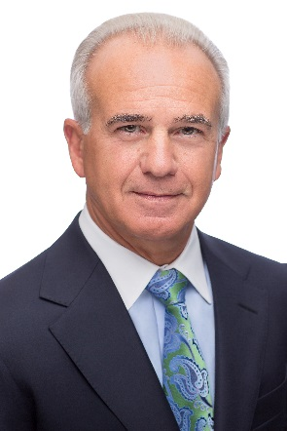
Nicholas E. Calio
President and CEO
Airlines for America

Nicholas E. Calio is president and chief executive officer of Airlines for America (A4A), the trade association for the country’s leading passenger and cargo airlines.

Mr. Calio leads the organization, which advocates for America’s airlines as models of safety, customer service and environmental responsibility, and as the indispensable network that drives nearly $1.5 trillion in U.S. economic activity and more than 11 million U.S. jobs. Prior to joining A4A in January 2011, Mr. Calio was Citigroup’s Executive Vice President for Global Government Affairs, and a member of its Senior Leadership Committee. He was responsible for the company’s government affairs globally, including U.S. federal government relations, U.S. state government relations and international government relations.

Before joining Citigroup, Mr. Calio served as Assistant to the President for Legislative Affairs for President George W. Bush and President George H.W. Bush, with primary responsibility for formulating and implementing White House legislative strategy. In 1993, Mr. Calio co-founded O’Brien*Calio, a law and lobbying firm rated by a Fortune Magazine survey as “one of the ten most powerful” in Washington.

Mr. Calio is a graduate of Ohio Wesleyan University; and Case Western Reserve University School of Law. He serves on the Board of Trustees of Ohio Wesleyan University; the Wolf Trap Foundation; the U.S. Capitol Historical Society; and the First Tee of Washington, D.C.

