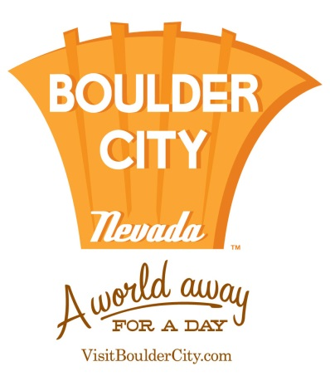
FOR IMMEDIATE RELEASE
Nov. 7, 2016

BOULDER CITY TRANSFORMS INTO WINTER WONDERLAND
WITH ARRAY OF HOLIDAY EVENTS
The Magical Celebration Begins Dec. 2
Boulder City, Nev. – The Boulder City streets will come to life with holiday events that are both merry and bright. Boasting several celebratory activities, the destination is the ultimate gathering place for residents and visitors alike. Guests will enjoy traditional events, including: the annual Christmas Tree Lighting, Santa’s Picture Party, Lake Mead’s Parade of Lights and more.
Friday, Dec 2
- Christmas Tree Lighting
Kicking off this year’s festivities is the beloved Christmas Tree Lighting. Friends, family and the fun-loving Jingle Cat will come together to view the spectacular tree’s debut. Lights will be strung and hearts will be warmed, as the celebration is complete with hot chocolate and live entertainment.
When: 6 p.m.
Where: Frank Crowe Park, 640 Nevada Way Boulder City
Saturday, Dec 3
- Santa’s Picture Party
The traditions continue as the Chamber of Commerce presents Santa’s Picture Party. Tiny tots from far and wide can climb onto Santa Claus’ lap and pose for photos. After sharing their holiday wish list with Jolly Old St. Nicholas, each child will be treated to a complimentary coloring book and goodie bag.
When: 11 a.m. – 2 p.m.
Where: Boulder City Recreation Center – Old Gymnasium Stage, 900 Arizona St. Boulder City

- Santa’s Electric Night Parade
‘Tis the season to stroll through the festive streets of Boulder City. This epic parade transforms historic downtown into a holiday spectacle for all. Decorative floats, marching bands and musical groups will gather in good spirits and spread cheer throughout the city. The event serves as a perfect pre-party to the Lake Mead Parade of Lights.
When: 4:30 p.m.
Where: Boulder City’s Historic District, begins at Nevada Way and Colorado St.

- Lake Mead Parade of Lights
The highly-anticipated Lake Mead Parade of Lights continues to be a community favorite. Hosted by the Lake Mead Boat Owners Association, the 40th annual parade will leave spectators in awe as themed boats depart the Marina and glide past Boulder Beach.
When: 6:30 p.m.
Where: Lake Mead Marina

- Holiday Train Rides at Nevada Southern Railway
The Santa Train
Santa and Mrs. Claus will join families on this festive holiday train ride, taking photos and listening to wish list items. Children who have also written letters to Santa can mail them directly to the North Pole from the station. Tickets are $6 per seat and seats are first come first serve. For more information, visit www.nevadasouthern.com.
When: Dec. 3, 4, 10, 11, 19 and 20
Departure Times: 10 a.m., 11 a.m., 12 p.m., 1 p.m., 2 p.m. and 3 p.m.

- The Pajama Train
All aboard! Adorned in their favorite pajamas, guests will experience an enchanted holiday adventure on a nighttime train ride. In its 4th year, the special ride provides a visit from Santa Claus, storytelling and tasty hot chocolate and cookies. Ticket prices start at $20 for Coach Class. For more information, visit www.nevadasouthern.com.
When: Dec. 9, 17, 18, 21, 22 and 23
Departure Times: 6 p.m. and 8 p.m.
Saturday, Dec. 10
- Night of Lights
Holiday revelers may journey through “Who-ville” at the annual Night of Lights, presented by St. Jude’s Ranch. This event encourages guests to get into the holiday spirit with hay rides, scrumptious treats, live entertainment and more. Admission is free and open to the public. For more information, visit www.stjudesranch.org.
When: 5 p.m. – 8 p.m.
Where: St. Jude’s Ranch, 100 St. Jude’s St. Boulder City

###
About Boulder City
Boulder City is known as a green oasis in the desert. Located approximately 20 miles from the glitter and excitement of Las Vegas and just a few miles from the grandeur of Hoover Dam and Lake Mead, the destination offers a quiet, relaxed living environment. Boulder City takes pride in its quality recreational facilities such as Bootleg Canyon mountain bike trails, Boulder City Golf Course, and Boulder Creek Golf Club. For more information visit, www.visitbouldercity.com.

Press Contact
Allie Edwards
R&R Partners
T: 702.318.4289
Allie.Edwards@rrpartners.com

