

FOR IMMEDIATE RELEASE  August 9, 2016 | Contact:  Courtney Fitzgerald  cfitzgerald@lvcva.com  Office: 702-892-7686
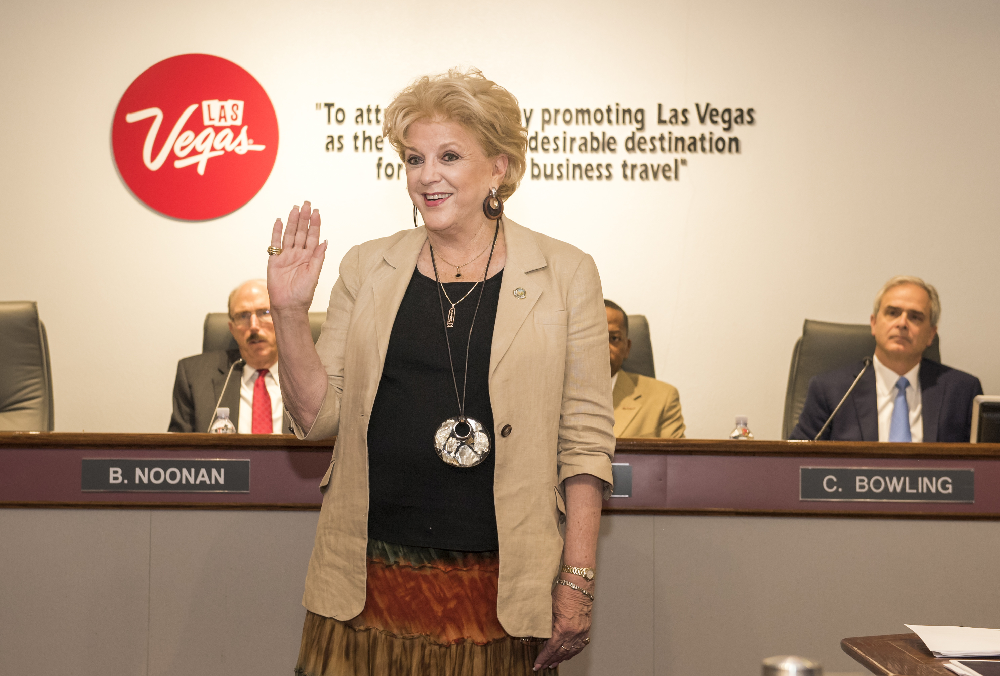

Mayor of Las Vegas Carolyn Goodman Named to LVCVA Board of Directors

LAS VEGAS – Mayor of Las Vegas Carolyn Goodman is the newest member of the Las Vegas Convention and Visitors Authority’s (LVCVA) Board of Directors after being sworn in during today’s meeting. Goodman was approved by the Las Vegas City Council to take over the position previously occupied by Las Vegas Mayor Pro Tem Steve Ross.
Goodman is a 52-year resident of Las Vegas and has served as Mayor of Las Vegas since 2011. In 2015, she began her second term as Mayor. Goodman previously served on the LVCVA Board of Directors from July 2011 to June 2015.
The LVCVA Board of Directors is comprised of 14 members representing the county, incorporated cities within the county and private citizens on behalf of various segments of the county’s tourism industry. The board’s primary function is to formulate policies to guide the LVCVA in fulfilling its mission of attracting an ever-increasing number of visitors to Southern Nevada.
Also approved today by the LVCVA Board of Directors was funding for The World Series of Team Roping, a Dolly Parton concert in Laughlin, and the Customer Service Excellence program run by the Chamber of Commerce.
ABOUT THE LVCVA
The Las Vegas Convention and Visitors Authority (LVCVA) is charged with marketing Southern Nevada as a tourism and convention destination worldwide, and also with operating the Las Vegas Convention Center and Cashman Center. With nearly 150,000 hotel rooms in Las Vegas alone and more 11 million square feet of meeting and exhibit space citywide, the LVCVA's mission centers on attracting ever increasing numbers of leisure and business visitors to the area. Download the virtual reality app, Vegas VR, to experience Las Vegas from your iPhone or Android by visiting http://www.vrtv.vegas/. For more information, go to www.lvcva.com or www.lasvegas.com.

###

