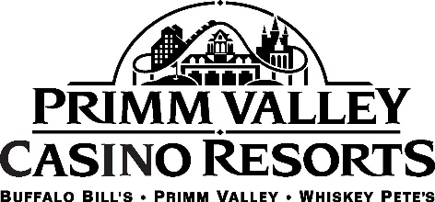

ATTRACTIONS
Primm’s mantra of short on distance but not on fun rings true for guests. The resorts offer a plethora of experiences, activities and play for those driving through or stopping for a getaway.
Star of the Desert Arena is located in Buffalo Bill’s and hosts world-famous acts such as Dolly Parton, The Beach Boys, Rick Springfield, The Band Perry and many others. The concert venue seats more than 6,500. Star of the Desert Arena also has comedians scheduled to perform.
The adventurous can shoot through the Buffalo Bill’s casino, soar high above the desert landscape all before plummeting 209-feet to the ground at nearly 100 mph on The Desperado. Nicknamed “The Speed Demon” by The Travel Channel, this roller coaster is sure to get the adrenaline pumping for even the most daring.
Those looking to for a more relaxing adventure can try the other rides at Buffalo Bill’s, Adventure Canyon Log Flume or Maxflight Cyber Coaster. Adventure Canyon Log Flume gently floats riders through the casino, before entering a dark tunnel followed by rapids and a 50-foot drop that leaves everyone feeling cool and refreshed, and only slightly damp. The Maxflight Cyber Coaster is a virtual roller coaster that travels and experiences roller coasters from around the world.
Buffalo Bill’s Arcade is the perfect place for some easy-going and laid-back fun. The Arcade has the classics, tried-and-true favorites and newer games for players. Try pinball, action-packed video games or test driving skills on the track at top speeds, shoot to win and many more. An Arcade is also at Primm Valley and Whiskey Pete’s.
Catch the latest and greatest movies at Carolee Theater. Grab some popcorn and a cool beverage before settling in to the comfortable chairs for the film.
Across the highway at Whiskey Pete’s is the Bonnie and Clyde collection. Artifacts from the infamous duo, known for their crime-spree, are on display in glass cases for history fans and the curious. Displays include the bullet-riddled car the partners were driving their final day, the shirt Clyde was wearing as well as mementos from the couple’s travels.
SHOPPING
The Fashion Outlets of Las Vegas are home to more than 80 designer stores including Calvin Klein, Coach, Kate Spade New York, Michael Kors, Neiman Marcus Last Call and many others. The Fashion Outlets have easy access for visitors with a connected, indoor walkway from Primm Valley. The shopping center has two themed courts, the Urban Court that is styled after New York’s Time Square and the South Beach Court that was inspired by the sunny Florida coast, as well as a food court.
SPA
Relax and unwind in The Spa at Primm Valley. This full-service spa offers massages, facials, body treatments, manicures, pedicures, waxing and specialty services that melt all worries and stress away. The steam rooms and comfortable lounges invite guests to begin their preferred treatments with soothing music. Located next to The Spa is the fitness center.

